|  |  |
| --- | --- |
|  | **MINISTRY OF EDUCATION AND TRAINING** |

**FPT UNIVERSITY**

|  |  |
| --- | --- |
| Capstone Project Document | |
| **Peer-to-Peer Lending System** | |
| **Group 10 - IS** | |
| **Group members** | Nguyễn Trung Dũng – SE62576 (Leader)  Huỳnh Văn Lộc – SE62291  Lê Ngô Minh – SE62705 |
| **Supervisor** | Nguyễn Huy Hùng |
| **Ext. Supervisor** | N/A |
| **Project Code** | PPLS |

– **Ho Chi Minh City, 13 May, 2019** –

Table of contents

List of tables 6

List of Figures 11

A. Introduction 14

1. Project Information 14

2. Introduction 14

3. Current Situation 14

4. Problem Definition 14

5. Proposed Solution 15

**5.1 Feature functions** 15

**5.2** **Advantages and disadvantages** 15

6. Functional Requirements 15

7. Role & Responsibility 16

B. Software Project Management Plan 16

1. Problem Definition 16

2. Project Organization 19

3. Project Management Plan 21

4. Coding Convention 22

C. Software Requirement Specification 22

1. User Requirement Specification 22

2. System Requirement Specification 23

3. Software System Attribute 83

4. Conceptual Diagram 84

D. Software Design Description 85

1. Design Overview 85

2. System Architectural Design 87

3. Component Diagram 89

4. Detailed Description 91

**4.1 Class Diagram** 91

**4.2 Class Diagram Explanation** 91

**4.3 Interaction Diagram** 99

5. Interface 106

5.1 User Interface Design 106

5.1.1 User 106

**5.1.1.1** **HomePage** 106

**5.1.1.2** **Login** 107

**5.1.1.3** **Forgot Password** 109

**5.1.1.4** **Register** 110

**5.1.1.5** **Manage User** 111

**5.1.1.6** **Create Request** 113

**5.1.1.7** **Own Requests** 115

**5.1.1.8** **Lending Requests** 116

**5.1.1.9** **Detail Request** 118

**5.1.1.10** **Make Deal** 120

**5.1.1.11** **Do Payment** 122

**5.1.1.12** **Own transactions** 123

**5.1.1.13** **Check Timeline** 124

**5.1.1.14** **History requests** 125

**5.1.1.15** **User Profile** 127

5.1.2 Admin 129

**5.1.2.1** **Login** 129

**5.1.2.2** **Manage Admin** 130

**5.1.2.3** **Pending documents** 131

**5.1.2.4** **User List** 132

**5.1.2.5** **Document detail** 133

**5.1.2.6** **List document type** 135

**5.1.2.7** **Edit document type** 136

**5.1.2.8** **Add new document type** 137

6. Database Design 139

6.1. Entity relationship diagram (ERD) 139

6.2. Entity Data Dictionary 140

7. Algorithms 143

**7.1 Record Transaction** 143

**7.2 Interest lending** 144

**7.3 Lending/Payback** 145

E. System Implementation & Test 148

1. Introduction 148

2. Data Relationship Diagram 149

**2.1** **Physical diagram** 149

**2.2**  **Data dictionary** 149

3. Test Plan 150

3.1. Features To Be Tested 150

3.2. Features Not To Be Tested 151

4. System Testing Test Case 151

## List of tables

Table 1 - Hardware Requirements for Server 18

Table 2 - Hardware requirement for PC 18

Table 3 - Software Requirement 19

Table 4 - Roles and responsibilities 21

Table 5 - Tools and techniques 21

Table 6 - Deliverables 22

Table 7 - <Guest> Login use case specification 27

Table 8 – <Guest> View transaction use case specification 29

Table 9 – <Guest>Valid Transaction with Blockchain use case specification 30

Table 10 – <Guest> Sign up use case specification 32

Table 11– <Authorized User> Logout use case specification 35

Table 12 – <Authorized User> View profile use case specification 36

Table 13 – <Authorized User> Edit profile use case specification 37

Table 14 – <Authorized User> Change password use case specification 39

Table 15– <Authorized User> Create request use case specification 41

Table 16– <Authorized User> View own request use case specification 42

Table 17 – <Authorized User> Delete request use case specification 44

Table 18 – <Authorized User> Cancel request use case specification 46

Table 19 – <Authorized User> View trading request use case specification 47

Table 20 – <Authorized User> View history request use case specification 49

Table 21 – <Authorized User> View lending request use case specification 50

Table 22 – <Authorized User> Do payment use case specification 52

Table 23 – <Authorized User> Accept request use case specification 54

Table 24 – <Authorized User> Make deal use case specification 56

Table 25 – <Authorized User> View detail request use case specification 58

Table 26 – <Authorized User> View detail request use case specification 59

Table 27 – <Authorized User> Valid transaction with blockchain use case specification 61

Table 28 – <Authorized User> Upload document use case specification 64

Table 29 – <Admin> Get list users use case specification 66

Table 30 – <Admin> Activate/Deactivate user use case specification 67

Table 31 – <Admin> View list pending document use case specification 69

Table 32 – <Admin> Accept document use case specification 71

Table 33 – <Admin> Reject document use case specification 74

Table 34 – <Admin> View list document type use case specification 75

Table 35 – <Admin> Add document type use case specification 76

Table 36 – <Admin> Edit document type use case specification 77

Table 37 – <System> Process make transaction use case specification 79

Table 38 – <System> Process save transaction use case specification 81

Table 39 – <System> Process notify use case specification 82

Table 40 – Conceptual Diagram Data Dictionary 85

Table 41 – Front End Component Diagram Dictionary 90

Table 42– Back End Component Diagram Dictionary 90

Table 43 – Class Diagram PPLS 92

Table 44 – <Class Diagram Attributes> User 93

Table 45 – <Class Diagram Methods> User 93

Table 46 – <Class Diagram Attributes> Request 93

Table 47 – <Class Diagram Methods> Request 94

Table 48 – <Class Diagram Attributes> Deal 94

Table 49 – <Class Diagram Methods> Deal 95

Table 50 – <Class Diagram Attributes> Milestone 95

Table 51 – <Class Diagram Methods> Milestone 95

Table 52 – <Class Diagram Attributes> Transaction 96

Table 53 – <Class Diagram Methods> Transaction 96

Table 54 – <Class Diagram Attributes> Backup Deal 97

Table 55 – <Class Diagram Methods> Backup Deal 97

Table 56 – <Class Diagram Attributes> Backup milestone 97

Table 57 – <Class Diagram Methods> Backup milestone 97

Table 58 – <Class Diagram Attributes> Document 98

Table 59 – <Class Diagram Methods> Document 98

Table 60 – <Class Diagram Attributes> Document Type 98

Table 61 – <Class Diagram Attributes> DocumentFile 99

Table 62 <Buttons/Hyperlinks>User Login 107

Table 63 <Fields> Login 107

Table 64 <Buttons/Hyperlinks> Login 108

Table 65 <Fields> Forgot Password 109

Table 66 <Buttons/Hyperlinks> Forgot Password 110

Table 67 <Fields> Register 111

Table 68 <Buttons/Hyperlinks> Register 111

Table 69 <Buttons/Hyperlinks> Manage User 112

Table 70 <Fields> Create Request 114

Table 71 <Buttons/Hyperlinks> Create Request 114

Table 72 <Buttons/Hyperlinks> Own Requests 116

Table 73 <Fields> Lending Requests 117

Table 74 <Buttons/Hyperlinks> Lending Requests 117

Table 75 <Fields> Detail Request (Lender) 119

Table 76 <Buttons/Hyperlinks> Detail Request (Lender) 119

Table 77 <Fields> Make Deal (Lender) 121

Table 78 <Buttons/Hyperlinks> Forgot Password 121

Table 79 <Buttons/Hyperlinks> Do Payment 122

Table 80 <Fields> Own transactions 123

Table 81 <Buttons/Hyperlinks> Own transactions 123

Table 82 <Fields> Check Timeline 125

Table 83 <Buttons/Hyperlinks> Check Timeline 125

Table 84 <Fields> History Requests 126

Table 85 <Buttons/Hyperlinks> History Requests 126

Table 86 <Fields> User Profile 128

Table 87 <Buttons/Hyperlinks> User Profile 128

Table 88 <Fields> Login 130

Table 89 <Buttons/Hyperlinks> Login 130

Table 90 <Fields> Manage Admin 130

Table 91 <Fields> Pending documents 131

Table 92 <Buttons/Hyperlinks> Pending documents 131

Table 93 <Fields> User List 132

Table 94 <Buttons/Hyperlinks> User List 132

Table 95 <Fields> Document Detail 134

Table 96 <Buttons/Hyperlinks> Document Detail 134

Table 97 <Fields> List document type 135

Table 98 <Buttons/Hyperlinks> List document type 135

Table 99 <Fields> Edit document type 136

Table 100 <Buttons/Hyperlinks> Edit document type 137

Table 101 <Fields> Add new document type 138

Table 102 <Buttons/Hyperlinks> Add new document type 138

Table 103 Entity Relationship Diagram Dictionary 140

Table 104 Physical Diagram Dictionary 150

Table 105 <Test case> Valid transaction 153

Table 106<Test case> Forgot password 153

Table 107 <Test case> View request 155

Table 111 <Test case> *Valid transaction (Authorized User)* 171

Table 112 <Test case> *My Profile* 180

Table 113 <Test case> *List user* 181

Table 114 <Test case> *Pending documents* 183

## List of Figures

Figure 1 - Scrum Framework 20

Figure 2 – <Guest> Overview Use Case 26

Figure 3 – <Guest> Login Use Case 26

Figure 4 – <Guest> View Transaction Use Case 28

Figure 5 – <Guest>Valid Transaction with Blockchain Use Case 29

Figure 6 – <Guest> Sign Up Use Case 31

Figure 7 – Authorized User Overview Use Case 33

Figure 8 – <Authorized User> Logout Use Case 34

Figure 9 – <Authorized User> View Profile Use Case 35

Figure 10 – <Authorized User> Edit Profile Use Case 36

Figure 11 – <Authorized User> Change Password Use Case 38

Figure 12 – <Authorized User> Create Request Use Case 39

Figure 13 – <Authorized User> View Own Request Use Case 41

Figure 14 – <Authorized User> Delete Request Use Case 43

Figure 15 – <Authorized User> Cancel Request Use Case 44

Figure 16 – <Authorized User> View trading request use case 46

Figure 17 – <Authorized User> View History Request Use Case 48

Figure 18 – <Authorized User> View Lending Request Use Case 49

Figure 19 – <Authorized User> Do Payment Use Case 51

Figure 20 – <Authorized User> Accept Request Use Case 53

Figure 21 – <Authorized User> Make Deal Use Case 55

Figure 22 – <Authorized User> View Detail Request Use Case 56

Figure 23 – <Authorized User> View Own Transaction Use Case 58

Figure 24 – <Authorized User> Valid Transaction With Blockchain Use Case 59

Figure 25 – <Authorized User> Upload Document Use Case 61

Figure 26– <Admin> Overview Use Case 64

Figure 27– <Admin> Get List Users Use Case 65

Figure 28 – <Admin> Activate/Deactivate User Use Case 66

Figure 29 – <Admin> View List Pending Document Use Case 68

Figure 30 – <Admin> Accept Document Use Case 69

Figure 31– <Admin> Reject Document Use Case 72

Figure 32 – <Admin> View List Document Type Use Case 74

Figure 33 – <Admin> Add Document Type Use Case 75

Figure 34 – <Admin> Add Document Type Use Case 76

Figure 35 – <System> Overview Use Case 78

Figure 36 – <System> Process Make Transaction Use Case 78

Figure 37 – <System> Process Save Transaction Use Case 80

Figure 38 – <System> Process Notify Use Case 81

Figure 39 - Conceptual Diagram 84

Figure 40 – Software Architecture Design 87

Figure 41 – Front End User Component Diagram 89

Figure 42 – Back End Component Diagram 90

Figure 43 – Class Diagram 91

Figure 44 <Sequence Diagram> Guest Login 100

Figure 45 <Sequence Diagram> Accept Deal 101

Figure 46 <Sequence Diagram> Create request 102

Figure 47 <Sequence Diagram> Make deal 103

Figure 48 <Sequence Diagram> Valid document 104

Figure 49 <Sequence Diagram> Do payment and sent to BigchainDB 105

Figure 50 Homepage 106

Figure 51 - Login 107

Figure 52 - Forgot Password 109

Figure 53 Register 110

Figure 54 - Manage User 112

Figure 55 Create Request 113

Figure 56 Own Requests 115

Figure 57 Lending Requests 116

Figure 58 Detail Request (Lender) 118

Figure 59 Make Deal (Lender) 120

Figure 60 Do Payment 122

Figure 61 Own transactions 123

Figure 62 Check Timeline 124

Figure 63 History Requests 125

Figure 64 User Profile 127

Figure 65 Login 129

Figure 66 Manage Admin 130

Figure 67 Pending documents 131

Figure 68 User List 132

Figure 69 Document Detail 133

Figure 70 List document type 135

Figure 71 Edit document type 136

Figure 72 Add new document type 137

Figure 73 Entity Relationship Diagram 139

Figure 74. Example of BigchainDB transaction 144

Figure 75– Lending/Payback process 146

Figure 76 Physical Diagram 149

# Introduction

## Project Information

* Project name:  **Peer-to-peer Lending System**
* Project Code: **PPLS**
* Product Type: **Website Application**
* Start Date: **May 13rd, 2019**
* End Date: **--**

## Introduction

These days, borrowing money is no longer strange. Borrowing money to invest in a project or to buy something like washing machine, phone, etc.… that can be seen every day around our lives. However, borrowing money from banks still exists many cumbersome procedures that make borrowers encounter many difficulties in borrowing money. Moreover, whether transactions can be changed, or even deleted to protect an individual may cause someone to be guilty.

In this document, we introduce a solution to make loan transactions transparent, a web application called Peer-to-peer Lending System. This Peer-to-peer Lending System helps people borrow money directly by making an agreement with the lender, from which all transactions will be stored on the Blockchain and viewed by anyone in the system.

## Current Situation

As mentioned in the introduction, borrowing money causes many difficulties for borrowers because many procedures need to be authenticated by the authorities. This makes many people in urgent need to earn illegal money such as interest loans.

Also, trust between people and people is still deficient to be able to lend directly between two people. That's why creating trust among people is a necessity.

## Problem Definition

Below are the disadvantages of the current situation:

* Currently, if you want to borrow money from the bank, you need a lot of documents, as well as many complicated procedures. Not to mention whether you are approved for a loan after going through a customer appraisal step.
* The current interest rate is quite high. For unsecured loans VPBank from 15.91-21% / year, TPBank from 8.28 - 17% / year, ACB up to 22% / year. As for mortgage loans, about 5-12%/year.
* The amount can be borrowed from the bank is not too much. The maximum limit of banks falls between 300 million VND and 1 billion VND.

## Proposed Solution

We will build a website using blockchain to reduce the time of borrowing money from banks and increase the borrowing limit to higher than the current banks. Features will be implemented in the system:

### **5.1 Feature functions**

* Create requirements to borrow money from people who need to borrow money.
* Create and set the necessary milestones in borrowing as well as the most appropriate payments created by borrowers and lenders.
* Store transactions using Blockchain
* Use online payment gateways for transferring loans as well as paying such as Paypal, Ethereum, Momo, ….

### **5.2** **Advantages and disadvantages**

The advantages and disadvantages of the proposed solution:

* **Advantages**:
* Optimize time to do loan procedures.
* The loan limit is not dependent on banks so the limit may be much higher.
* **Disadvantages**:
* There are still risks when lending.

## Functional Requirements

Function requirements of the system are listed below:

**6.1 Admin:**

* Admin can activate, or deactivate the account.
* Amin can view list users.
* Admin can approvedocuments for increasing loan limit of user.
* Admin can reject document of user.
* Admin can manage document type.

**6.2 Authorized User:**

* User can create a borrowing request.
* User can detect a borrowing request.
* User can view detail of a request.
* User can accept request after view detail.
* User can make a deal with the chosen request.
* User can view them all own transactions.
* User can view them all history requests.
* User can upload identity document for verifying to get loan limit

**6.3 Guest:**

* User can sign up a new account.
* User can log in into the system.
* User can view all transactions.

## Role & Responsibility

|  |  |  |  |  |
| --- | --- | --- | --- | --- |
| **No** | **Full Name** | **Role** | **Position** | **Contact** |
| 1 | Nguyễn Huy Hùng | Project Manager | Supervisor | hungnh@fpt.edu.vn |
| 2 | Nguyễn Trung Dũng | Developer | Leader | dungntse62576@fpt.edu.vn |
| 3 | Huỳnh Văn Lộc | Developer | Member | lochvse62291@fpt.edu.vn |
| 4 | Lê Ngô Minh | Developer | Member | minhlnse62705@fpt.edu.vn |
| 5 | Hoàng Nhật Đông | Developer | Member | donghnse62357@fpt.edu.vn |

# Software Project Management Plan

## Problem Definition

* 1. **Name of this Capstone Project**
* Official name: Peer-to-Peer Lending System Based on Blockchain Technology
* Vietnamese name: Ứng Dụng Vay Tiền Giữa Các Cá Nhân Trên Nền Tảng BlockChain
* Abbreviation: PPLS
  1. **Problem Abstract**
* This project is a concern for individuals who have a surplus of money and want to invest in profits, but they need transparency in transactions. We call it the Peer-to-peer Lending System (PPLS). PPLS will provide users with an interactive and easy-to-use interface for making transactions.
* Individuals use the website as a reputable trading channel because every recorded transaction is saved to the Blockchain. And Blockchain is a network where all transparency is exposed, so people can only view and cannot edit any transaction after it has been done.
* The Peer-to-peer Lending System can ensure transparency in all transactions between users, thereby reducing concerns about fraud in transactions.
* Finally, PPLS will perform the transactional data control between the database and Blockchain, thereby creating more credibility for customers that the transaction history has not been changed.
  1. **Project Overview**
     1. **Current Situation**

Below are the problems encountered in this project:

• Limit time and human resource: Team has only four members and time for all project is about 13 weeks for writing a document, implementing the products, and testing.

• Framework study: team members have a problem when applying the play framework into the project. The team needs an amount of time to get familiar with new techniques.

• New technique: Some team members are new to the techniques used in the project. The team needs an amount of time to get familiar with those techniques.

• Lack of UI (user interface), UX (user experience) design skill: Our team members all study IS major, and no one has studied UI, UX design. Therefore, some UI may misunderstand or hard to use with normal users.

* + 1. **The Proposed System**

Building a web application that allows individuals lending money to others. Proof of leading will be stored in a blockchain-based system to secure lending transaction. Admin can manage user and accept users though their identity information. Individuals can create and process a transaction anytime. Besides, they can process to payback money in full amount or breaking the payment in different amount.

The task will be assigned vertically to team members so that if one member quits, the team will not lack resources.

* + 1. **Boundaries of the System**

The system can:

* Allow Admin to manage user accounts.
* Allow Admin to accept User’s document for increasing limit loans.
* Allow Individuals to conduct borrowing request.
* Allow Individuals to view and accept by other individuals.
* Allow Individuals payback in full amount; or breaking the payment in different amounts.

The system cannot:

* Current system just support Paypal for payment.
  + 1. **Future Plans**
* The system is currently being developed on the web platform:
* We will develop our system on Android and iOS platform
* The current system uses some user information to identify the user:
* We will add more other user identification information to reduce risks when users join the system and increase user loan limits.
* The current system cannot evaluate user reliability.
* We will design a scale to evaluate users after each transaction as well as milestones to be able to evaluate user reliability.
* The current system uses paypal as a payment method.
* We will support more payment method such as Momo, Ethereum, and so on.
* The current system cannot support user select deal that they want to choose when they use cancel deal function. Mean that when user cancel deal function system automatically restore deal to the original deal (the first deal that user create when they create request).
* We will design a function that help user can choose a deal that they want when they cancel deal. The function will show all deal between two users. So that, user can choose what they want.
* The current system still not support investigation function.
* We will add investigation function to our system in the future to support the investigation.
  + 1. **Development environment**
       1. **Hardware requirements**

**For server**

|  |  |  |
| --- | --- | --- |
| **Hardware** | **Minimum Requirement** | **Recommended** |
| **Internet Connection** | Cable, Wi-Fi (4 Mbps) | Cable, Wi-Fi (8 Mbps) |
| **Operation System** | Ubuntu 18.04 | Ubuntu 18.04 |
| **Computer Processor** | Intel® Xeon ® 1.4GHz | Intel® Xeon ® Quad Core (12M Cache, 2.50 GHz) |
| **Computer memory** | 4GB RAM | 12 GB RAM or more |
| **Storage space** | 5GB | 15GB or more |

Table 1 - Hardware Requirements for Server

**For PC**

|  |  |  |
| --- | --- | --- |
| **PC** | **Minimum Requirements** | **Recommended** |
| **Internet Connection** | Cable, Wi-Fi (4 Mbps) | Cable, Wi-Fi (8 Mbps) |
| **Operating System** | Window 7 | Window 10. |
| **Computer Processor** | Intel® Core i3 1.4GHz | Intel® Core i5 2.50GHz |
| **Computer Memory** | 2GB RAM | 4GB RAM or more |
| **Web Browser** | Firefox (v52 or higher), Chromes (v42 or higher) | Chrome latest stable version |

Table 2 - Hardware requirement for PC

* + - 1. **Software requirement**

|  |  |  |
| --- | --- | --- |
| **Software** | **Name / Version** | **Description** |
| **Operation System** | Windows Server 2014 | Operating system and platform for development |
| **Environment** | Java EE 8.0, Node v10, npm v6 | Specification for developing web application |
| **Modeling tool** | StarUML, Software Ideas Modeler | Used to design diagram |
| **IDE** | Intellij IDEA 2018.1.5, Visual Studio Code 1.35.1, A5M2 2.12.1 (SQL) | Programming tools |
| **DBMS** | MYSQL 8.0 | Used to create & manage the database for system |
| **Source control** | Git on IDE (Github) | Used for source control |
| **Web browser** | Chrome 69 or above | Testing browser |

Table 3 - Software Requirement

## Project Organization

* 1. **Software Process Model**



Figure 1 - Scrum Framework

* 1. **Roles and responsibilities**

|  |  |  |  |
| --- | --- | --- | --- |
| **No** | **Full name** | **Role in Group** | **Responsibilities** |
| **1** | Nguyễn Huy Hùng | Product Owner | * Specify user requirement * Control the development process * Give out technique and business analysis support |
| **2** | Nguyễn Trung Dũng | Scrum Master | * Managing process * Designing database * Clarifying requirements * Prepare documents * GUI Design * Create test plan * Coding * Testing * Arrange Meeting * Risk Management |
| **3** | Huỳnh Văn Lộc | Scrum team member | * Designing database * Clarifying requirements * Prepare documents * GUI Design * Create a test plan * Coding * Testing |
| **4** | Lê Ngô Minh | Scrum team member | * Designing database * Clarifying requirements * Prepare documents * GUI Design * Create a test plan * Coding * Testing |

Table 4 - Roles and responsibilities

* 1. **Tools and Techniques**

|  |  |
| --- | --- |
| Tool/Technique | Name |
| Front-end | HTML, CSS, JavaScript, ReactJS, Reactstrap. |
| Back-end | JavaEE, SpringBoot framework, JPA, Hibernate, Python, Flask framework |
| IDE | NetBeans 8.2, IntelliJ IDEA 17.2 |
| DBMS | MySQL |
| Source Control | Github |
| Modeling tool | StarUML, Software Idea Modelers |

Table 5 - Tools and techniques

## Project Management Plan

* + 1. **Product Backlog**

Product Backlog could be found here.

* + 1. **Sprint Backlog**

Sprint Backlog can be found [here](https://docs.google.com/spreadsheets/d/1DvHD5Bwmk1IL5XokeVP7r67h5yaPtwHpret4qHMtcmw/edit?usp=sharing)

* + 1. **Deliverables**

|  |  |  |
| --- | --- | --- |
| **No** | **Deliverable** | **Note** |
| 1 | Introduction, Entity Relationship Diagram, Use Case Overview, Mock UI | Sprint 1 |
| 2 | Study Spring Boot Framework, React JS, BigchainDB, Design User Interface for Web Application | Sprint 2 |
| … |  |  |
|  |  |  |

Table 6 - Deliverables

* + 1. **All Meeting Minutes**

All sprint meeting minutes could be found here.

## Coding Convention

**Summary**:

* **Naming Convention**:
* Variable names should be short yet meaningful. The choice of a variable name should be designed to indicate to the casual observer the intent of its use.
* Methods should be verbs, in mixed case with the first letter lowercase, with the first letter of each internal word capitalized.
* **Indentation**:
* One declaration per line is recommended since it encourages commenting.
* In absolutely no case should variables and functions be declared on the same line.
* Do not put different types on the same line.
* **Declarations Convention:**
  + One declaration per line is recommended since it encourages commenting.
  + Using Java Code Convention from:

<http://www.oracle.com/technetwork/java/codeconvtoc-136057.html>

# Software Requirement Specification

## User Requirement Specification

* 1. **Guest Requirement**

*Guest is a person who doesn’t have access to the system. Guest-only tries some demo features. To use all functions, guest must log in. These are some functions guest can use:*

* Login.
* View History Transactions.
  1. **Authorized User Requirement**

*Authorized User is an authorized user who has permission to login into the system. With authorized user role, user can use below functions:*

* Create borrowing requests.
* View list borrowing requests.
* View list pending requests.
* View list dealing requests.
* View list history requests.
* View list trading requests.
* View list owns requests.
* View detail of a request.
* Accept request after view detail.
* Cancel a request after view list dealing requests.
* Make a deal with the chosen request.
* Pay for the deal borrowed.
  1. **Admin Requirement**

*Admin is an authorized user who has permission to login into the system under the Admin role. Admin can use below management functions:*

* Activate/Deactivate User account.
* View all pending documents.
* Accept user documents.
* Reject user documents.

## System Requirement Specification

* 1. **External Interface Requirement**
     1. **User Interface**
* GUI should be simple, clear, intuitive, and reminiscent.
* The interface design is an iterate process includes design, sketching, prototyping, user assessment.
* The User Interface uses language is English.
  + 1. **Hardware Interface**
* Desktop PC.
  + 1. **Software Interface**
* Web application: work with browsers Firefox (v52 or higher), Chrome (v28 or higher), Internet Explorer (v10 or above) or with any web browser that supports HTML5 & CSS3.
  + 1. **Communication Protocol**

Use HTTP protocol 1.1 for communication between:

Web application and web server

* 1. **System Overview Use Case**

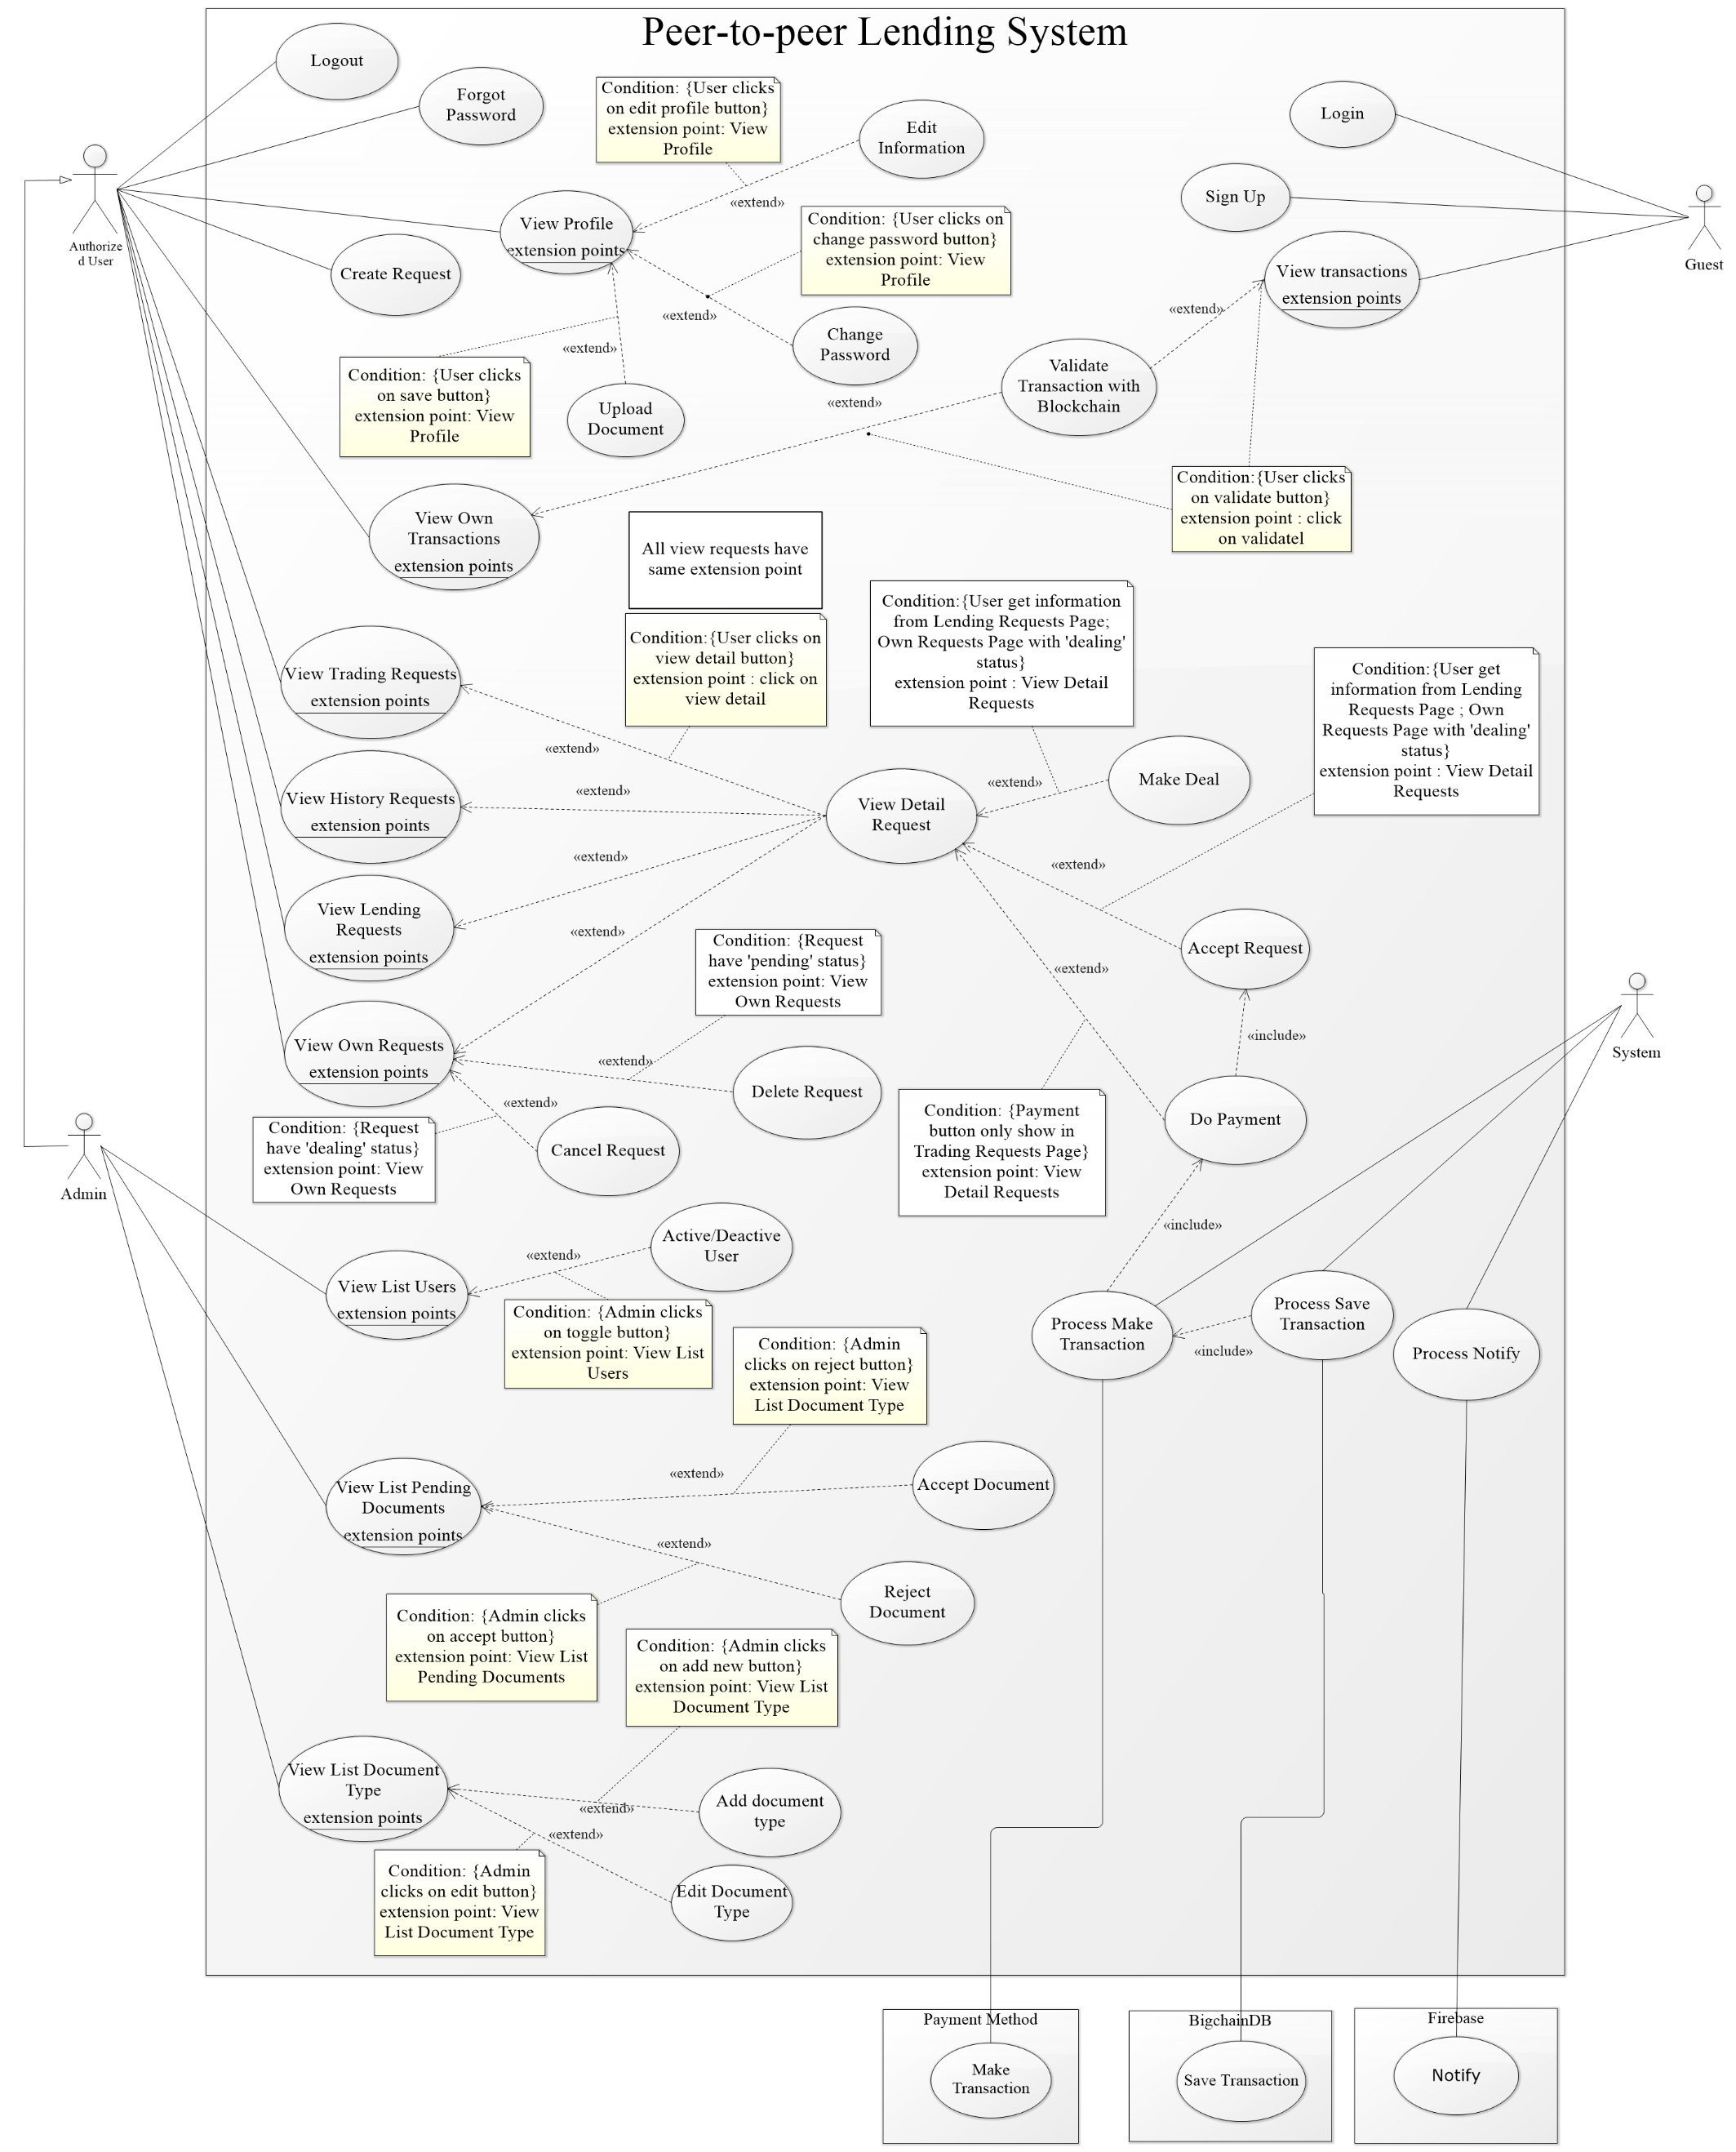

* 1. **List of use case**
     1. **<Guest> Overview Use Case**

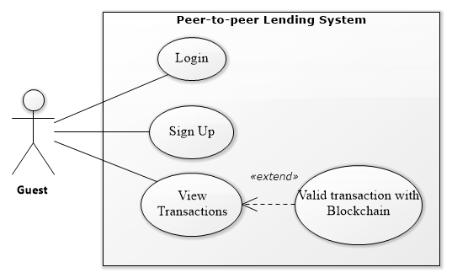

Figure 2 – <Guest> Overview Use Case

* + - 1. **<Guest> Login**

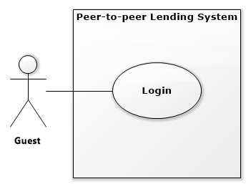

Figure 3 – <Guest> Login Use Case

|  |  |  |  |
| --- | --- | --- | --- |
| **USE CASE – PPLS_GU_01** | | | |
| **Use Case No.** | PPLS_GU_01 | **Use Case Version** | 1.0 |
| **Use Case Name** | Login | | |
| **Author** | DungNT | | |
| **Date** | 22/05/2019 | **Priority** | Normal |
| **Actor:**   * Guest   **Summary:**   * Allow guest to log in the system.   **Goal:**   * Guest can log in the system with a specific role.   **Triggers:**   * Guest sends login command.   **Preconditions:** N/A  **Post conditions:**   * Success: Guest is exactly authorized with a specific role in the system. * Fail: System shows error messages.   **Main Success Scenario:**   |  |  |  | | --- | --- | --- | | **Step** | **Actor Action** | **System Response** | | 1 | Guest goes to the login page. | The system requires identity information from Guest:  -Username: text input.  - Password: text input. | | 2 | Guest inputs information. |  | | 3 | Guest sends a command to log in to the system. | Guest logins system with their specific role. [Alternative 1] |   **Alternative Scenario:**   |  |  |  | | --- | --- | --- | | **No** | **Actor Action** | **System Response** | | 1 | Guest enter wrong identity information. | The system shows error message “username or password is incorrect. Please try again.” |   **Exceptions:**   |  |  |  | | --- | --- | --- | | **No** | **Actor Action** | **System Response** | |  |  |  |   **Relationships:** N/A  **Business Rules:**   * Password is encrypted before being sent to the server. * After login to the system, the guest will be redirected to view request page (user can see the other request). | | | |

Table 7 - <Guest> Login use case specification

* + - 1. **<Guest> View Transactions**

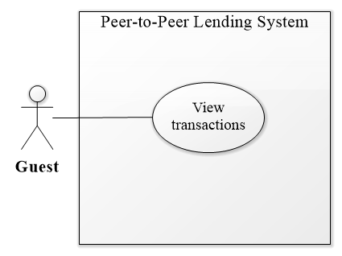

Figure 4 – <Guest> View Transaction Use Case

|  |  |  |  |
| --- | --- | --- | --- |
| **USE CASE – PPLS_GU_02** | | | |
| **Use Case No.** | PPLS_GU_02 | **Use Case Version** | 1.0 |
| **Use Case Name** | View transactions | | |
| **Author** | LocHV | | |
| **Date** | 22/05/2019 | **Priority** | Normal |
| **Actor:**   * Guest   **Summary:**   * Allow guests to view some transactions that completed.   **Goal:**   * Guest can see that there are successful transactions.   **Triggers:**   * Guest sends getting transactions command.   **Preconditions:** N/A  **Post conditions:**   * Success: Guest can view transactions. * Fail: System shows error messages.   **Main Success Scenario:**   |  |  |  | | --- | --- | --- | | **Step** | **Actor Action** | **System Response** | | 1 | Guest goes to the homepage. | Getting all present transactions with the following information:  - Id  - sender  - receiver  - amount  - createDate  - Status |   **Alternative Scenario:**   |  |  |  | | --- | --- | --- | | **No** | **Actor Action** | **System Response** | |  |  |  |   **Exceptions:**   |  |  |  | | --- | --- | --- | | **No** | **Actor Action** | **System Response** | |  |  |  |   **Relationships:** PPLS_GU_03  **Business Rules:**   * Some completed transactions must be listed (20 transactions will be listed). * Transactions must be ordered descending by transaction day. | | | |

Table 8 – <Guest> View transaction use case specification

* + - 1. **<Guest> Validate Transaction with blockchain**

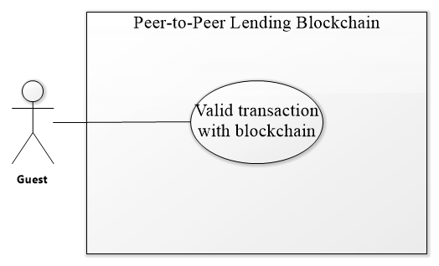

Figure 5 – <Guest>Valid Transaction with Blockchain Use Case

|  |  |  |  |
| --- | --- | --- | --- |
| **USE CASE – PPLS_GU_03** | | | |
| **Use Case No.** | PPLS_GU_03 | **Use Case Version** | 1.0 |
| **Use Case Name** | Validate transaction with blockchain | | |
| **Author** | LocHV | | |
| **Date** | 22/05/2019 | **Priority** | Normal |
| **Actor:**   * Guest   **Summary:**   * Allow guests to compare transaction between database and blockchain.   **Goal:**   * Guest can check that transaction in the database is real transaction that is saved in the blockchain.   **Triggers:**   * Guest sends a valid transaction with blockchain command.   **Preconditions:** N/A  **Post conditions:**   * Success: Guest can check that transaction is valid or not. * Fail: System shows error messages.   **Main Success Scenario:**   |  |  |  | | --- | --- | --- | | **Step** | **Actor Action** | **System Response** | | 1 | Guest click on validate button | System show check validate modal:   * Check Sender * Check Receiver * Check Amount * Check Create Date   After check this information system show:   * ID Transaction * Status (valid transaction)   [Alternative 1] |   **Alternative Scenario:**   |  |  |  | | --- | --- | --- | | **Step** | **Actor Action** | **System Response** | | 1 | Guest click on validate button | System show check validate modal:   * Check Sender * Check Receiver * Check Amount * Check Create Date   After check this information system show:   * ID Transaction * Status (invalid transaction) |   **Exceptions:**   |  |  |  | | --- | --- | --- | | **Step** | **Actor Action** | **System Response** | |  |  |  |   **Relationships:** PPLS_GU_02  **Business Rules:**   * System will get transaction from database compare to transaction in blockchain. | | | |

Table 9 – <Guest>Valid Transaction with Blockchain use case specification

* + - 1. **<Guest> Sign Up**

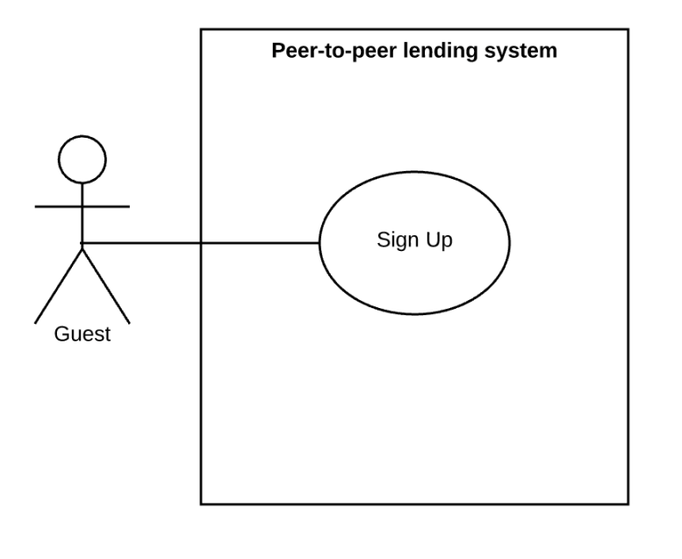

Figure 6 – <Guest> Sign Up Use Case

|  |  |  |  |
| --- | --- | --- | --- |
| **USE CASE – PPLS_GU_04** | | | |
| **Use Case No.** | PPLS_GU_04 | **Use Case Version** | 1.0 |
| **Use Case Name** | Sign up | | |
| **Author** | LocHV | | |
| **Date** | 25/05/2019 | **Priority** | Normal |
| **Actor:**   * Guest   **Summary:**   * Allow guest to sign up an account in the system.   **Goal:**   * Guests create an account to become a user of the system.   **Triggers:**   * Guests send sign up command.   **Preconditions:** N/A  **Post conditions:**   * Success: Guests create a new account successfully. * Fail: System shows error messages.   **Main Success Scenario:**   |  |  |  | | --- | --- | --- | | **Step** | **Actor Action** | **System Response** | | 1 | The guest goes to register page. | The system requires identity information from Guest:  - FirstName: text input.  - LastName: text input.  - Email: text input  - Username: text input.  - Password: text input.  - Confirm password: text input.  - Phone number: text input | | 2 | Guest inputs information. |  | | 3 | Guest sends a command to register a new account. | Guest create new account  [Alternative 1] [Alternative 2] [Alternative 3] |   **Alternative Scenario:**   |  |  |  | | --- | --- | --- | | **No** | **Actor Action** | **System Response** | | 1 | Duplicate username or email | The system shows an error message “This username has been used. Please choose another username.” | | 2 | Guest enter the wrong format. | The system shows error message with format: “Filed is wrong format”. Ex: “Email is wrong format”, “FirstName is wrong format”, “Phone number contains at least 10 digit and at biggest 12 digit” and so on. | | 3 | The guest does not input all information | The system shows error message “Please fill out this field.” |   **Exceptions:**   |  |  |  | | --- | --- | --- | | **No** | **Actor Action** | **System Response** | |  |  |  |   **Relationships:** N/A  **Business Rules:**   * FirstName and LastName contains character only. * Email follow format like this: [example@gmail.com](mailto:example@gmail.com). * Username not contains special characters. * Password length is 8 characters. * Confirm password is match password. * Phone number length from 10 digit and 12 digit. | | | |

Table 10 – <Guest> Sign up use case specification

* + 1. **<Authorized User> Overview Use Case**

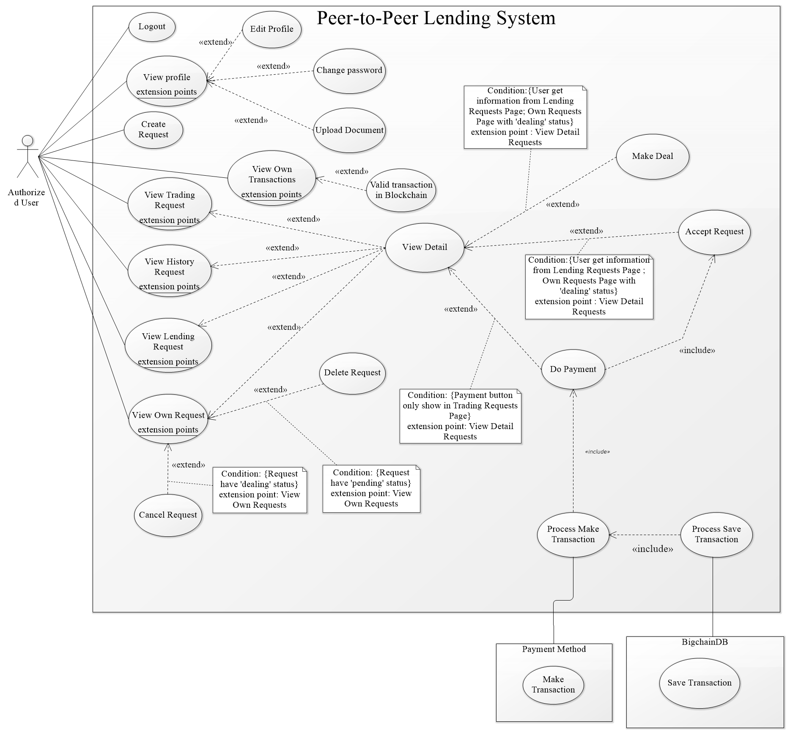

Figure 7 – Authorized User Overview Use Case

* + - 1. **<Authorized User> Logout**

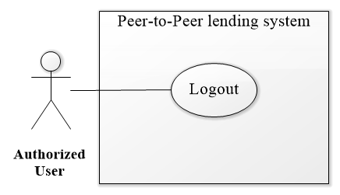

Figure 8 – <Authorized User> Logout Use Case

|  |  |  |  |
| --- | --- | --- | --- |
| **USE CASE – PPLS_AU_01** | | | |
| **Use Case No.** | PPLS_AU_01 | **Use Case Version** | 1.0 |
| **Use Case Name** | Logout | | |
| **Author** | LocHV | | |
| **Date** | 22/05/2019 | **Priority** | Normal |
| **Actor:**   * Authorized User   **Summary:**   * Authorized User can log out.   **Goal:**   * Authorized User can log out.   **Triggers:**   * Authorized User sends log out the command.   **Preconditions:** N/A.  **Post conditions:**   * Success: Authorized User logs out and back to view transaction page (Home page). * Fail: System shows error messages.   **Main Success Scenario:**   |  |  |  | | --- | --- | --- | | **Step** | **Actor Action** | **System Response** | | 1 | Authorized User click the logout button | System redirects to view transaction page (Homepage) |   **Alternative Scenario:**   |  |  |  | | --- | --- | --- | | **Step** | **Actor Action** | **System Response** | |  |  |  |   **Exceptions:**   |  |  |  | | --- | --- | --- | | **No** | **Actor Action** | **System Response** | |  |  |  |   **Relationships:** N/A  **Business Rules:**   * The system will remove user data in localStorage (not clear all localStorage) | | | |

Table 11– <Authorized User> Logout use case specification

* + - 1. **<Authorized User> View Profile**

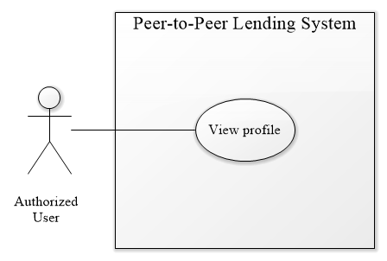

Figure 9 – <Authorized User> View Profile Use Case

|  |  |  |  |
| --- | --- | --- | --- |
| **USE CASE – PPLS_AU_02** | | | |
| **Use Case No.** | PPLS_AU_02 | **Use Case Version** | 1.0 |
| **Use Case Name** | View profile | | |
| **Author** | LocHV | | |
| **Date** | 22/05/2019 | **Priority** | Normal |
| **Actor:**   * Authorized User   **Summary:**   * Allow Authorized User can view their profile and their identification that uploaded.   **Goal:**   * Authorized User check information that they are uploaded in the system.   **Triggers:**   * Authorized User sends view profile command.   **Preconditions:** Must log in as an authorized user  **Post conditions:**   * Success: They can view the information in view profile page. * Fail: System shows error messages   **Main Success Scenario:**   |  |  |  | | --- | --- | --- | | **Step** | **Actor Action** | **System Response** | | 1 | Authorized User click on the view profile button | The system redirects to view the profile page |   **Alternative Scenario:**   |  |  |  | | --- | --- | --- | | **Step** | **Actor Action** | **System Response** | |  |  |  |   **Exceptions:**   |  |  |  | | --- | --- | --- | | **No** | **Actor Action** | **System Response** | | 1 |  | System redirects to the login page when the token timeout |   **Relationships:** PPLS_AU_03, PPLS_AU_04, PPLS_AU_18  **Business Rules:**   * N/A. | | | |

Table 12 – <Authorized User> View profile use case specification

* + - 1. **<Authorized User> Edit Profile**

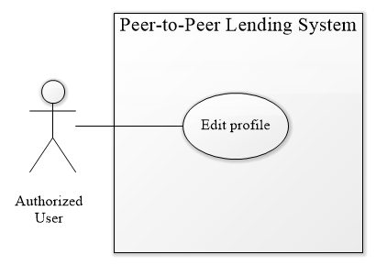

Figure 10 – <Authorized User> Edit Profile Use Case

|  |  |  |  |
| --- | --- | --- | --- |
| **USE CASE – PPLS_AU_03** | | | |
| **Use Case No.** | PPLS_AU_03 | **Use Case Version** | 1.0 |
| **Use Case Name** | Edit Profile | | |
| **Author** | LocHV | | |
| **Date** | 22/05/2019 | **Priority** | Normal |
| **Actor:**   * Authorized User.   **Summary:**   * Allow authorized user edit information in their profile.   **Goal:**   * An authorized user could change their information if their information had changed.   **Triggers:**   * The authorized user sends edit profile command.   **Preconditions:**   * Must log in as Authorized User.   **Post conditions:**   * Success: Authorized User can edit profile. * Fail: System shows error messages.   **Main Success Scenario:**   |  |  |  | | --- | --- | --- | | **Step** | **Actor Action** | **System Response** | | 1 | Authorized User click button edit profile in view profile page. | The system shows edit profile form include:   * FirstName * LastName * Email * Phone Number | | 2 | Authorized User edits their profile. | [Alternative 1] [Alternative 2] | | 3 | Authorized User click save profile | Show dialog save success  [Exception 1] |   **Alternative Scenario:**   |  |  |  | | --- | --- | --- | | **No** | **Actor Action** | **System Response** | | 1 | Authorized user enter the wrong format. | The system shows error message with format: “Filed is wrong format”. Ex: “Email is wrong format”, “FirstName is wrong format”, “Phone number contains at least 10 digit and at biggest 12 digit” and so on. | | 2 | Authorized user does not input all information | The system shows error message “Please fill out this field.” |   **Exceptions:**   |  |  |  | | --- | --- | --- | | **No** | **Actor Action** | **System Response** | | 1 |  | System redirects to the login page when the token timeout |   **Relationships:** PPLS_AU_02  **Business Rules:**   * FirstName and LastName contains character only. * Email follow format like this: [example@gmail.com](mailto:example@gmail.com). * Phone number length from 10 digit and 12 digit. | | | |

Table 13 – <Authorized User> Edit profile use case specification

* + - 1. **<Authorized User> Change Password**

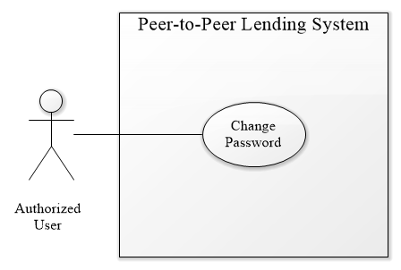

Figure 11 – <Authorized User> Change Password Use Case

|  |  |  |  |
| --- | --- | --- | --- |
| **USE CASE – PPLS_AU_04** | | | |
| **Use Case No.** | PPLS_AU_04 | **Use Case Version** | 1.0 |
| **Use Case Name** | Change Password | | |
| **Author** | LocHV | | |
| **Date** | 22/05/2019 | **Priority** | Normal |
| **Actor:**   * Authorized User.   **Summary:**   * Allow authorized user change password in their profile.   **Goal:**   * An authorized user can change their password.   **Triggers:**   * The authorized user sends a change password command.   **Preconditions:**   * Must log in as Authorized User.   **Post conditions:**   * Success: Authorized User can change their password. * Fail: System shows error messages.   **Main Success Scenario:**   |  |  |  | | --- | --- | --- | | **Step** | **Actor Action** | **System Response** | | 1 | Authorized User click button change password in view profile page. | System shows change password form:  - Old password: input type password  - New password: input type password  - confirm password: input type password | | 2 | Authorized User change their password. |  | | 3 | Authorized User click save password | Show dialog saves success and redirects to the login page.  [Exception 1] [Exception 2] |   **Alternative Scenario:**   |  |  |  | | --- | --- | --- | | **No** | **Actor Action** | **System Response** | | 1 | Authorized User change their password | System show error message: “Password length at least 8 characters” |   **Exceptions:**   |  |  |  | | --- | --- | --- | | **No** | **Actor Action** | **System Response** | | 1 |  | The system redirects to the login page when the token timeout | | 2 |  | System show error message: “Old password is wrong”. |   **Relationships:** PPLS_AU_02  **Business Rules:**   * Password length at least 8 characters. | | | |

Table 14 – <Authorized User> Change password use case specification

* + - 1. **<Authorized User> Create Request**

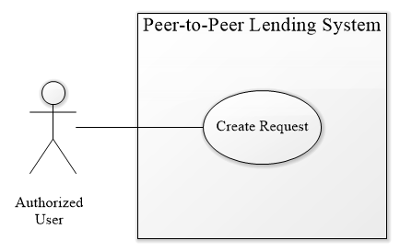

Figure 12 – <Authorized User> Create Request Use Case

|  |  |  |  |
| --- | --- | --- | --- |
| **USE CASE – PPLS_AU_05** | | | |
| **Use Case No.** | PPLS_AU_05 | **Use Case Version** | 1.0 |
| **Use Case Name** | Create request | | |
| **Author** | LocHV | | |
| **Date** | 22/05/2019 | **Priority** | Normal |
| **Actor:**   * Authorized User.   **Summary:**   * Allow authorized user to create borrow request.   **Goal:**   * Authorized User can create a request to borrow money.   **Triggers:**   * Authorized User sends create request command.   **Preconditions:**   * Must log in as Authorized User   **Post conditions:**   * Success: Authorized User create a borrow request. * Fail: System shows error messages.   **Main Success Scenario:**   |  |  |  | | --- | --- | --- | | **Step** | **Actor Action** | **System Response** | | 1 | Go to create request page. | System show creates request form:   * Amount: Input type number * Interest rate: text * Lending timeline * Payback timeline | | 2 | Authorized user enter information into the form | [Alternative 1] [Alternative 2] | | 3 | Authorized user click create request button | System shows dialog success and redirect to view own request page.  [Exception 1] |   **Alternative Scenario:**   |  |  |  | | --- | --- | --- | | **No** | **Actor Action** | **System Response** | | 1 | Guest enter the wrong format. | The system shows error message. Ex: “The amount must be a multiple of 500.000 VND!”, “The amount must be lower than 1 billion!”, “The amount”. | | 2 | The guest not enough loan limit | The system shows the error message “The amount must be lower than loan limit.”. |   **Exceptions:**   |  |  |  | | --- | --- | --- | | **No** | **Actor Action** | **System Response** | | 1 |  | System redirects to the login page when the token timeout |   **Relationships:** N/A  **Business Rules:**   * Amount less than 1.000.000.000 VND * Amount must be a multiple of 500.000 VND * Interest rate 18% per year * Create success will redirect to view own request page. | | | |

Table 15– <Authorized User> Create request use case specification

* + - 1. **<Authorized User> View Own Request**

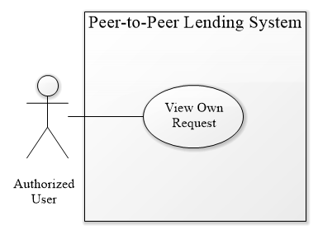

Figure 13 – <Authorized User> View Own Request Use Case

|  |  |  |  |
| --- | --- | --- | --- |
| **USE CASE – PPLS_AU_06** | | | |
| **Use Case No.** | PPLS_AU_06 | **Use Case Version** | 1.0 |
| **Use Case Name** | View own request | | |
| **Author** | LocHV | | |
| **Date** | 22/05/2019 | **Priority** | Normal |
| **Actor:**   * Authorized User.   **Summary:**   * Allow authorized user to view their request include pending request (new request) and dealing request (request is dealing).   **Goal:**   * Authorized User can view their request.   **Triggers:**   * Authorized User sends view own request command.   **Preconditions:**   * Must log in as Authorized User   **Post conditions:**   * Success: Authorized User can view their request. * Fail: System shows error messages.   **Main Success Scenario:**   |  |  |  | | --- | --- | --- | | **Step** | **Actor Action** | **System Response** | | 1 | Authorized User goes to view own request. | System show view own request page with two tabs include pending request and dealing request.  Each tab includes information:   * ID * Amount * Create Date * Duration * Status * View Detail * Delete (Pending Request) * Cancel (Dealing Request)   [Exception 1][Alternative 1] |   **Alternative Scenario:**   |  |  |  | | --- | --- | --- | | **No** | **Actor Action** | **System Response** | | 1 | Authorized User goes to view own request. | System show view own request page with two tabs and each tab not contain data yet. System show message “No data” |   **Exceptions:**   |  |  |  | | --- | --- | --- | | **No** | **Actor Action** | **System Response** | | 1 |  | System redirects to login when the token timeout |   **Relationships:** PPLS_AU_07, PPLS_AU_08, PPLS_AU_15  **Business Rules:**   * View own request page will get all user’s request with pending and dealing status. * This page use paging. * When delete a pending request, remove a pending request from database (pending request do not need to keep in database so that we decide to remove it) * When cancel deal, system restore original deal automatically. * If user do not have request in each tab, system show message “No data”. | | | |

Table 16 – <Authorized User> View own request use case specification

* + - 1. **<Authorized User> Delete Request**

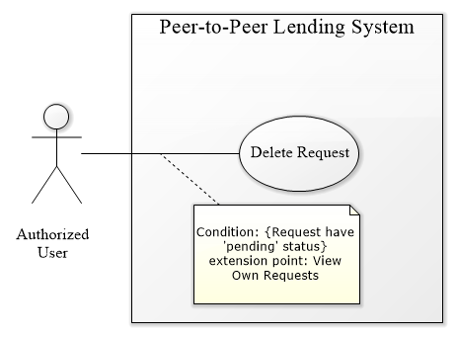

Figure 14 – <Authorized User> Delete Request Use Case

|  |  |  |  |
| --- | --- | --- | --- |
| **USE CASE – PPLS_AU_07** | | | |
| **Use Case No.** | PPLS_AU_07 | **Use Case Version** | 1.0 |
| **Use Case Name** | Delete Request | | |
| **Author** | LocHV | | |
| **Date** | 22/05/2019 | **Priority** | Normal |
| **Actor:**   * Authorized User.   **Summary:**   * Allow authorized user to delete their pending request (new request).   **Goal:**   * Authorized User can delete their request.   **Triggers:**   * Authorized User sends delete request command.   **Preconditions:**   * Must log in as Authorized User   **Post conditions:**   * Success: Authorized User can delete their request. * Fail: System shows error messages.   **Main Success Scenario:**   |  |  |  | | --- | --- | --- | | **Step** | **Actor Action** | **System Response** | | 1 | Authorized User clicks on the delete button. | System show Yes/No confirm dialog | | 2 | Authorized User click on yes button | System show success dialog  [Alternative 1][Exception 1] |   **Alternative Scenario:**   |  |  |  | | --- | --- | --- | | **No** | **Actor Action** | **System Response** | | 1 | Authorized User click on no button | System hide Yes/No dialog |   **Exceptions:**   |  |  |  | | --- | --- | --- | | **No** | **Actor Action** | **System Response** | | 1 |  | The system redirects to login when the token timeout |   **Relationships:** PPLS_AU_06  **Business Rules:**   * Authorized User can delete their pending request (new request) * Authorized User cannot delete other request. * Show pop-up confirm before execute this function. | | | |

Table 17 – <Authorized User> Delete request use case specification

* + - 1. **<Authorized User> Cancel Request**

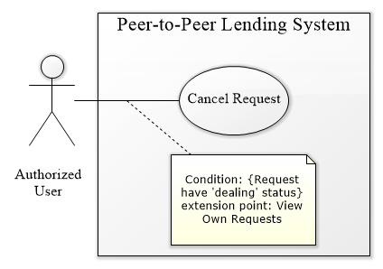

Figure 15 – <Authorized User> Cancel Request Use Case

|  |  |  |  |
| --- | --- | --- | --- |
| **USE CASE – PPLS_AU_08** | | | |
| **Use Case No.** | PPLS_AU_08 | **Use Case Version** | 1.0 |
| **Use Case Name** | Cancel Request | | |
| **Author** | LocHV | | |
| **Date** | 22/05/2019 | **Priority** | Normal |
| **Actor:**   * Authorized User.   **Summary:**   * Allow authorized user to cancel their dealing request (request is dealing).   **Goal:**   * Authorized User can cancel their request that is dealing.   **Triggers:**   * Authorized User sends cancel request command.   **Preconditions:**   * Must log in as Authorized User   **Post conditions:**   * Success: Authorized User can cancel their request. * Fail: System shows error messages.   **Main Success Scenario:**   |  |  |  | | --- | --- | --- | | **Step** | **Actor Action** | **System Response** | | 1 | Authorized User click on cancel button. | System show Yes/No confirm dialog. | | 2 | Authorized User click on yes button | System show success dialog.  [Alternative 1][Exception 1] |   **Alternative Scenario:**   |  |  |  | | --- | --- | --- | | **No** | **Actor Action** | **System Response** | | 1 | Authorized User click on no button | System hide Yes/No dialog. |   **Exceptions:**   |  |  |  | | --- | --- | --- | | **No** | **Actor Action** | **System Response** | | 1 |  | System redirects to login when the token timeout |   **Relationships:** PPLS_AU_06  **Business Rules:**   * Authorized User can cancel their dealing request (request is dealing) * Authorized User cannot cancel other request. * Show pop-up confirm before execute this function. | | | |

Table 18 – <Authorized User> Cancel request use case specification

* + - 1. **<Authorized User> View Trading Request**

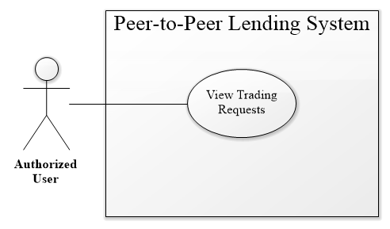

Figure 16 – <Authorized User> View trading request use case

|  |  |  |  |
| --- | --- | --- | --- |
| **USE CASE – PPLS_AU_09** | | | |
| **Use Case No.** | PPLS_AU_09 | **Use Case Version** | 1.0 |
| **Use Case Name** | View Trading Request | | |
| **Author** | LocHV | | |
| **Date** | 22/05/2019 | **Priority** | Normal |
| **Actor:**   * Authorized User.   **Summary:**   * Allow authorized user to view their trading request (request is in the process).   **Goal:**   * Authorized User can view their request that is in process.   **Triggers:**   * Authorized User sends view trading request command.   **Preconditions:**   * Must log in as Authorized User   **Post conditions:**   * Success: Authorized User can view their trading request. * Fail: System shows error messages.   **Main Success Scenario:**   |  |  |  | | --- | --- | --- | | **Step** | **Actor Action** | **System Response** | | 1 | Authorized User goes to view trading request page. | System show trading request with two tabs include borrow and lend request.  Each tab includes information:   * ID * Amount * Create Date * User * View Detail   [Exception 1] [Alternative 1] |   **Alternative Scenario:**   |  |  |  | | --- | --- | --- | | **No** | **Actor Action** | **System Response** | | 1 | Authorized User goes to view trading request. | System show view trading request page with two tabs and each tab not contain data yet. System show message “No data” |   **Exceptions:**   |  |  |  | | --- | --- | --- | | **No** | **Actor Action** | **System Response** | | 1 |  | System redirects to login when the token timeout |   **Relationships:** PPLS_AU_15, PPLS_AU_12  **Business Rules:**   * View trading request page will get all user’s request with trading status, split to borrow and lend request. * This page use paging. * If user do not have request in each tab, system show message “No data”. | | | |

Table 19 – <Authorized User> View trading request use case specification

* + - 1. **<Authorized User> View History Request**

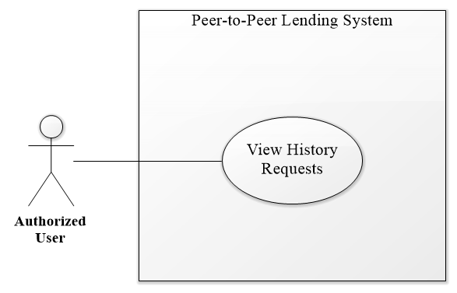

Figure 17 – <Authorized User> View History Request Use Case

|  |  |  |  |
| --- | --- | --- | --- |
| **USE CASE – PPLS_AU_10** | | | |
| **Use Case No.** | PPLS_AU_10 | **Use Case Version** | 1.0 |
| **Use Case Name** | View History Request | | |
| **Author** | LocHV | | |
| **Date** | 22/05/2019 | **Priority** | Normal |
| **Actor:**   * Authorized User.   **Summary:**   * Allow authorized user to view history request (Request had done).   **Goal:**   * Authorized User view request that had done.   **Triggers:**   * Authorized User sends view history request command.   **Preconditions:**   * Must log in as Authorized User   **Post conditions:**   * Success: Authorized User can view history request. * Fail: System shows error messages.   **Main Success Scenario:**   |  |  |  | | --- | --- | --- | | **Step** | **Actor Action** | **System Response** | | 1 | Authorized User goes to view history request. | System shows view history request page includes information:   * ID * Amount * Create Date * Status * View Detail   [Exception 1] [Alternative 1] |   **Alternative Scenario:**   |  |  |  | | --- | --- | --- | | **No** | **Actor Action** | **System Response** | | 1 | Authorized User goes to view history request. | System show view history request page. System show message “No data” if user has no data. |   **Exceptions:**   |  |  |  | | --- | --- | --- | | **No** | **Actor Action** | **System Response** | | 1 |  | System redirects to login when the token timeout |   **Relationships:** PPLS_AU_15  **Business Rules:**   * View history request page will get all user’s request with done status. * This page use paging. * If user do not have request in each tab, system show message “No data”. | | | |

Table 20 – <Authorized User> View history request use case specification

* + - 1. **<Authorized User> View Lending Request**

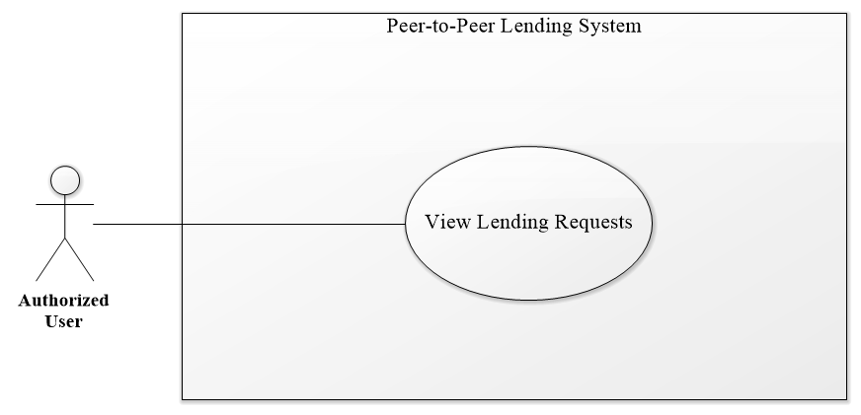

Figure 18 – <Authorized User> View Lending Request Use Case

|  |  |  |  |
| --- | --- | --- | --- |
| **USE CASE – PPLS_AU_11** | | | |
| **Use Case No.** | PPLS_AU_11 | **Use Case Version** | 1.0 |
| **Use Case Name** | View Lending Request | | |
| **Author** | LocHV | | |
| **Date** | 22/05/2019 | **Priority** | Normal |
| **Actor:**   * Authorized User.   **Summary:**   * Allow authorized user to view the other request (borrow request from the other user).   **Goal:**   * Authorized User view borrows request.   **Triggers:**   * Authorized User sends view lending request command.   **Preconditions:**   * Must log in as Authorized User   **Post conditions:**   * Success: Authorized User can view lending request. * Fail: System shows error messages.   **Main Success Scenario:**   |  |  |  | | --- | --- | --- | | **Step** | **Actor Action** | **System Response** | | 1 | Authorized User goes to view lending request. | System show view lending request page includes information:   * ID * Amount * User * Create Date * View Detail   [Exception 1] [Alternative 1] |   **Alternative Scenario:**   |  |  |  | | --- | --- | --- | | **No** | **Actor Action** | **System Response** | | 1 | Authorized User goes to view lending request. | System show view lending request page. System show message “No data” if user has no data. |   **Exceptions:**   |  |  |  | | --- | --- | --- | | **No** | **Actor Action** | **System Response** | | 1 |  | System redirects to login when the token timeout |   **Relationships:** PPLS_AU_15  **Business Rules:**   * View lending request page will get all request from other user with pending status * This page use paging. * If user do not have request in each tab, system show message “No data”. | | | |

Table 21 – <Authorized User> View lending request use case specification

* + - 1. **<Authorized User> Do Payment**

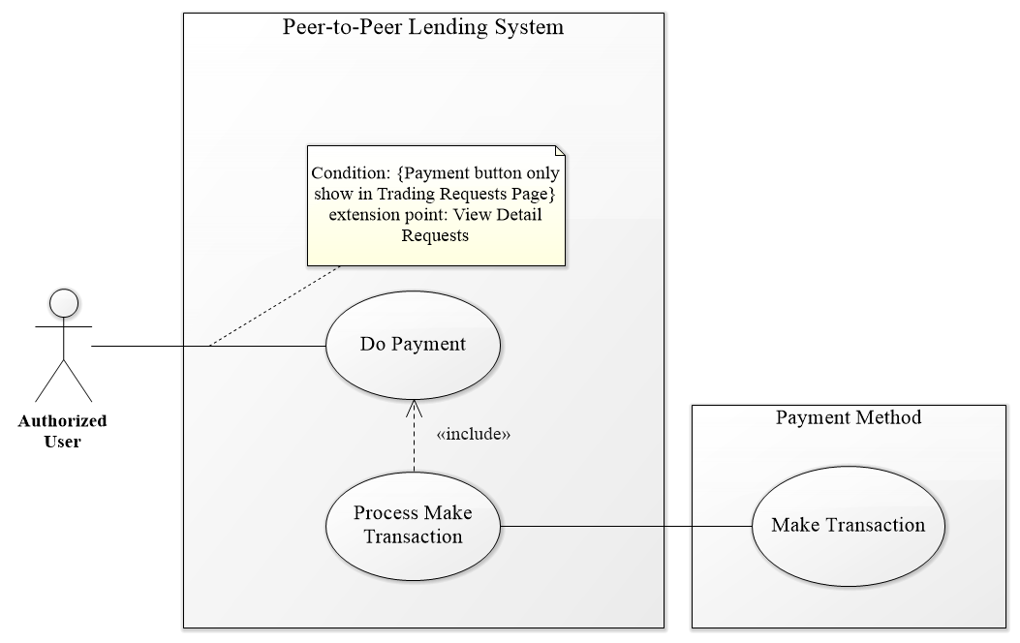

Figure 19 – <Authorized User> Do Payment Use Case

|  |  |  |  |
| --- | --- | --- | --- |
| **USE CASE – PPLS_AU_12** | | | |
| **Use Case No.** | PPLS_AU_12 | **Use Case Version** | 1.0 |
| **Use Case Name** | Do Payment | | |
| **Author** | LocHV | | |
| **Date** | 22/05/2019 | **Priority** | Normal |
| **Actor:**   * Authorized User.   **Summary:**   * Allow authorized user to pay transaction.   **Goal:**   * Authorized User pays their transaction (lend, payback).   **Triggers:**   * Authorized User sends do payment command.   **Preconditions:**   * Must log in as Authorized User   **Post conditions:**   * Success: Authorized User can pay their transaction. * Fail: System shows error messages.   **Main Success Scenario:**   |  |  |  | | --- | --- | --- | | **Step** | **Actor Action** | **System Response** | | 1 | Authorized User click on payment button (PayPal button) | System show Paypal page. | | 2 | Authorized User login to PayPal using PayPal account | Paypal show payment form | | 3 | Authorized User click on pay now button | System show success dialog |   **Alternative Scenario:**   |  |  |  | | --- | --- | --- | | **No** | **Actor Action** | **System Response** | |  |  |  |   **Exceptions:**   |  |  |  | | --- | --- | --- | | **No** | **Actor Action** | **System Response** | | 1 |  | System redirects to login when the token timeout |   **Relationships:** PPLS_AU_15, PPLS_SY_01  **Business Rules:**   * Do payment use to accept the request and pay money for trading request. * View detail trading request, system show timeline with check timeline button to pay transaction. | | | |

Table 22 – <Authorized User> Do payment use case specification

* + - 1. **<Authorized User> Accept Request**

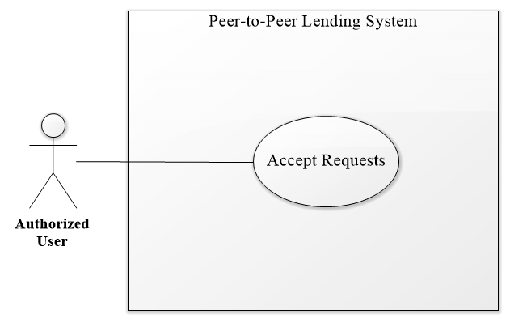

Figure 20 – <Authorized User> Accept Request Use Case

|  |  |  |  |
| --- | --- | --- | --- |
| **USE CASE – PPLS_AU_13** | | | |
| **Use Case No.** | PPLS_AU_13 | **Use Case Version** | 1.0 |
| **Use Case Name** | Accept request | | |
| **Author** | LocHV | | |
| **Date** | 22/05/2019 | **Priority** | Normal |
| **Actor:**   * Authorized User.   **Summary:**   * Allow authorized user to accept another user request.   **Goal:**   * Authorized User accepts borrow request from another user.   **Triggers:**   * Authorized User sends accept request command.   **Preconditions:**   * Must log in as Authorized User   **Post conditions:**   * Success: Authorized User accepts the request and request change to trading status. * Fail: System shows error messages.   **Main Success Scenario:**   |  |  |  | | --- | --- | --- | | **Step** | **Actor Action** | **System Response** | | 1 | Authorized User click on accept request | System show accepts the dialog contain paypal button. | | 2 | Authorized User do payment | System shows success dialog and redirect to view trading request page.  [Exception 1] |   **Alternative Scenario:**   |  |  |  | | --- | --- | --- | | **No** | **Actor Action** | **System Response** | |  |  |  |   **Exceptions:**   |  |  |  | | --- | --- | --- | | **No** | **Actor Action** | **System Response** | | 1 |  | System redirects to login when the token timeout |   **Relationships:** PPLS_AU_15, PPLS_AU_12  **Business Rules:**   * Authorized User can accept dealing request and pending request. * Authorized User cannot accept another request. * After accept request, system save transaction and deal to blockchain and change request’s status to trading. * Accept button will show pop-up contain paypal button. | | | |

Table 23 – <Authorized User> Accept request use case specification

* + - 1. **<Authorized User> Make Deal**

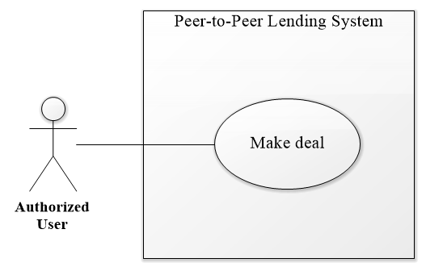

Figure 21 – <Authorized User> Make Deal Use Case

|  |  |  |  |
| --- | --- | --- | --- |
| **USE CASE – PPLS_AU_14** | | | |
| **Use Case No.** | PPLS_AU_14 | **Use Case Version** | 1.0 |
| **Use Case Name** | Make deal | | |
| **Author** | LocHV | | |
| **Date** | 22/05/2019 | **Priority** | Normal |
| **Actor:**   * Authorized User.   **Summary:**   * Allow authorized user to edit borrow request to make a deal with another user.   **Goal:**   * Authorized User negotiates borrow request with another user.   **Triggers:**   * Authorized User sends make deal command.   **Preconditions:**   * Must log in as Authorized User   **Post conditions:**   * Success: Authorized User make a deal with another user. * Fail: System shows error messages.   **Main Success Scenario:**   |  |  |  | | --- | --- | --- | | **Step** | **Actor Action** | **System Response** | | 1 | Authorized User click on make deal button | System show edit borrows request form.   * Borrow name: text * Total amount: text * Borrow amount: text * Interest rate: text * Interest Received: text * Lending timeline (Editable) * Payback timeline (Editable) | | 2 | Authorized User edit form |  | | 3 | Authorized User click on save deal button | System show Yes/No dialog | | 4 | Authorized User click on Yes button | System hide Yes/No dialog  [Alternative 1][Exception 1] |   **Alternative Scenario:**   |  |  |  | | --- | --- | --- | | **No** | **Actor Action** | **System Response** | | 1 | Authorized User click on No button | System hide Yes/No dialog |   **Exceptions:**   |  |  |  | | --- | --- | --- | | **No** | **Actor Action** | **System Response** | | 1 |  | System redirects to login when the token timeout |   **Relationships:** PPLS_AU_15, PPLS_AU_12  **Business Rules:**   * Authorized User can make a deal with the pending request. * Authorized User after make deal will wait for a response (another user can make a deal or accept the request). * After make deal, request’s status change to dealing. | | | |

Table 24 – <Authorized User> Make deal use case specification

* + - 1. **<Authorized User> View Detail Request**

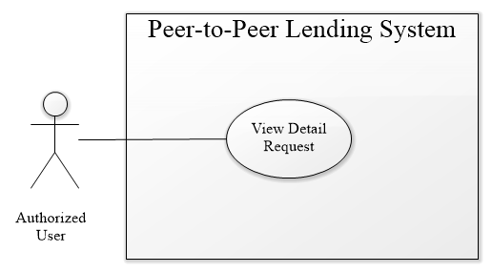

Figure 22 – <Authorized User> View Detail Request Use Case

|  |  |  |  |
| --- | --- | --- | --- |
| **USE CASE – PPLS_AU_15** | | | |
| **Use Case No.** | PPLS_AU_15 | **Use Case Version** | 1.0 |
| **Use Case Name** | View Detail Request | | |
| **Author** | LocHV | | |
| **Date** | 22/05/2019 | **Priority** | Normal |
| **Actor:**   * Authorized User.   **Summary:**   * Allow authorized user to view detail borrow request.   **Goal:**   * Authorized User can view detail borrow request to make decision ignore, make a deal or accept this request.   **Triggers:**   * Authorized User sends view detail request command.   **Preconditions:**   * Must log in as Authorized User   **Post conditions:**   * Success: Authorized User view detail borrows request. * Fail: System shows error messages.   **Main Success Scenario:**   |  |  |  | | --- | --- | --- | | **Step** | **Actor Action** | **System Response** | | 1 | Authorized User click on the view detail button | System shows borrow request page.   * Borrow name: text * Total amount: text * Borrow amount: text * Interest rate: text * Interest Received: text * Lending timeline * Payback timeline * Make deal (button) * Accept (button)   [Exception 1] [Alternative 1] |   **Alternative Scenario:**   |  |  |  | | --- | --- | --- | | **No** | **Actor Action** | **System Response** | | 1 | Authorized user reload view detail page | System will redirect to previous view page. |   **Exceptions:**   |  |  |  | | --- | --- | --- | | **No** | **Actor Action** | **System Response** | | 1 |  | The system redirects to login when the token timeout |   **Relationships:** PPLS_AU_06, PPLS_AU_09, PPLS_AU_10, PPLS_AU_11, PPLS_AU_12, PPLS_AU_13, PPLS_AU_14  **Business Rules:**   * View detail page with hide/show make deal and accept button depend on view page before you go to view detail page. * Pending, trading and history request’s status will hide make deal and accept button (view detail only). * Dealing request’s status and lending requests page will show make deal and accept button * View detail page allow to edit lending timeline and payback timeline when user clicks on make deal button * Accept button will show pop-up contain paypal button. | | | |

Table 25 – <Authorized User> View detail request use case specification

* + - 1. **<Authorized User> View Own Transaction**

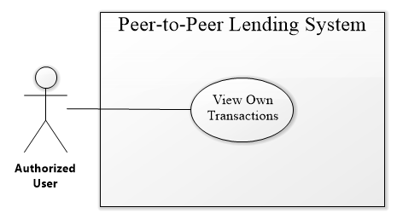

Figure 23 – <Authorized User> View Own Transaction Use Case

|  |  |  |  |
| --- | --- | --- | --- |
| **USE CASE – PPLS_AU_16** | | | |
| **Use Case No.** | PPLS_AU_16 | **Use Case Version** | 1.0 |
| **Use Case Name** | View Own Transaction | | |
| **Author** | LocHV | | |
| **Date** | 22/05/2019 | **Priority** | Normal |
| **Actor:**   * Authorized User.   **Summary:**   * Allow authorized user to view all their transactions.   **Goal:**   * Authorized User can view their transactions that are done and check the validate of transaction.   **Triggers:**   * Authorized User sends view own transactions command.   **Preconditions:**   * Must log in as Authorized User   **Post conditions:**   * Success: Authorized User views their transaction. * Fail: System shows error messages.   **Main Success Scenario:**   |  |  |  | | --- | --- | --- | | **Step** | **Actor Action** | **System Response** | | 1 | Authorized User clicks on view own transaction. | System show own transaction page:   * Id tx Blockchain (tx is transaction) * Sender * Receiver * Amount * Create Date * Validate (Button)   [Exception 1] |   **Alternative Scenario:**   |  |  |  | | --- | --- | --- | | **No** | **Actor Action** | **System Response** | |  |  |  |   **Exceptions:**   |  |  |  | | --- | --- | --- | | **No** | **Actor Action** | **System Response** | | 1 |  | The system redirects to login when the token timeout |   **Relationships:** N/A  **Business Rules:**   * N/A. | | | |

Table 26 – <Authorized User> View detail request use case specification

* + - 1. **<Authorized User> Valid Transaction with Blockchain**

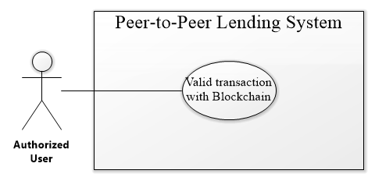

Figure 24 – <Authorized User> Valid Transaction With Blockchain Use Case

|  |  |  |  |
| --- | --- | --- | --- |
| **USE CASE – PPLS_AU_17** | | | |
| **Use Case No.** | PPLS_AU_17 | **Use Case Version** | 1.0 |
| **Use Case Name** | The valid transaction with Blockchain | | |
| **Author** | LocHV | | |
| **Date** | 22/05/2019 | **Priority** | Normal |
| **Actor:**   * Authorized User.   **Summary:**   * Allow authorized user to valid their transaction with blockchain.   **Goal:**   * Authorized User can check valid their transaction with a transaction that saved in the blockchain.   **Triggers:**   * Authorized User sends a valid transaction with blockchain command.   **Preconditions:**   * Mustlog in as Authorized User   **Post conditions:**   * Success: Authorized User check validates of the transaction. * Fail: System shows error messages.   **Main Success Scenario:**   |  |  |  | | --- | --- | --- | | **Step** | **Actor Action** | **System Response** | | 1 | Authorized User click on validate. | System show check validate modal:   * Check Sender * Check Receiver * Check Amount * Check Create Date   After check this information system show:   * ID Transaction * Status (valid transaction)   [Alternative 1] |   **Alternative Scenario:**   |  |  |  | | --- | --- | --- | | **No** | **Actor Action** | **System Response** | | 1 | Authorized User click on validate. | System show check validate modal:   * Check Sender * Check Receiver * Check Amount * Check Create Date   After check this information system show:   * ID Transaction * Status (invalid transaction) |   **Exceptions:**   |  |  |  | | --- | --- | --- | | **No** | **Actor Action** | **System Response** | |  |  |  |   **Relationships:** PPLS_AU_16  **Business Rules:**   * System will get transaction from database compare to transaction in blockchain. | | | |

Table 27 – <Authorized User> Valid transaction with blockchain use case specification

* + - 1. **<Authorized User> Upload Document**

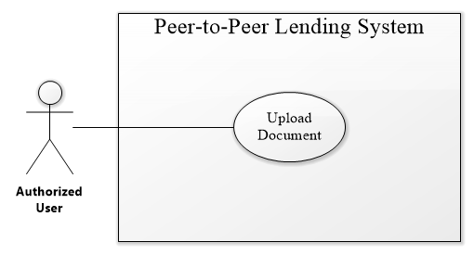

Figure 25 – <Authorized User> Upload Document Use Case

|  |  |  |  |
| --- | --- | --- | --- |
| **USE CASE – PPLS_AU_18** | | | |
| **Use Case No.** | PPLS_AU_18 | **Use Case Version** | 1.0 |
| **Use Case Name** | Upload Document | | |
| **Author** | LocHV | | |
| **Date** | 22/05/2019 | **Priority** | Normal |
| **Actor:**   * Authorized User.   **Summary:**   * Allow authorized user to upload the document that can identify the user.   **Goal:**   * Authorized User can upload a document such as identity card, driving license, passport, and identify the video. The document will be checked by the system administrator to verify the user.   **Triggers:**   * Authorized User sends upload document command.   **Preconditions:**   * Must log in as Authorized User   **Post conditions:**   * Success: Authorized User upload document. * Fail: System shows error messages.   **Main Success Scenario:**   |  |  |  | | --- | --- | --- | | **Step** | **Actor Action** | **System Response** | | 1 | Authorized User clicks on My Profile. | System show user information, document collapse, and two-button:   * Phone Number * Email address * First name * Last name   Current document collapse   * Identify Card * Password * Driving License * Identify Video   Button   * Edit Profile * Change Password | | 2 | Authorized User click on Identify Card collapse | System show identifies card collapse:   * Input file * Save button   [Alternative 4] | | 3 | Authorized User click on the Input file | System show select files input  [Exception 1] [Exception 2] | | 4 | Authorized User click on Save Button | System show success message: “save success.”  [Exception 3] |   **Alternative Scenario:**   |  |  |  | | --- | --- | --- | | **No** | **Actor Action** | **System Response** | | 1 | Authorized User click on Passport collapse | System show passport collapse:   * Input file * Save button   [Alternative 4] | | 2 | Authorized User click on Driving License collapse | System show driving license collapse:   * Input file * Save button   [Alternative 4] | | 3 | Authorized User click on Identify video collapse | System show identifies video collapse:   * Start camera (button) * Start Recording (button) * Play (button) * Save video (button)   [Alternative 5]  Step 1: Authorized User click on Start Camera button:   * Browser show media accept   Step 2: Authorized User click on Start Recording button   * System record video   Step 3: Authorized User click on the Play button   * System show video that is recorded   Step 4: Authorized User click on Save video button   * System show success message: “save success.”   [Exception 3] | | 4 |  | System show uploaded an image if the user had already loaded image | | 5 |  | System show message: “You had already upload video, system will keep your Identity Video due to User Privacy.” |   **Exceptions:**   |  |  |  | | --- | --- | --- | | **No** | **Actor Action** | **System Response** | | 1 | Authorized User click on Save button. | System show error message: “please select image to load.” | | 2 | Authorized User select another file type | System show error message: “please select image files.” | | 3 |  | The system redirects to the login page when the token timeout |   **Relationships:** PPLS_AU_02  **Business Rules:**   * When authorized user open identify video collapse, the system activates start camera button and deactivate start recording button, play button and save video * When authorized user to accept using media, the system activates start recording button and deactivate play button and save the video. * When authorized user clicks to save video button, system shows success message and show the message “You had already upload video, waiting for validating from Admin” instead of system show tool to record video. * System will show image after user load document except video. * Authorized user can upload document again if admin reject document. * Authorized user can view document if admin accept document. * System will show status message depend on document’s status. Ex: pending status: “Document is waiting for validation”, valid status show image only, invalid status show upload button to upload again. | | | |

Table 28 – <Authorized User> Upload document use case specification

* + 1. **<Admin> Overview Use Case**

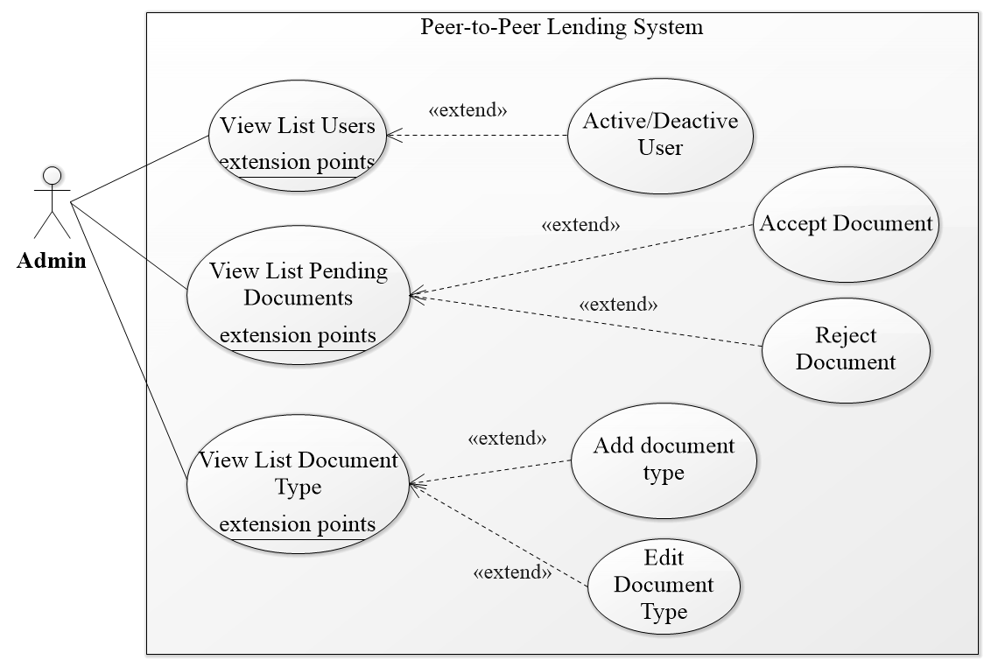

Figure 26 – <Admin> Overview Use Case

* + - 1. **<Admin> Get List Users**

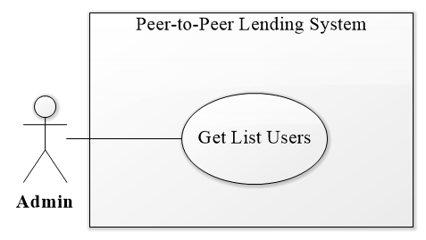

Figure 27 – <Admin> Get List Users Use Case

|  |  |  |  |
| --- | --- | --- | --- |
| **USE CASE – PPLS_AD_01** | | | |
| **Use Case No.** | PPLS_AD_01 | **Use Case Version** | 1.0 |
| **Use Case Name** | Get list users | | |
| **Author** | LocHV | | |
| **Date** | 22/05/2019 | **Priority** | Normal |
| **Actor:**   * Admin.   **Summary:**   * Allow admin to view the list of users.   **Goal:**   * Admin can view the list of users.   **Triggers:**   * Admin sends get list users command.   **Preconditions:**   * Must log in as Admin   **Post conditions:**   * Success: Admin view list of users. * Fail: System shows error messages.   **Main Success Scenario:**   |  |  |  | | --- | --- | --- | | **Step** | **Actor Action** | **System Response** | | 1 | Admin go to view user list | The system shows a view user list page include:   * ID * Username * FirstName * LastName * Activate/Deactivate (Toggle button)   [Exception 1] |   **Alternative Scenario:**   |  |  |  | | --- | --- | --- | | **No** | **Actor Action** | **System Response** | |  |  |  |   **Exceptions:**   |  |  |  | | --- | --- | --- | | **No** | **Actor Action** | **System Response** | | 1 |  | System redirects to login when the token timeout |   **Relationships:** PPLS_AD_02  **Business Rules:**   * N/A. | | | |

Table 29 – <Admin> Get list users use case specification

* + - 1. **<Admin> Activate / Deactivate User**

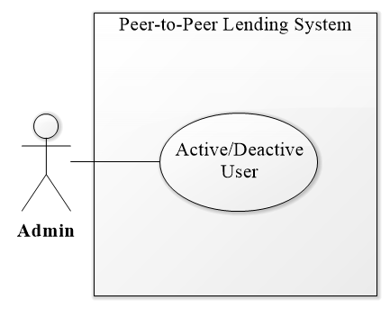

Figure 28 – <Admin> Activate/Deactivate User Use Case

|  |  |  |  |
| --- | --- | --- | --- |
| **USE CASE – PPLS_AD_02** | | | |
| **Use Case No.** | PPLS_AD_02 | **Use Case Version** | 1.0 |
| **Use Case Name** | Activate/Deactivate User | | |
| **Author** | LocHV | | |
| **Date** | 22/05/2019 | **Priority** | Normal |
| **Actor:**   * Admin.   **Summary:**   * Allow admin to activate or deactivate the user.   **Goal:**   * Admin can activate or deactivate user if had any problems.   **Triggers:**   * Admin sends activate/deactivate user command.   **Preconditions:**   * Must log in as Admin   **Post conditions:**   * Success: Admin activates or deactivate the user. * Fail: System shows error messages.   **Main Success Scenario:**   |  |  |  | | --- | --- | --- | | **Step** | **Actor Action** | **System Response** | | 1 | Admin click on toggle button (activate) | The toggle button will activate.  [Alternative 1] |   **Alternative Scenario:**   |  |  |  | | --- | --- | --- | | **No** | **Actor Action** | **System Response** | | 1 | Admin click on toggle button (deactivate) | The toggle button will deactivate. |   **Exceptions:**   |  |  |  | | --- | --- | --- | | **No** | **Actor Action** | **System Response** | |  |  |  |   **Relationships:** PPLS_AD_01  **Business Rules:**   * Admin clicks on toggle button to change account’s status. * Show confirm pop-up when execute this function. | | | |

Table 30 – <Admin> Activate/Deactivate user use case specification

* + - 1. **<Admin> View List Pending Documents**

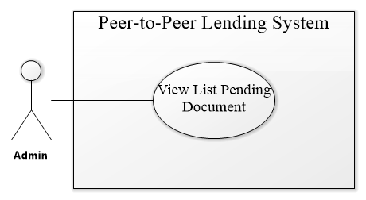

Figure 29 – <Admin> View List Pending Document Use Case

|  |  |  |  |
| --- | --- | --- | --- |
| **USE CASE – PPLS_AD_03** | | | |
| **Use Case No.** | PPLS_AD_03 | **Use Case Version** | 1.0 |
| **Use Case Name** | View List Pending Document | | |
| **Author** | LocHV | | |
| **Date** | 22/05/2019 | **Priority** | Normal |
| **Actor:**   * Admin.   **Summary:**   * Allow admin to view list all pending document.   **Goal:**   * Admin can view all pending document.   **Triggers:**   * Admin sends view list pending document command.   **Preconditions:**   * Must log in as Admin   **Post conditions:**   * Success: Admin can view list pending document. * Fail: System shows error messages.   **Main Success Scenario:**   |  |  |  | | --- | --- | --- | | **Step** | **Actor Action** | **System Response** | | 1 | Admin click on pending document | System show pending document page:   * ID * Username * Fullname * Document Type * Status (Button)   [Exception 1] |   **Alternative Scenario:**   |  |  |  | | --- | --- | --- | | **No** | **Actor Action** | **System Response** | |  |  |  |   **Exceptions:**   |  |  |  | | --- | --- | --- | | **No** | **Actor Action** | **System Response** | | 1 |  | System redirects to login when the token timeout |   **Relationships:** PPLS_AD_04, PPLS_AD_05  **Business Rules:**   * N/A | | | |

Table 31 – <Admin> View list pending document use case specification

* + - 1. **<Admin> Accept Document**

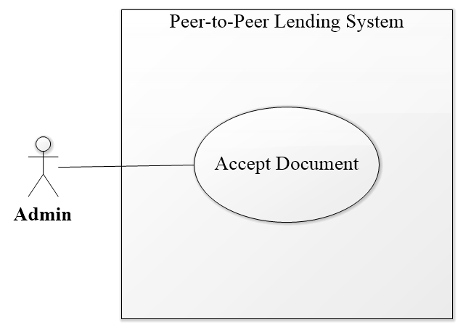

Figure 30 – <Admin> Accept Document Use Case

|  |  |  |  |
| --- | --- | --- | --- |
| **USE CASE – PPLS_AD_04** | | | |
| **Use Case No.** | PPLS_AD_04 | **Use Case Version** | 1.0 |
| **Use Case Name** | Accept Document | | |
| **Author** | LocHV | | |
| **Date** | 22/05/2019 | **Priority** | Normal |
| **Actor:**   * Admin.   **Summary:**   * Allow admin to accept a document from the user.   **Goal:**   * Admin can accept the document.   **Triggers:**   * Admin sends accept document command.   **Preconditions:**   * Must log in as Admin   **Post conditions:**   * Success: Admin can accept the document. * Fail: System shows error messages.   **Main Success Scenario:**   |  |  |  | | --- | --- | --- | | **Step** | **Actor Action** | **System Response** | | 1 | Admin click on Identify Card collapse | System show identifies card collapse:   * Document Image * Valid ID document (Input) * Approve (button) * Reject (button)   [Alternative 2] [Alternative 3] [Alternative 4] | | 2 | Admin enter id document |  | | 3 | Admin click on approve button | System show confirms approve modal:   * Approve **Identity Card** of **dungnt** ? (dungnt is username)   [Exception 2] | | 4 | Admin click on Yes button | The system will accept and send a notification to user  [Exception 1] |   **Alternative Scenario:**   |  |  |  | | --- | --- | --- | | **No** | **Actor Action** | **System Response** | | 1 | Admin click on No button | System hide confirm approve modal | | 2 | Admin click on Passport collapse | System show passport collapse:   * Document Image * Valid ID document (Input) * Approve (button) * Reject (button) | | 3 | Admin click on Driving License collapse | System show driving license collapse:   * Document Image * Valid ID document (Input) * Approve (button) * Reject (button) | | 4 | Admin click on Identify Video collapse | System show identifies video collapse:   * Document Image * Valid ID document (Input) * Approve (button) * Reject (button) |   **Exceptions:**   |  |  |  | | --- | --- | --- | | **No** | **Actor Action** | **System Response** | | 1 |  | System redirects to login when the token timeout | | 2 | Admin click on approve button but not enter id document | System show message: “Field is required” |   **Relationships:** PPLS_AD_03  **Business Rules:**   * System show confirm modal when click on approve button. * ID document is an id of each document. Ex: document id of identity card is identity card number, document id of passport is passport number and so on. (document id of video is username_video). | | | |

Table 32 – <Admin> Accept document use case specification

* + - 1. **<Admin> Reject Document**

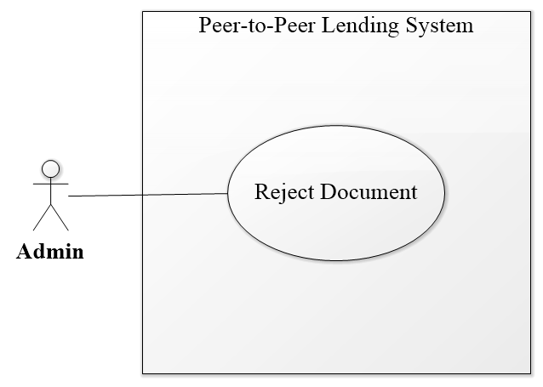

Figure 31– <Admin> Reject Document Use Case

|  |  |  |  |
| --- | --- | --- | --- |
| **USE CASE – PPLS_AD_05** | | | |
| **Use Case No.** | PPLS_AD_05 | **Use Case Version** | 1.0 |
| **Use Case Name** | Reject Document | | |
| **Author** | LocHV | | |
| **Date** | 22/05/2019 | **Priority** | Normal |
| **Actor:**   * Admin.   **Summary:**   * Allow admin to reject document from the user.   **Goal:**   * Admin can reject document.   **Triggers:**   * Admin sends recject document command.   **Preconditions:**   * Must logged in as Admin   **Post conditions:**   * Success: Admin can reject document. * Fail: System shows error messages.   **Main Success Scenario:**   |  |  |  | | --- | --- | --- | | **Step** | **Actor Action** | **System Response** | | 1 | Admin click on Identify Card collapse | System show identifies card collapse:   * Document Image * Valid ID document (Input) * Approve (button) * Reject (button)   [Alternative 2] [Alternative 3] [Alternative 4] | | 2 | Admin enter id document |  | | 3 | Admin click on reject button | System show confirms reject modal:  Reject **Identity Card** of **dungnt** ? (dungnt is username)  [Exception 2] | | 4 | Admin click on Yes button | The system will reject and send a notification to user  [Exception 1] |   **Alternative Scenario:**   |  |  |  | | --- | --- | --- | | **No** | **Actor Action** | **System Response** | | 1 | Admin click on No button | System hide confirm reject modal | | 2 | Admin click on Passport collapse | System show passport collapse:   * Document Image * Valid ID document (Input) * Approve (button) * Reject (button) | | 3 | Admin click on Driving License collapse | System show driving license collapse:   * Document Image * Valid ID document (Input) * Approve (button) * Reject (button) | | 4 | Admin click on Identify Video collapse | System show identifies video collapse:   * Document Image * Valid ID document (Input) * Approve (button) * Reject (button) |   **Exceptions:**   |  |  |  | | --- | --- | --- | | **No** | **Actor Action** | **System Response** | | 1 |  | System redirects to login when the token timeout |   **Relationships:** PPLS_AD_03  **Business Rules:**   * System show confirm modal when to click on reject button. | | | |

Table 33 – <Admin> Reject document use case specification

* + - 1. **<Admin> View List Document Type**

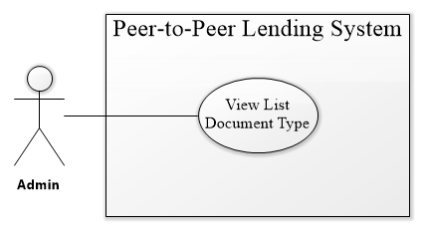

Figure 32 – <Admin> View List Document Type Use Case

|  |  |  |  |
| --- | --- | --- | --- |
| **USE CASE – PPLS_AD_06** | | | |
| **Use Case No.** | PPLS_AD_06 | **Use Case Version** | 1.0 |
| **Use Case Name** | View list document type | | |
| **Author** | LocHV | | |
| **Date** | 22/05/2019 | **Priority** | Normal |
| **Actor:**   * Admin.   **Summary:**   * Allow admin to view list document type.   **Goal:**   * Admin can view list document type.   **Triggers:**   * Admin sends view list document type command.   **Preconditions:**   * Must log in as Admin   **Post conditions:**   * Success: Admin can view list document type. * Fail: System shows error messages.   **Main Success Scenario:**   |  |  |  | | --- | --- | --- | | **Step** | **Actor Action** | **System Response** | | 1 | Admin goes to document type page | System show document type page include:   * ID * Name Type * Amount Limit * Acronym * Add new (button) * Edit (button) |   **Alternative Scenario:**   |  |  |  | | --- | --- | --- | | **No** | **Actor Action** | **System Response** | |  |  |  |   **Exceptions:**   |  |  |  | | --- | --- | --- | | **No** | **Actor Action** | **System Response** | | 1 |  | System redirect to login page when token timeout. |   **Relationships:** N/A  **Business Rules:**   * N/A | | | |

Table 34 – <Admin> View list document type use case specification

* + - 1. **<Admin> Add Document Type**

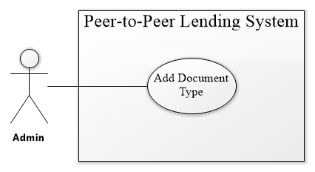

Figure 33 – <Admin> Add Document Type Use Case

|  |  |  |  |
| --- | --- | --- | --- |
| **USE CASE – PPLS_AD_07** | | | |
| **Use Case No.** | PPLS_AD_07 | **Use Case Version** | 1.0 |
| **Use Case Name** | Add document type | | |
| **Author** | LocHV | | |
| **Date** | 22/05/2019 | **Priority** | Normal |
| **Actor:**   * Admin.   **Summary:**   * Allow admin to add document type.   **Goal:**   * Admin can add document type.   **Triggers:**   * Admin sends add document type command.   **Preconditions:**   * Must log in as Admin   **Post conditions:**   * Success: Admin can add document type. * Fail: System shows error messages.   **Main Success Scenario:**   |  |  |  | | --- | --- | --- | | **Step** | **Actor Action** | **System Response** | | 1 | Admin clicks on “Add new” button. | System show pop-up include:   * Name * Amount Limit * Acronym | | 2 | Admin input information | [Alternative 2] | | 3 | Admin clicks on “Add” button | System save new document type and reload page to update list document.  [Alternative 1] [Exception 1] |   **Alternative Scenario:**   |  |  |  | | --- | --- | --- | | **No** | **Actor Action** | **System Response** | | 1 | Admin clicks on “Cancel” button | System hide add new pop-up. | | 2 | Admin input information | System show error message: “Name not contain special characters and numbers”, “The amount must be a multiple of 500.000 VND!”, “The amount must be lower than 10 Million!”, “Document name cannot be blank!”, “Acronym cannot be blank!”, “Acronym not contain special characters”. |   **Exceptions:**   |  |  |  | | --- | --- | --- | | **No** | **Actor Action** | **System Response** | | 1 |  | System redirect to login page when token timeout. |   **Relationships:** N/A  **Business Rules:**   * Name not contain special characters and numbers. * Amount is multiple of 500.000 VND and amount is lower than 10.000.000 VND * Acronym not contain special characters. * All field is required, disable “Add” button when amount is blank. | | | |

Table 35 – <Admin> Add document type use case specification

* + - 1. **<Admin> Edit Document Type**

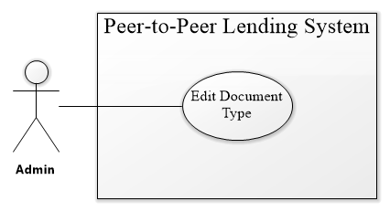

Figure 34 – <Admin> Edit Document Type Use Case

|  |  |  |  |
| --- | --- | --- | --- |
| **USE CASE – PPLS_AD_08** | | | |
| **Use Case No.** | PPLS_AD_08 | **Use Case Version** | 1.0 |
| **Use Case Name** | Edit document type | | |
| **Author** | LocHV | | |
| **Date** | 22/05/2019 | **Priority** | Normal |
| **Actor:**   * Admin.   **Summary:**   * Allow admin to edit document type.   **Goal:**   * Admin can edit document type.   **Triggers:**   * Admin sends edit document type command.   **Preconditions:**   * Must log in as Admin   **Post conditions:**   * Success: Admin can edit document type. * Fail: System shows error messages.   **Main Success Scenario:**   |  |  |  | | --- | --- | --- | | **Step** | **Actor Action** | **System Response** | | 1 | Admin clicks on “Edit” button | System show edit pop-up include:   * Name * Amount Limit * Acronym | | 2 | Admin edit information | [Alternative 2] | | 3 | Admin clicks on “Add” button | System save new document type and reload page to update list document.  [Alternative 1] [Exception 1] |   **Alternative Scenario:**   |  |  |  | | --- | --- | --- | | **No** | **Actor Action** | **System Response** | | 1 | Admin clicks on “Cancel” button | System hide add new pop-up. | | 2 | Admin input information | System show error message: “Name not contain special characters and numbers”, “The amount must be a multiple of 500.000 VND!”, “The amount must be lower than 10 Million!”, “Document name cannot be blank!”, “Acronym cannot be blank!”, “Acronym not contain special characters”. |   **Exceptions:**   |  |  |  | | --- | --- | --- | | **No** | **Actor Action** | **System Response** | | 1 |  | System redirect to login page when token timeout. |   **Relationships:** N/A  **Business Rules:**   * Name not contain special characters and numbers. * Amount is multiple of 500.000 VND and amount is lower than 10.000.000 VND * Acronym not contain special characters. * All field is required, disable “Add” button when amount is blank. | | | |

Table 36 – <Admin> Edit document type use case specification

* + 1. **<System> Overview use case**

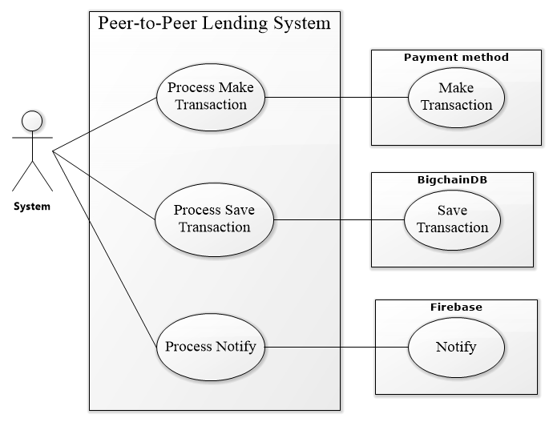

Figure 35 – <System> Overview Use Case

* + - 1. **<System> Process Make Transaction**

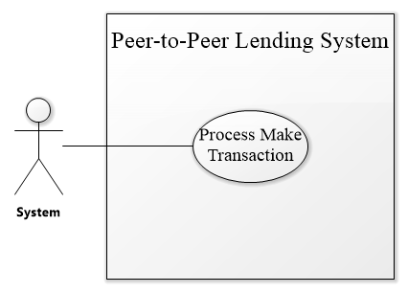

Figure 36 – <System> Process Make Transaction Use Case

|  |  |  |  |
| --- | --- | --- | --- |
| **USE CASE – PPLS_SY_01** | | | |
| **Use Case No.** | PPLS_SY_01 | **Use Case Version** | 1.0 |
| **Use Case Name** | Process make transaction | | |
| **Author** | LocHV | | |
| **Date** | 22/05/2019 | **Priority** | Normal |
| **Actor:**   * System.   **Summary:**   * Allow the system to process make a transaction.   **Goal:**   * The system can process make a transaction.   **Triggers:**   * The system sends process make transaction command.   **Preconditions:**   * N/A   **Post conditions:**   * Success: System can process make transaction. * Fail: System shows error messages.   **Main Success Scenario:**   |  |  |  | | --- | --- | --- | | **Step** | **Actor Action** | **System Response** | | 1 |  | System gets the amount and call PayPal to execute the payment. |   **Alternative Scenario:**   |  |  |  | | --- | --- | --- | | **No** | **Actor Action** | **System Response** | |  |  |  |   **Exceptions:**   |  |  |  | | --- | --- | --- | | **No** | **Actor Action** | **System Response** | |  |  |  |   **Relationships:** PPLS_AU_12, PPLS_SY_02  **Business Rules:**   * Before the PayPal call, the system converts currency from Vietnam dong to US dollar | | | |

Table 37 – <System> Process make transaction use case specification

* + - 1. **<System> Process Save Transaction**

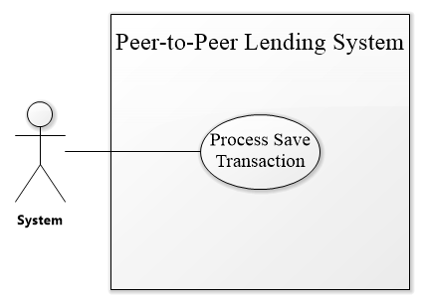

Figure 37 – <System> Process Save Transaction Use Case

|  |  |  |  |
| --- | --- | --- | --- |
| **USE CASE – PPLS_SY_01** | | | |
| **Use Case No.** | PPLS_SY_01 | **Use Case Version** | 1.0 |
| **Use Case Name** | Process save transaction | | |
| **Author** | LocHV | | |
| **Date** | 22/05/2019 | **Priority** | Normal |
| **Actor:**   * System.   **Summary:**   * Allow the system to process save the transaction.   **Goal:**   * System can process save transaction.   **Triggers:**   * System sends process save transaction command.   **Preconditions:**   * N/A   **Post conditions:**   * Success: System can process save transaction. * Fail: System shows error messages.   **Main Success Scenario:**   |  |  |  | | --- | --- | --- | | **Step** | **Actor Action** | **System Response** | | 1 |  | After PayPal return success, system gets information of user, PayPal and call bigchainDB to save the transaction and deal. |   **Alternative Scenario:**   |  |  |  | | --- | --- | --- | | **No** | **Actor Action** | **System Response** | |  |  |  |   **Exceptions:**   |  |  |  | | --- | --- | --- | | **No** | **Actor Action** | **System Response** | |  |  |  |   **Relationships:** PPLS_SY_01  **Business Rules:**   * Information save to bigchainDB include:   + transaction id   + amount   + lender username   + borrower username   + create date   + deal data     - deal id     - deal amount     - interest rate     - borrower username     - lender username     - milestone       * id       * previous date       * present date       * type       * percent       * transaction         + transaction id         + amount         + amount valid         + create date         + transaction id         + lender username         + borrower username         + status         + milestone id | | | |

Table 38 – <System> Process save transaction use case specification

* + - 1. **<System> Process Notify**

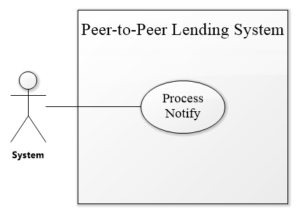

Figure 38 – <System> Process Notify Use Case

|  |  |  |  |
| --- | --- | --- | --- |
| **USE CASE – PPLS_SY_03** | | | |
| **Use Case No.** | PPLS_SY_03 | **Use Case Version** | 1.0 |
| **Use Case Name** | Process notify | | |
| **Author** | LocHV | | |
| **Date** | 22/05/2019 | **Priority** | Normal |
| **Actor:**   * System.   **Summary:**   * Allow the system to process notify.   **Goal:**   * The system can process notify.   **Triggers:**   * The system sends process to notify command.   **Preconditions:**   * N/A   **Post conditions:**   * Success: System can process notify. * Fail: System shows error messages.   **Main Success Scenario:**   |  |  |  | | --- | --- | --- | | **Step** | **Actor Action** | **System Response** | | 1 |  | The system gets username who will be received the message and call firebase. |   **Alternative Scenario:**   |  |  |  | | --- | --- | --- | | **No** | **Actor Action** | **System Response** | |  |  |  |   **Exceptions:**   |  |  |  | | --- | --- | --- | | **No** | **Actor Action** | **System Response** | |  |  |  |   **Relationships:** N/A  **Business Rules:**   * Notify is real time notification for user. | | | |

Table 39 – <System> Process notify use case specification

|  |  |
| --- | --- |
| **Entity Data dictionary: describe all content of all entities** | |
| **Entity Name** | **Description** |
| Authorized User | Abstract entity describes a user in the system include:   * ID * Username * FirstName * LastName * Password * Role * Status |
| Lender | Contain the lender’s information (Authorized user information) |
| Borrower | Contain the borrower’s information (Authorized user information) |
| Admin | Contain the admin’s information (Authorized user information) |
| Request | Contains the request’s information include:   * ID * LenderID * BorrowerID * Amount * InterestRate * CreateDate * BorrowDate |
| Deal | Contains the deal’s information include:   * ID * Status * BorrowTimes * PaybackTimes |
| Backup Deal | Contains the backup deal’s information (Deal information). |
| Milestone | Contains the milestone’s information include:   * ID * PreviousDate * PresentDate * Type * Percent |
| Backup Milestone | Contains the backup milestone’s information (Milestone information). |
| Transaction | Contains the transaction’s information include:   * ID * Sender * Receiver * Amount * AmountValid * IdTrx (ID Transaction) * Status * CreateDate |
| Document | Contains the document’s information include:   * ID * DocumentID * Status |
| Document Type | Contains the document type’s information include:   * ID * Name * AmountLimit * Acronym |
| Document File | Contains the document file’s information include:   * ID * FileName * FileType * Data |

Table 40 – Conceptual Diagram Data Dictionary

## Software System Attribute

#### Usability

Website’s UI is fit for each browser on each device

* Font style: Arial, Sans-serif
* Font size: 12px -26px
* Color: green, black, red, white, blue, …
* Background: White, Catalina Blue, Whisper…

#### 3.2 Reliability

* The information storing on the database is permanent.

#### Availability

* The system must be available at any time 24/7.

#### Security

* Only Admin has full access to the system.
* Input data is validated before saving to the database.

#### Maintainability

* The system is divided into separated modules for easy maintenance.

#### Portability

* The web application can be run on Chrome browser version 42 or later.

#### Performance

* The system has successfully tested with basic standard

## Conceptual Diagram

Figure 39 - Conceptual Diagram

**Data Dictionary**

|  |  |
| --- | --- |
| **Entity Data dictionary: describe all content of all entities** | |
| **Entity Name** | **Description** |
| Authorized User | Abstract entity describes a user in the system. Contain user information include:   * ID * Username * FirstName * LastName * Password * Status * Role |
| Lender | Contain the lender information (authorized user information). |
| Borrower | Contain the borrower information (authorized user information). |
| Admin | Contain the admin information (authorized user information). |
| Request | Contain the request information include:   * ID * LenderID * BorrowerID * Amount * InterestRate * CreateDate * BorrowDate * Status |
| Deal | Contain the deal information include:   * ID * BorrowTimes * PaybackTimes * Status |
| Backup Deal | Contain the backup deal information (deal information), represent for the first deal |
| Milestone | Contain the milestone information include:   * ID * PreviousDate * PresentDate * Type * Percent |
| Backup Milestone | Contain the backup milestone information (milestone information), represent for the first milestone |
| Document | Contain the document information include:   * ID * DocumentID * Status |
| Document Type | Contain the document type information include:   * ID * FileName * FileType * Data |
| Document File | Contain the document file information include:   * ID * Name * AmountLimit * Acronym |

Table 40 – Conceptual Diagram Data Dictionary

# Software Design Description

## Design Overview

- This document describes the technical and user interface design of PPLS Web Application. It includes the architectural design, the detailed design of common functions and business functions, and the design of the database model.

- The architectural design describes the overall architecture of the system and the architecture of each principal component and subsystem.

- The detailed design describes the static and dynamic structure for each component and functions. It includes class diagrams, class explanations, and sequence diagrams for each use cases.

- The database design describes the relationships between entities and the details of each entity.

- DocumentOverview:

Section 2: gives an overall description of the system architecture design.

Section 3: gives component diagrams that describe the connection and integration of the system.

Section 4: gives the detail design description, which includes a class diagram, class explanation, and sequence diagram to details the application functions.

Section 5: describe screens design.

Section 6: describe a fully attributed ERD.

Section 7: describe algorithms

## System Architectural Design

Figure 40 – Software Architecture Design

In Web Application, the system is developed under the MVC architecture style using Spring Framework. We choose this architecture for Web Application because of following advantages:

* The Spring Framework features its own MVC web application framework, defines interfaces for all of the responsibilities that must be handled by a modern request-based framework (such as Controller, View, HandlerAdapter,...)
* Spring Boot provided by Spring framework makes it easy to create stand-alone, production-grade Spring based Applications that you can "just run."
* Spring Security offers a powerful and convenient process for authentication.
* Its inversion of control feature creates the object in runtime and satisfies application dependencies.
* ReactJS is quite easy to be mastered.
* ReactJS is easy to maintain isolated components in React.
* Convenient React is highly competitive to MVC. One-way data flow provides maintainability and efficient arrangement of data and DOM elements.
* It is the most light-weighted framework among the ones that are widely used today.

As illustrated in Figure 40, the architecture consists of 3 layers: application layer, ledger processor layer, and BigchainDB network.

* The application layer provides the users essential functions of a content publishing platform. Besides, the digital wallet functionality, which allows the user to view transaction history and pay directly for the transaction is also supported.
* The ledger processor layer is the middleware communicator connecting the application layer with the BigchainDB network. This layer receives a query, register and transfer requests from the application to build a standard transaction before sending to the blockchain storage; transaction result is also retrieved in this layer to send back as a response to the application.
* The BigchainDB network is the underlying blockchain network recordings all transaction related to transaction payment assets.

## Component Diagram

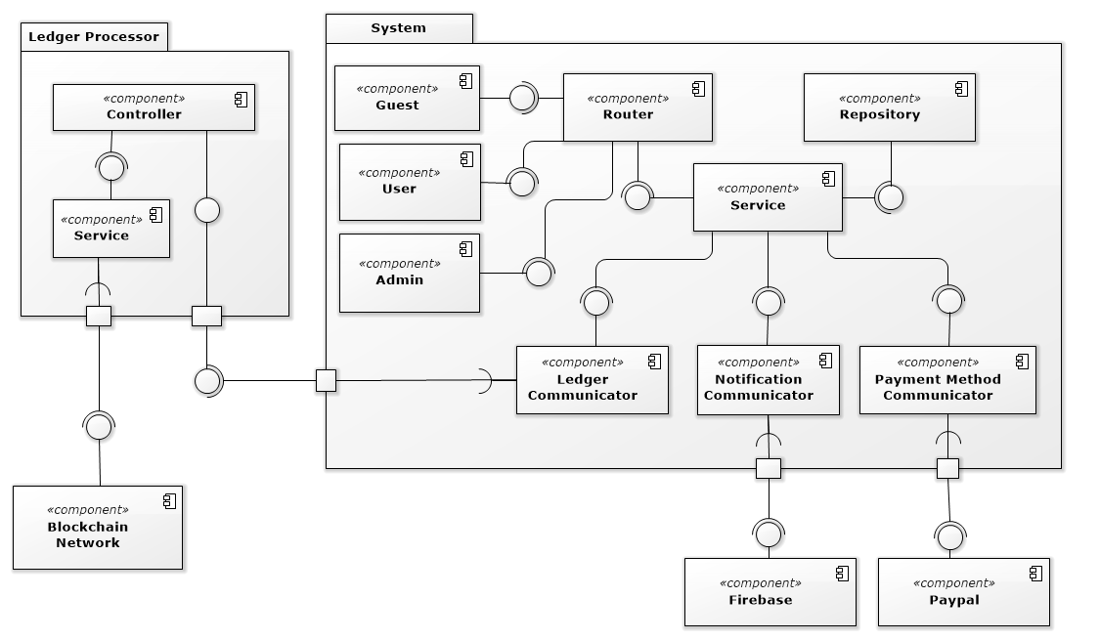

Figure 41 – Front End User Component Diagram

|  |  |
| --- | --- |
| COMPONENT DICTIONARY: DESCRIBES COMPONENTS | |
| System |  |
| Router | Handle request and response, accept input, and convert it to commands for the back end. |
| Repository Component | Component to handle the interaction between the system and database |
| Service Component | Component to handle the system’s business operations |
| Admin Component | Component to handle admin activities in the system |
| User Component | Component to handle user activities in the system |
| Guest Component | Component to handle guest activities in the system |
| Ledger communicator | Component to handle communication between system and ledger processor |
| Notification communicator | Component to handle communication notification process |
| Payment method communicator | Component to handle communication payment process |
| PayPal | Handle payment process with PayPal API |
| Firebase | Handle payment process with Firebase API |
| Ledger processor | Ledger processor to process business-related to the ledger |
| Controller | Handle HTTP request |
| Service | Handle ledger business operations |
| Blockchain network | Handle interaction between ledger processor and a blockchain database |

Table 41 – Front End Component Diagram Dictionary

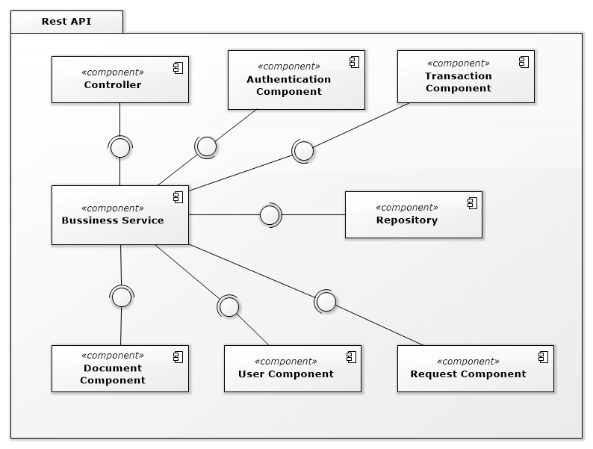

Figure 42 – Back End Component Diagram

|  |  |
| --- | --- |
| COMPONENT DICTIONARY: DESCRIBES COMPONENTS | |
| Rest API |  |
| Controller | Handle requests and responses; accept input and handle respone error |
| Bussiness Servies | Handle system’s business operations |
| Repository | Store Data |

Table 42– Back End Component Diagram Dictionary

## Detailed Description

### **4.1 Class Diagram**

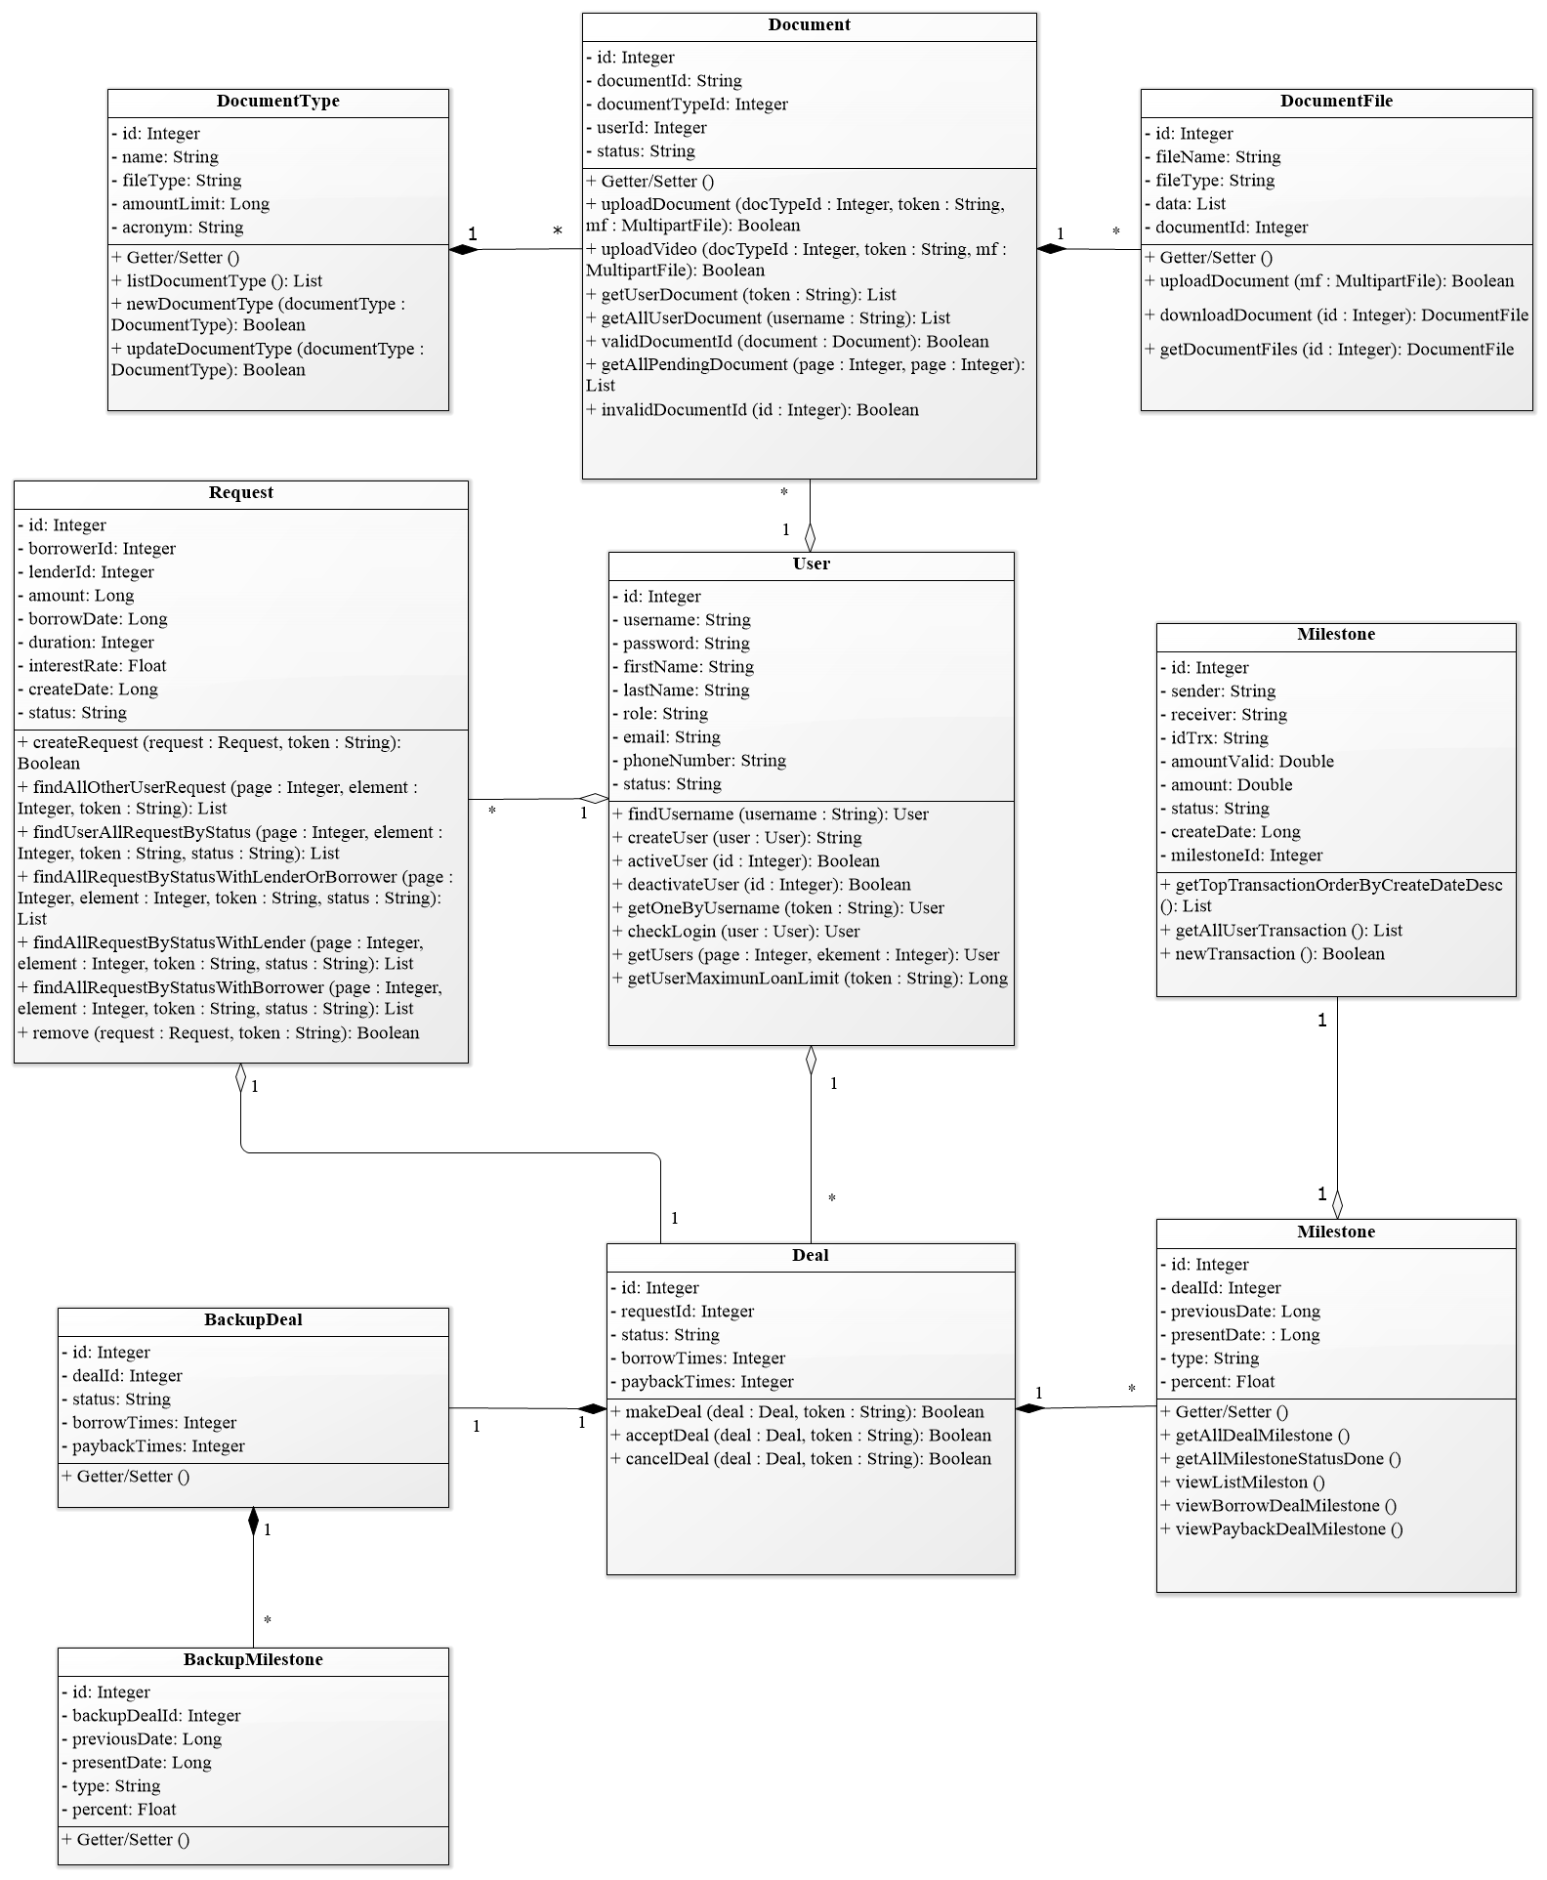

Figure 43 – Class Diagram

### **4.2 Class Diagram Explanation**

|  |  |  |
| --- | --- | --- |
| **CLASS DICTIONARY: DESCRIBE CLASS** | | |
| **Class Name** | **Mapping column with Conceptual diagram** | **Description** |
| **User** | AuthorizedUser | Contains the user information |
| **Request** | Request | Contains the request information |
| **Deal** | Deal | Contains the deal information |
| **Milestone** | Milestone | Contains the milestone information |
| **Transaction** | Transaction | Contains the transaction information |
| **BackupDeal** | BackupDeal | Contains the backup deal information |
| **BackupMilestone** | BackupMilestone | Contains the backup milestone information |
| **Document** | Document | Contains the document information |
| **DocumentType** | DocumentType | Contains the information of document type |
| **DocumentFile** | DocumentFile | Contains the information of document file |

Table 43 – Class Diagram PPLS

**4.2.1 User**

|  |  |  |  |
| --- | --- | --- | --- |
| **Attribute** | **Type** | **Visibility** | **Description** |
| id | Int | Private | Unique identifier of an account |
| username | String | Private | Account’s username |
| password | String | Private | Account’s password |
| lastName | String | Private | Account’s full name |
| firstName | String | Private | Account’s address |
| loanLimit | Long | Private | Account’s position |
| role | String | Private | Account’s Role |
| email | String | Private | Account’s Email |
| phoneNumber | String | Private | Account’s Phone Number |
| status | String | Private | Account’s Status |

Table 44 – <Class Diagram Attributes> User

|  |  |  |  |
| --- | --- | --- | --- |
| **Method** | **Redirect Type** | **Visibility** | **Description** |
| checkLogin | Object | Public | Login |
| createUser | boolean | Public | Create a new user |
| activeUser | boolean | Public | Active a user |
| deactivateUser | boolean | Public | Deactivate a user |
| getOneByUsername | Object | Public | Get a user information base on token |
| getUserMaximunLoanLimit | Long | Public | Get user maximum loan limit |
| getUsers | List | Public | Get User List |
| findUsername | object | Public | Get a user base on username |

Table 45 – <Class Diagram Methods> User

**4.2.2 Request**

|  |  |  |  |
| --- | --- | --- | --- |
| **Attribute** | **Type** | **Visibility** | **Description** |
| id | Integer | Private | Unique identifier of a request |
| amount | Long | Private | Amount of the request |
| borrowDate | Long | Private | Borrow date in timestamp |
| interestRate | Float | Private | Request interest rate |
| createDate | Long | Private | Create a date in timestamp |
| status | String | Private | Request’s status |
| borrowerId | Integer | Private | Id of borrower |
| lendId | Integer | Private | Id of Lender |

Table 46 – <Class Diagram Attributes> Request

|  |  |  |  |
| --- | --- | --- | --- |
| **Method** | **Redirect Type** | **Visibility** | **Description** |
| createRequest | boolean | Public | Add new request |
| findAllOtherUserRequest | List | Public | Find all request not belong to current login user |
| findUserAllRequestByStatus | List | Public | Find all borrower request by status |
| findAllRequestByStatusWithLenderOrBorrower | List | Public | Find all borrower and lender request by status |
| findAllRequestByStatusWithLender | List | Public | Find all lender request with status |
| findAllRequestByStatusWithBorrower | List | Public | Find all borrower request by status |
| remove | boolean | Public | Delete request with pending status only |

Table 47 – <Class Diagram Methods> Request

**4.2.3 Deal**

|  |  |  |  |
| --- | --- | --- | --- |
| **Attribute** | **Type** | **Visibility** | **Description** |
| id | Long | Private | Unique identifier |
| status | String | Private | Deal’s status |
| borrowTime | String | Private | Number of the borrowed time on request |
| paybackTime | Datetime | Private | Number of the lending time on request |
| userId | Integer | Private | Unique identifier of user |
| requestId | Integer | Private | Unique identifier of request |

Table 48 – <Class Diagram Attributes> Deal

|  |  |  |  |
| --- | --- | --- | --- |
| **Method** | **Redirect Type** | **Visibility** | **Description** |
| makeDeal | boolean | Public | Allow user to make a deal to request a loan |
| acceptDeal | boolean | Public | Accept deal that other people make to the request |
| cancelDeal | boolean | Public | Cancel deal and reset deal to the original deal |

Table 49 – <Class Diagram Methods> Deal

**4.2.4 Milestone**

|  |  |  |  |
| --- | --- | --- | --- |
| **Attribute** | **Type** | **Visibility** | **Description** |
| id | Integer | Private | Unique identifier |
| previousDate | Long | Private | Date of the previous milestone |
| presentDate | Long | Private | Date of current milestone |
| type | String | Private | Milestone’s type |
| percent | Float | Private | Milestone’s percent |
| dealId | Integer | Private | Unique identifier of deal |

Table 50 – <Class Diagram Attributes> Milestone

|  |  |  |  |
| --- | --- | --- | --- |
| **Method** | **Redirect Type** | **Visibility** | **Description** |
| newMilestone | boolean | Public | Add new milestone |
| updateMilestone | boolean | Public | Edit milestone |

Table 51 – <Class Diagram Methods> Milestone

**4.2.5 Transaction**

|  |  |  |  |
| --- | --- | --- | --- |
| **Attribute** | **Type** | **Visibility** | **Description** |
| id | Long | Private | Unique identifier |
| sender | String | Private | Sitemap’s map |
| receiver | String | Private | Url root |
| idTrx | Integer | Private | Type map |
| amountValid | Double | Private | Amount of transaction to check valid |
| amount | Double | Private | Amount of money send |
| status | String | Private | Status of the transaction |
| createDate | Long | Private | Transaction create date |
| milestoneId | Integer | Private | Unique identifier of milestone |

Table 52 – <Class Diagram Attributes> Transaction

|  |  |  |  |
| --- | --- | --- | --- |
| **Method** | **Redirect Type** | **Visibility** | **Description** |
| getTopTransactionOrderByCreateDateDesc | List | Public | Get top 20 transaction currently make of all player |
| getAllUserTransaction | List | Public | Get all transaction of a user |
| newTransaction | boolean | Public | Make a transaction |

Table 53 – <Class Diagram Methods> Transaction

**4.2.6 Backup Deal**

|  |  |  |  |
| --- | --- | --- | --- |
| **Attribute** | **Type** | **Visibility** | **Description** |
| id | Integer | Private | Unique identifier |
| status | String | Private | Backup deal status |
| borrowTime | Integer | Private | Backup deal borrowTime |
| paybackTime | Integer | Private | Backup deal paybackTime |
| dealId | Integer | Private | Unique identifierof deal |

Table 54 – <Class Diagram Attributes> Backup Deal

|  |  |  |  |
| --- | --- | --- | --- |
| **Method** | **Redirect Type** | **Visibility** | **Description** |
| addBackupDeal | Boolean | Public | Add new backup deal |
| removeBackupDeal | Boolean | Public | Remove backup deal |

Table 55 – <Class Diagram Methods> Backup Deal

**4.2.7 Backup Milestone**

|  |  |  |  |
| --- | --- | --- | --- |
| **Attribute** | **Type** | **Visibility** | **Description** |
| id | Long | Private | Unique identifier of a backup milestone |
| previousDate | Long | Private | Backup milestone previous date |
| presentDate | Long | Private | Backup milestone present date |
| type | String | Private | Backup milestone type |
| percent | Float | Private | Backup milestone percent |
| backupDealId | Integer | Private | Unique identifier of a backup deal |

Table 56 – <Class Diagram Attributes> Backup milestone

|  |  |  |  |
| --- | --- | --- | --- |
| **Method** | **Redirect Type** | **Visibility** | **Description** |
| addBackupMilestone | boolean | Public | Add new backup milestone |
| removeBackupMilestone | Boolean | Public | Remove backup milestone |

Table 57 – <Class Diagram Methods> Backup milestone

**4.2.8 Document**

|  |  |  |  |
| --- | --- | --- | --- |
| **Attribute** | **Type** | **Visibility** | **Description** |
| id | Long | Private | Unique identifier |
| documentId | Integer | Private | Id of a document |
| status | String | Private | Status of document to know it valid or not |
| documentTypeId | Integer | Private | Unique identifier of document type |
| userId | Integer | Private | Unique identifier of user |

Table 58 – <Class Diagram Attributes> Document

|  |  |  |  |
| --- | --- | --- | --- |
| **Method** | **Redirect Type** | **Visibility** | **Description** |
| uploadDocument | boolean | Public | Upload user document for admin to valid |
| uploadVideo | boolean | Public | Upload user video for admin to valid |
| getUserDocument | List | Public | Get all current login user document |
| getAllUserDocument | List | Public | Get all document of a user |
| validDocumentId | boolean | Public | Decide if a document is valid |
| getAllPendingDocument | List | Public | Get all pending document |
| invalidDocumentId | boolean | Public | Decide if a document is invalid |

Table 59 – <Class Diagram Methods> Document

**4.2.9 Document Type**

|  |  |  |  |
| --- | --- | --- | --- |
| **Attribute** | **Type** | **Visibility** | **Description** |
| id | Integer | Private | Unique identifier |
| name | String | Private | Name of document type |
| amountLimit | Long | Private | Amount gain of this document type |

Table 60 – <Class Diagram Attributes> Document Type

|  |  |  |  |
| --- | --- | --- | --- |
| **Method** | **Redirect Type** | **Visibility** | **Description** |
| listDocumentType | boolean | Public | Upload user document for admin to valid |
| newDocumentType | boolean | Public | Upload user video for admin to valid |
| updateDocumentType | List | Public | Get all current login user document |

* + 1. **DocumentFile**

|  |  |  |  |
| --- | --- | --- | --- |
| **Attribute** | **Type** | **Visibility** | **Description** |
| id | Long | Private | Unique identifier of a grammar report |
| fileName | Long | Private | Grammar error is found at position |
| fileType | String | Private | Grammar errors excerpt |
| data | String | Private | Appereance info |
| documentId | String | Private | Grammar error reason |

Table 61 – <Class Diagram Attributes> DocumentFile

### **4.3 Interaction Diagram**

#### 4.3.1 Login

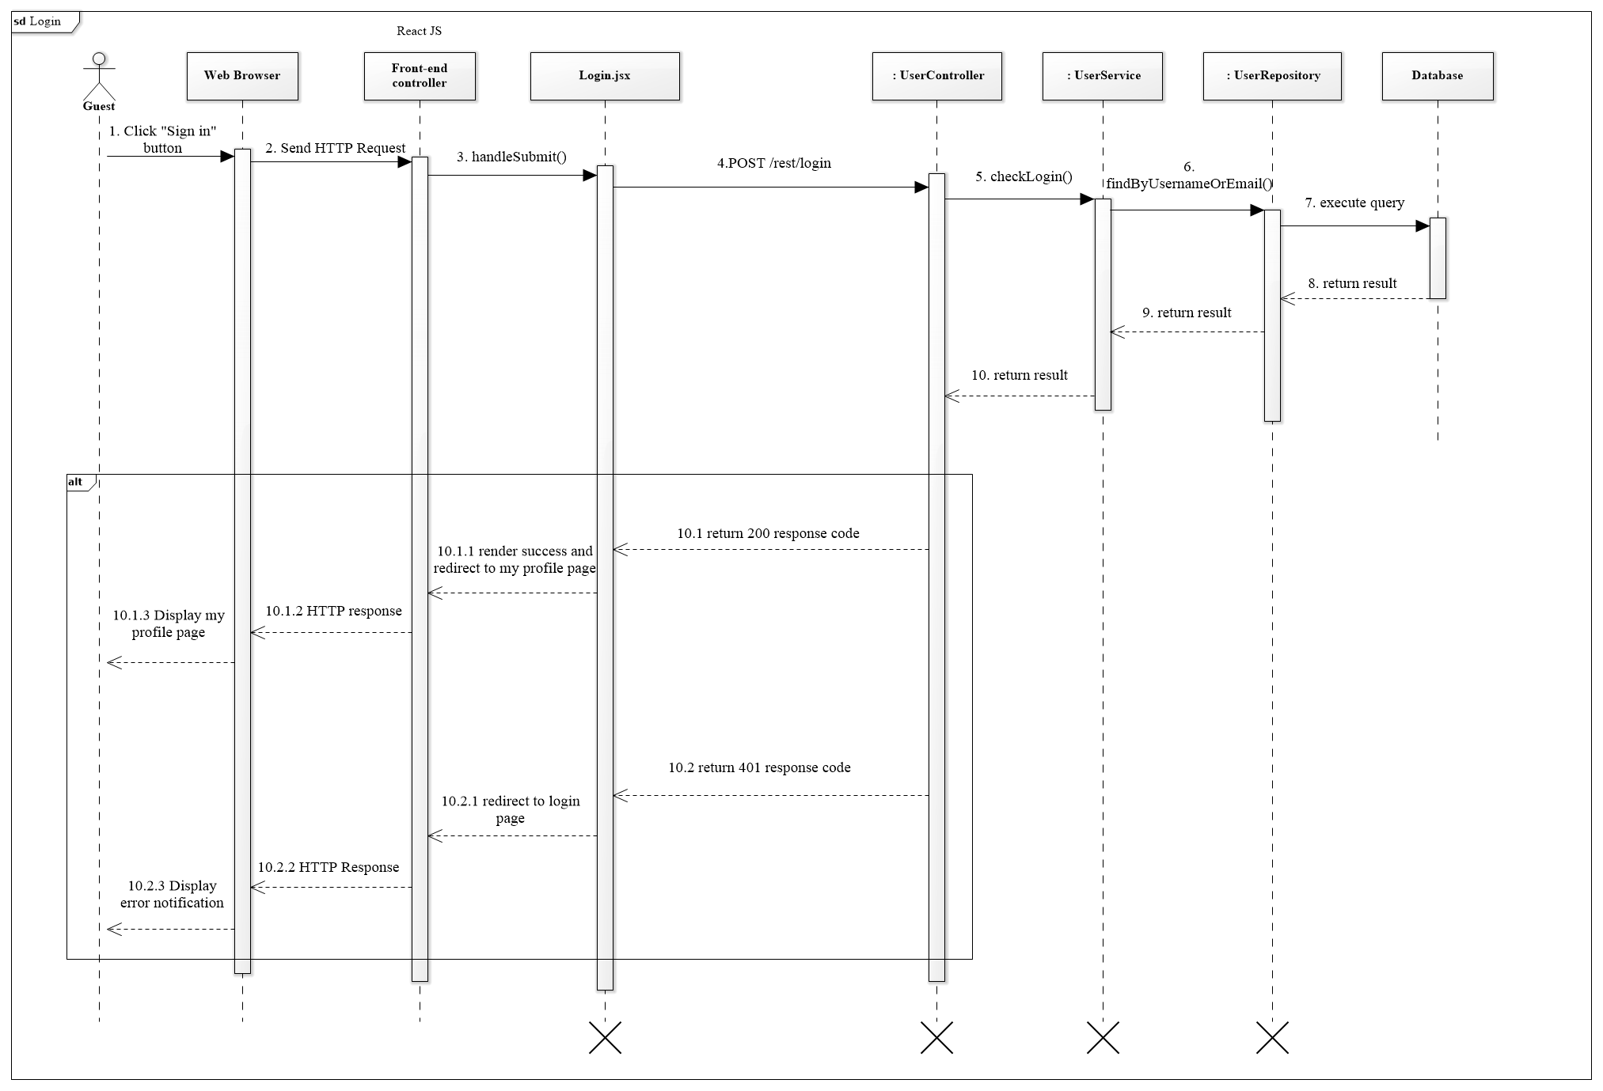

Figure 44 <Sequence Diagram> Guest Login

#### 4.3.2 Accept deal

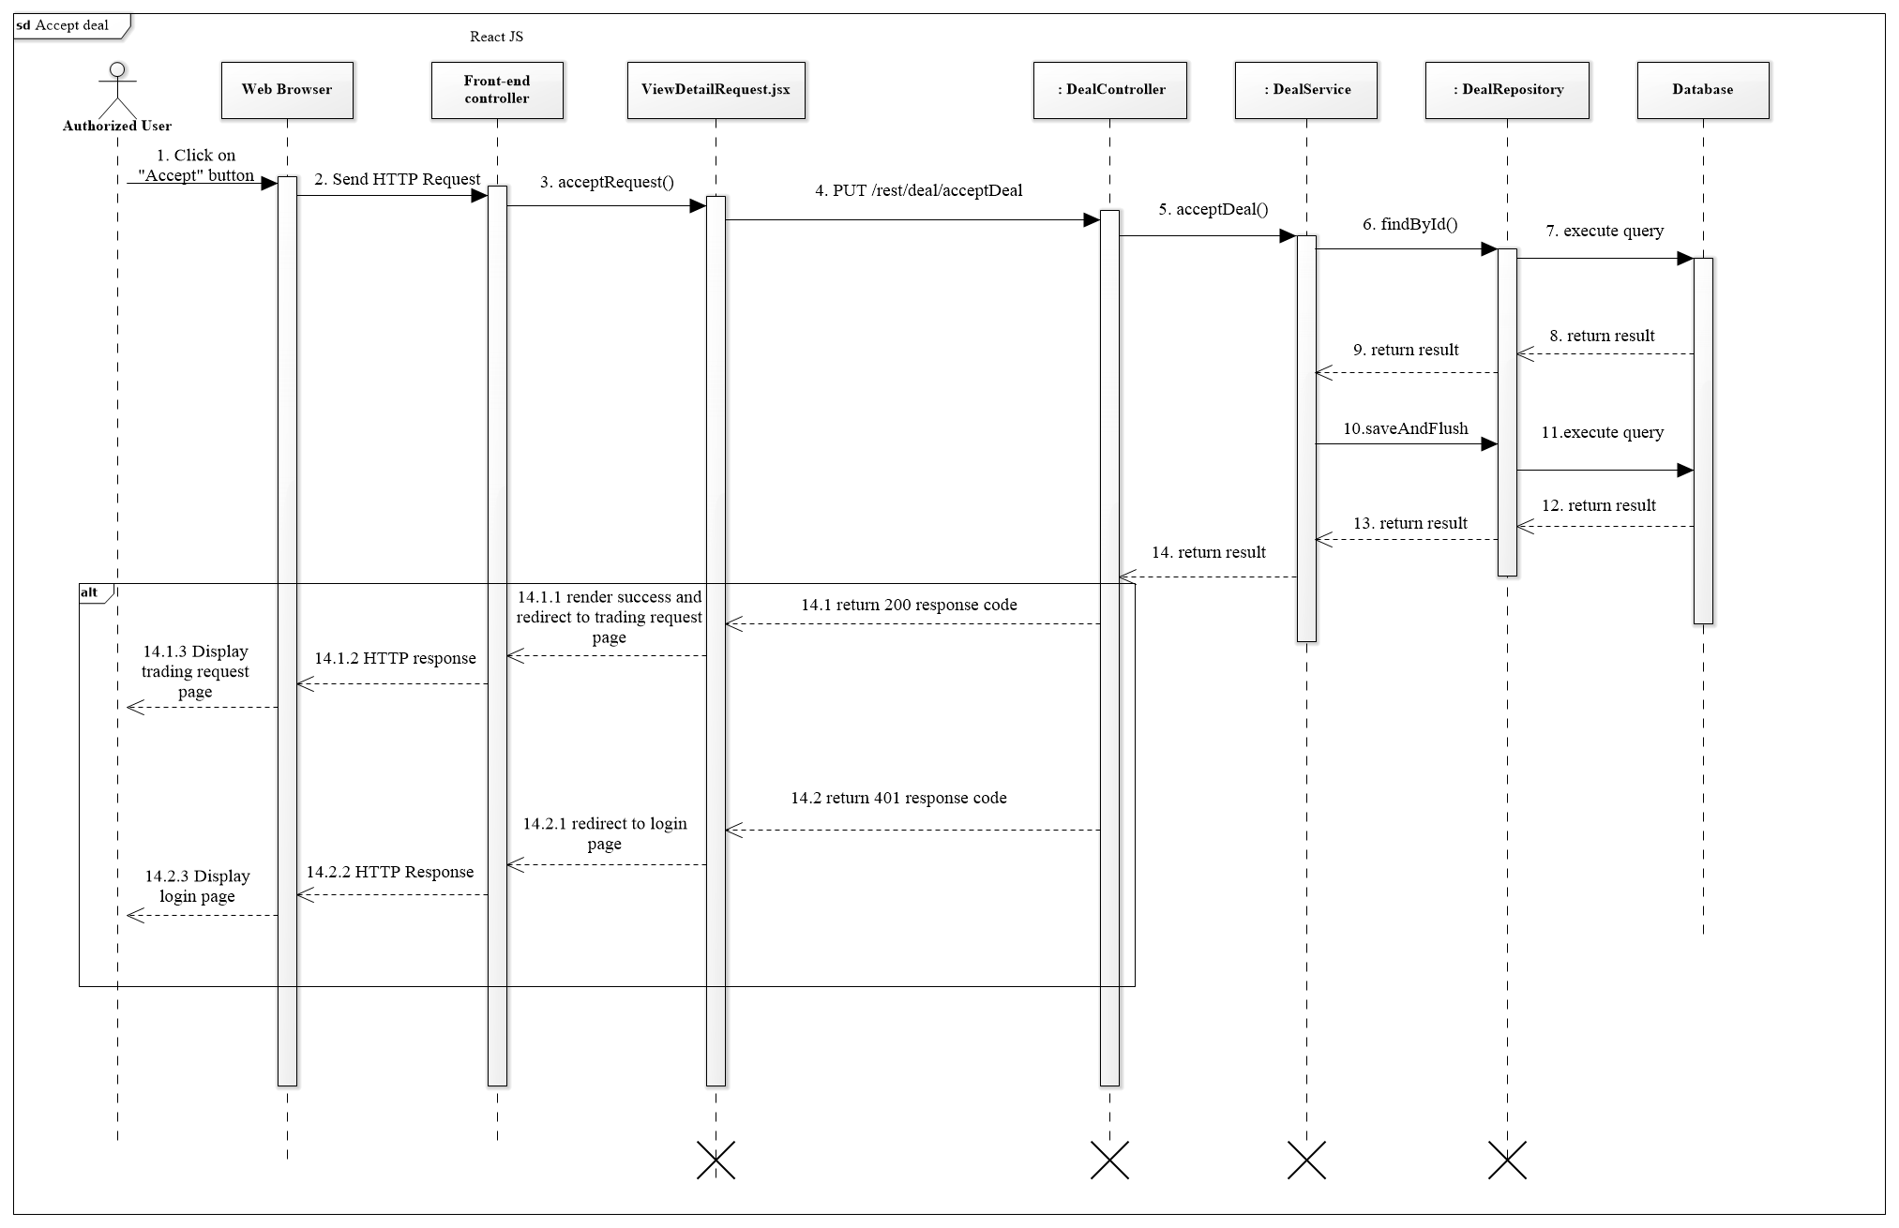

**Figure 45 <Sequence Diagram> Accept Deal**

#### 4.3.3 Create request

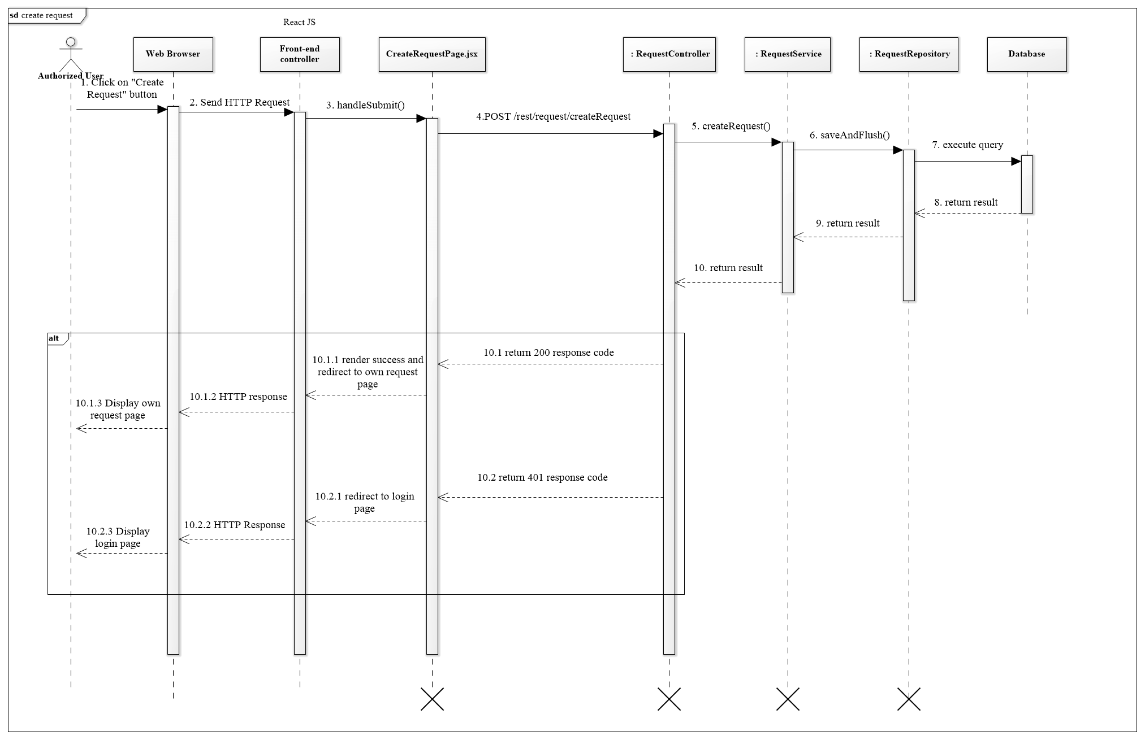

Figure 46 <Sequence Diagram> Create request

#### 4.3.4 Make deal

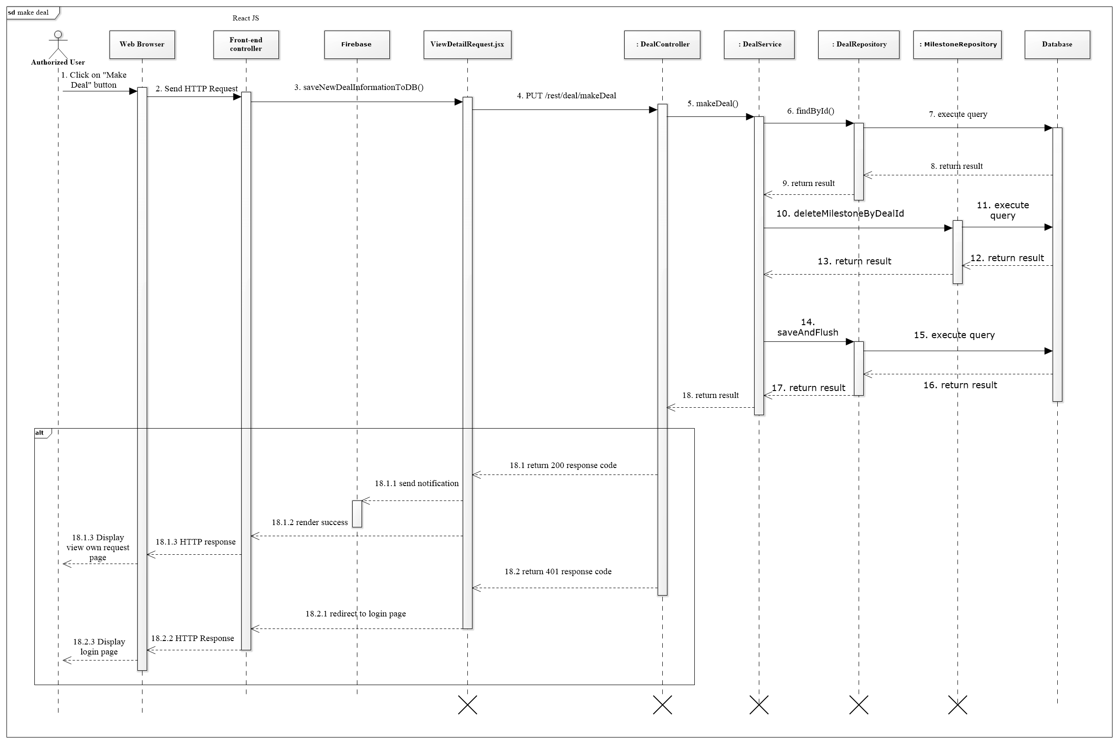

Figure 47 <Sequence Diagram> Make deal

#### 4.3.5 Valid document

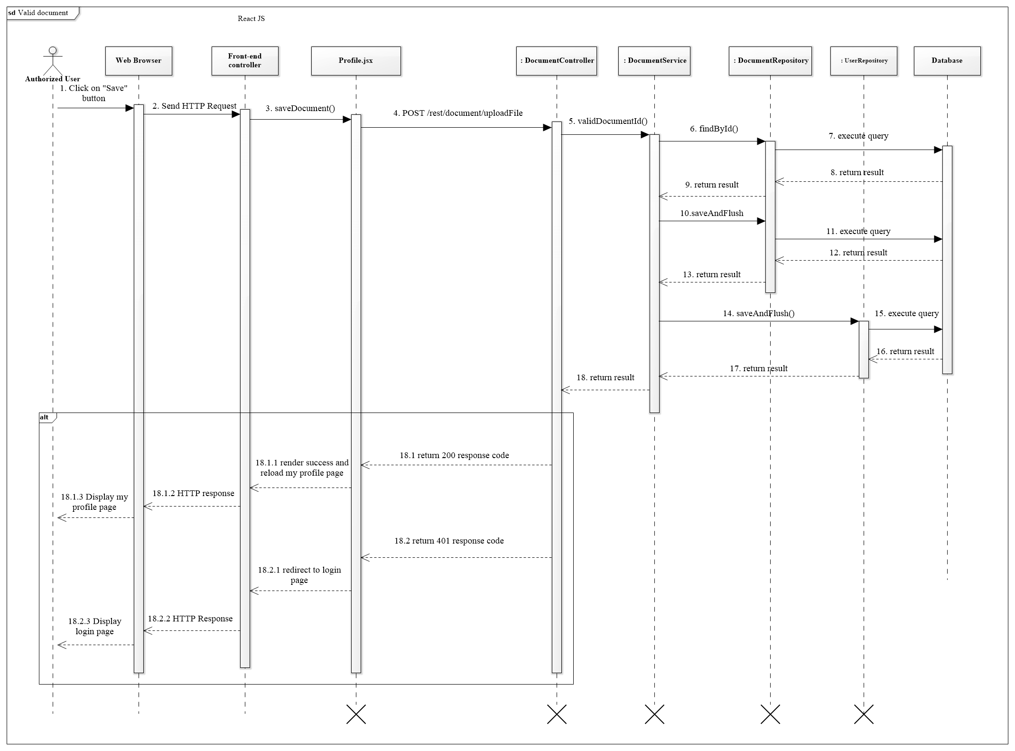

Figure 48 <Sequence Diagram> Valid document

#### 4.3.6 Do payment and sent to BigchainDB

Figure 49 <Sequence Diagram> Do payment and sent to BigchainDB

## Interface

## User Interface Design

## User

### **HomePage**

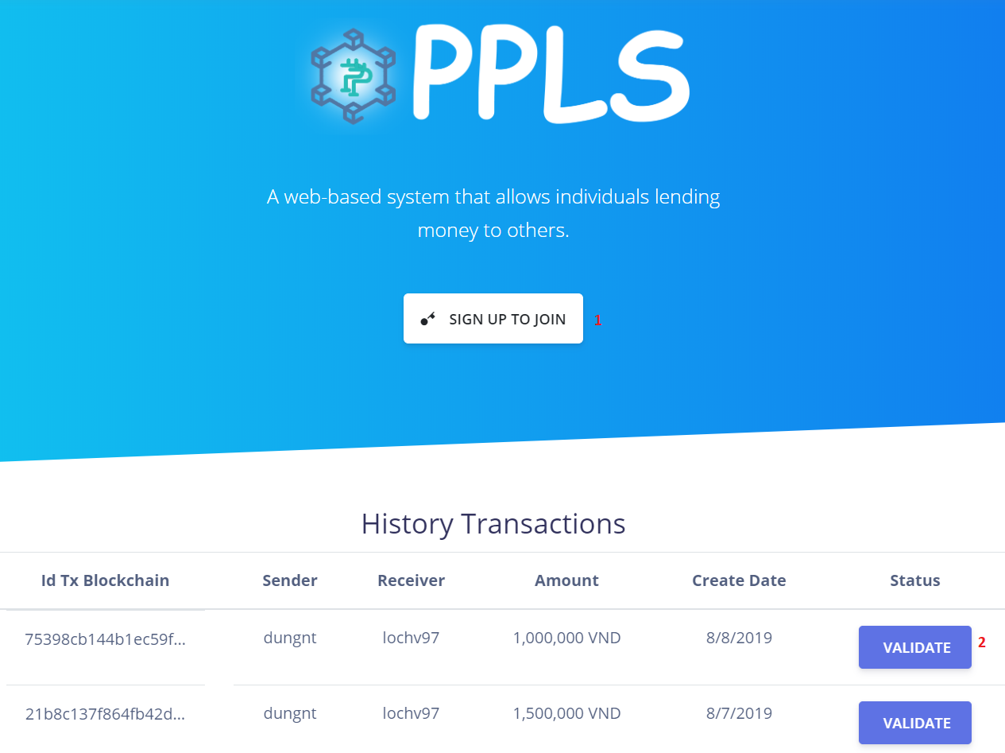

Figure 50 Homepage

**Buttons/Hyperlinks:**

|  |  |  |  |  |
| --- | --- | --- | --- | --- |
| **No** | **Function** | **Description** | **Validation** | **Outcome** |
| 3 | btnSignIn | Login into the system | Required | Transfer to Dashboard |
| 4 | btnLogin | Go to Login Page | Required | Transfer to Login Page |
| 5 | btnRegister | Go to Register Page | Required | Transfer to Register Page |
| 6 | Forget Password ? | Change UI to Forget Pasword | Required | Switch to Forget Pasword |
| 7 | Create new account | Go to Register Page | Required | Go to Register Page |

Table 62 <Buttons/Hyperlinks>User Login

### **Login**

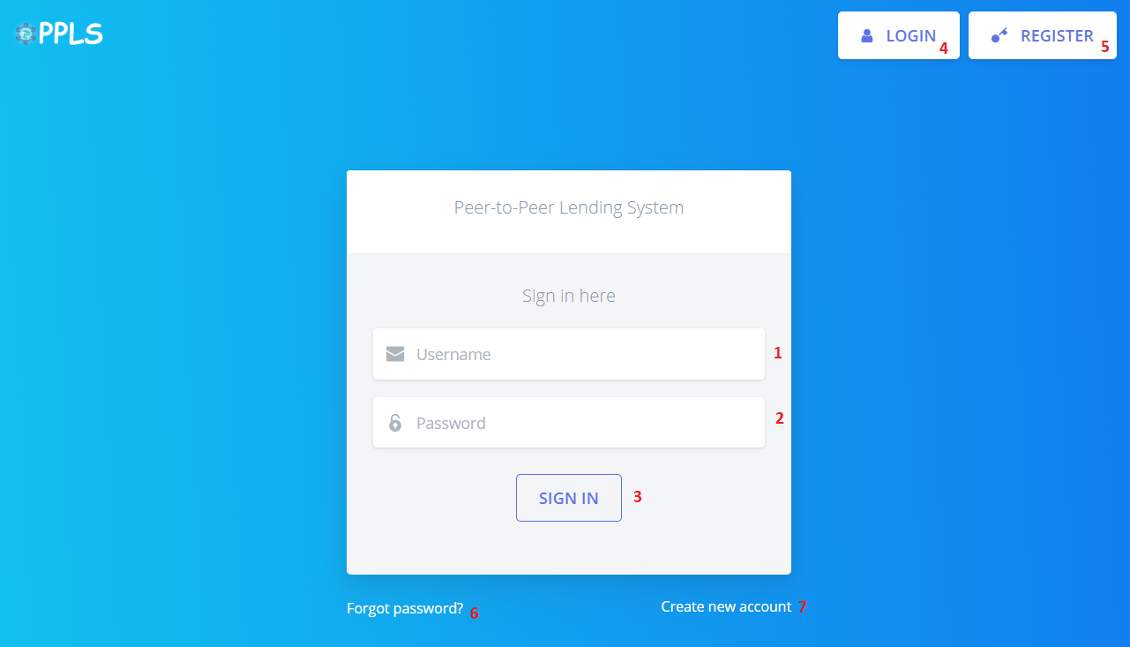

Figure 51 - Login

**Fields**

|  |  |  |  |  |  |  |
| --- | --- | --- | --- | --- | --- | --- |
| **No** | **Field Name** | **Description** | **Read only** | **Mandatory** | **Control Type** | **Data Type** |
| 1 | Username | Username to login | No | Yes | TextBox | String |
| 2 | Password | Password to login | No | Yes | TexBox | String |

Table 63 <Fields> Login

**Buttons/Hyperlinks:**

|  |  |  |  |  |
| --- | --- | --- | --- | --- |
| **No** | **Function** | **Description** | **Validation** | **Outcome** |
| 3 | btnSignIn | Login into the system | N/A | Transfer to Dashboard |
| 4 | btnLogin | Go to Login Page | N/A | Transfer to Login Page |
| 5 | btnRegister | Go to Register Page | N/A | Transfer to Register Page |
| 6 | Forget Password ? | Change UI to Forget Pasword | N/A | Switch to Forget Pasword |
| 7 | Create new account | Go to Register Page | N/A | Go to Register Page |

Table 64 <Buttons/Hyperlinks> Login

### **Forgot Password**

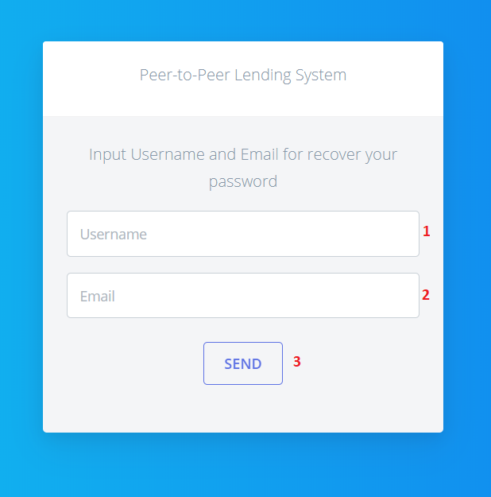

Figure 52 - Forgot Password

**Fields**

|  |  |  |  |  |  |  |
| --- | --- | --- | --- | --- | --- | --- |
| **No** | **Field Name** | **Description** | **Read only** | **Mandatory** | **Control Type** | **Data Type** |
| 1 | Username | Username to recover | No | Yes | TextBox | String |
| 2 | Email | Email to recover | No | Yes | TextBox | String |

Table 65 <Fields> Forgot Password

**Buttons/Hyperlinks:**

|  |  |  |  |  |
| --- | --- | --- | --- | --- |
| **No** | **Function** | **Description** | **Validation** | **Outcome** |
| 3 | btnSend | Send request to system | N/A | Transfer to Dashboard |

Table 66 <Buttons/Hyperlinks> Forgot Password

### **Register**

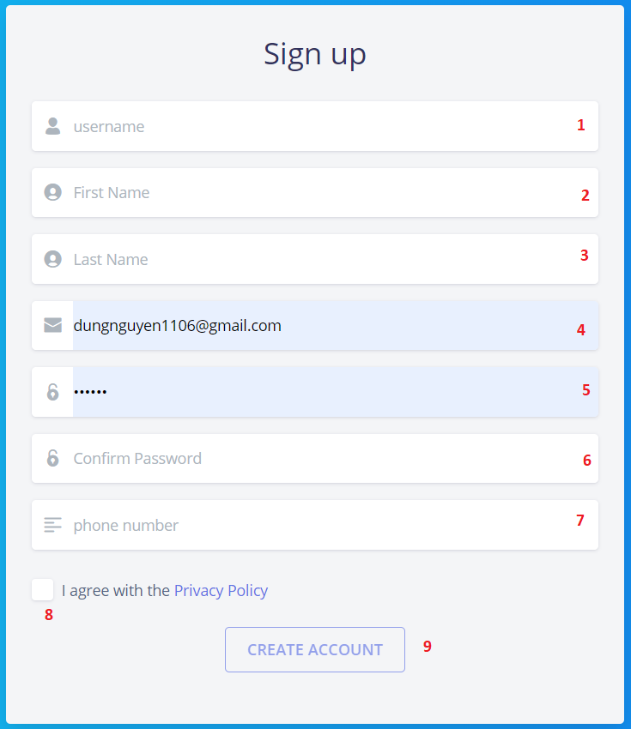

Figure 53 Register

**Fields**

|  |  |  |  |  |  |  |
| --- | --- | --- | --- | --- | --- | --- |
| **No** | **Field Name** | **Description** | **Read only** | **Mandatory** | **Control Type** | **Data Type** |
| 1 | Username | Username to register | No | Yes | TextBox | String |
| 2 | First Name | First Name to register | No | Yes | TextBox | String |
| 3 | Last Name | Last Name to register | No | Yes | TextBox | String |
| 4 | Email | Email to register | No | Yes | TextBox | String |
| 5 | Password | Password to register | No | Yes | TextBox | String |
| 6 | Confirm Password | Confirm Password to register | No | Yes | TextBox | String |
| 7 | Phone Number | Phone Number to register | No | Yes | TextBox | Number |

Table 67 <Fields> Register

**Buttons/Hyperlinks:**

|  |  |  |  |  |
| --- | --- | --- | --- | --- |
| **No** | **Function** | **Description** | **Validation** | **Outcome** |
| 8 | chkAgree | Agree Policy for registing | Required | Agree Policy for open “Create Account” Button |
| 9 | btnCreateAccount | Regist new account | Required | New account is registed |

Table 68 <Buttons/Hyperlinks> Register

### **Manage User**

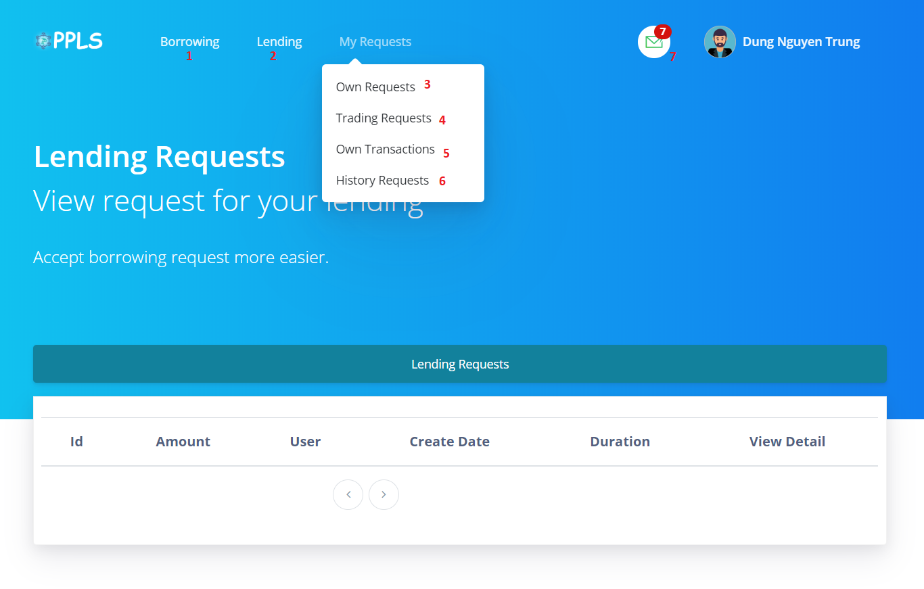

Figure 54 - Manage User

**Buttons/Hyperlinks:**

|  |  |  |  |  |
| --- | --- | --- | --- | --- |
| **No** | **Function** | **Description** | **Validation** | **Outcome** |
| 1 | Borrowing | Show create request dropdown | N/A | Transfer to Create Request Page |
| 2 | Lending | Show lending requests dropdown | N/A | Transfer to Lending Requests Page(default) |
| 3 | Own Requests | Go to Own Requests Page | N/A | Transfer to Own Requests Page |
| 4 | Trading Requests | Go to Trading Requests | N/A | Transfer to Trading Requests Page |
| 5 | Own Transactions | Go to Own Transactions | N/A | Transfer to Own Transactions Page |
| 6 | History Requests | Go to History Requests | N/A | Transfer to History Requests Page |
| 7 | Notifications | Show notification dropdown | N/A | List all notifications |

Table 69 <Buttons/Hyperlinks> Manage User

### **Create Request**

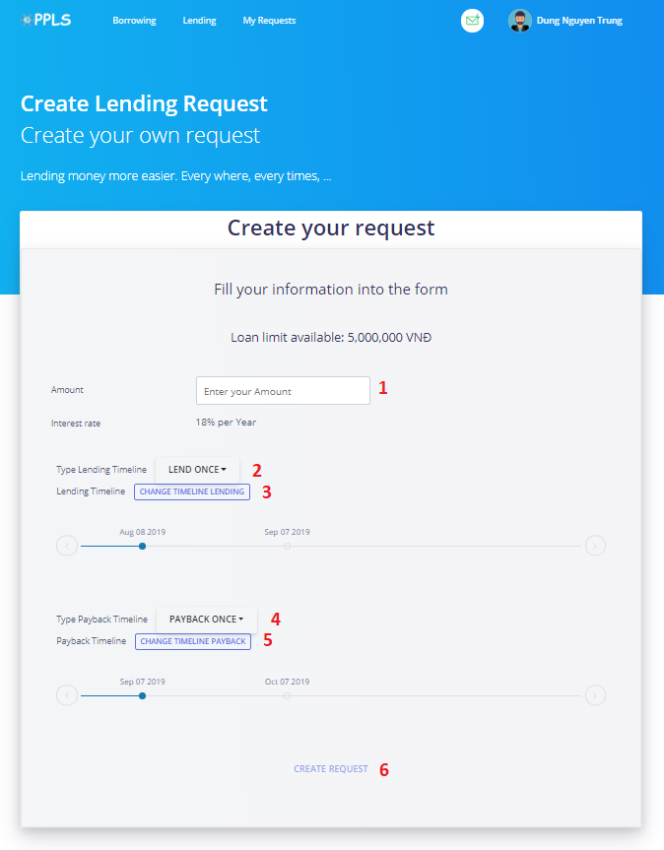

Figure 55 Create Request

**Fields**

|  |  |  |  |  |  |  |
| --- | --- | --- | --- | --- | --- | --- |
| **No** | **Field Name** | **Description** | **Read only** | **Mandatory** | **Control Type** | **Data Type** |
| 1 | Amount | Amount to create request | No | Yes | TextBox | String |

Table 70 <Fields> Create Request

**Buttons/Hyperlinks:**

|  |  |  |  |  |
| --- | --- | --- | --- | --- |
| **No** | **Function** | **Description** | **Validation** | **Outcome** |
| 2 | btnLendDropdown | Dropdown button to change Timeline Lending Once or Many | N/A | Transfer to Dashboard |
| 3 | btnChangeTLLending | Open editor for changing lending timeline | N/A |  |
| 4 | btnPaybackDropdown | Dropdown button to change Timeline Payback Once or Many | N/A |  |
| 5 | btnChangeTLPayback | Open editor for changing payback timeline | N/A |  |
| 6 | btnCreateRequest | Create new Request | Need the amount to be filled with the valid amount |  |

Table 71 <Buttons/Hyperlinks> Create Request

### **Own Requests**

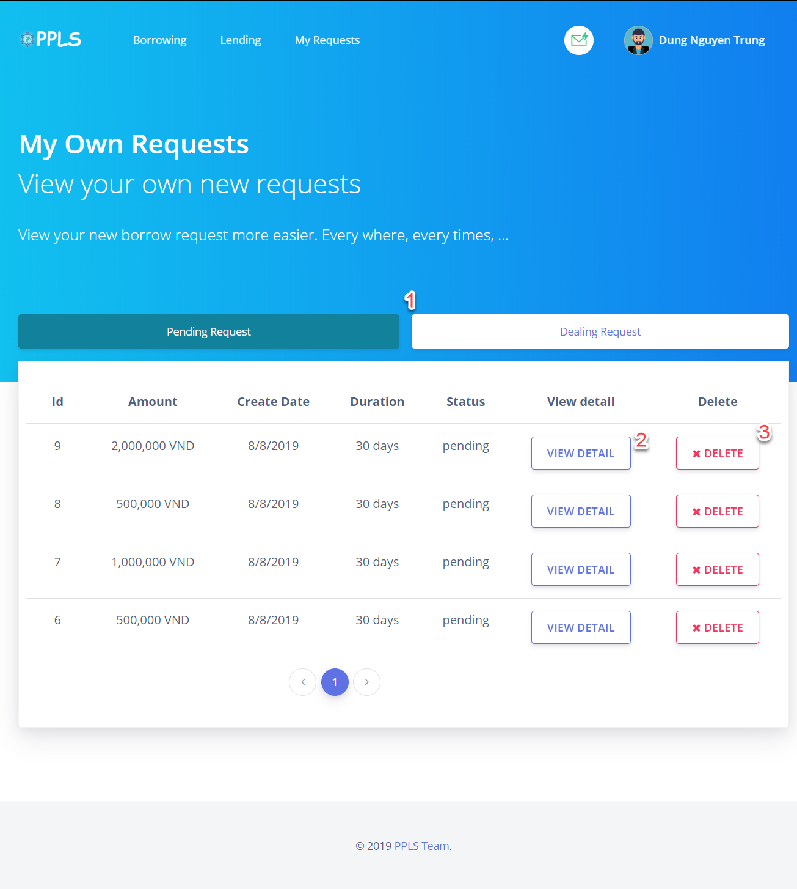

Figure 56 Own Requests

**Buttons/Hyperlinks:**

|  |  |  |  |  |
| --- | --- | --- | --- | --- |
| **No** | **Function** | **Description** | **Validation** | **Outcome** |
| **1** | RequestPending/DealingTab | Load all Pending/Dealing Requests. | N/A | Reload requests list. |
| 2 | btnViewDetail | Go to View Detail Request Page | N/A | Transfer to View Detail Request Page |
| 3 | btnDelete | Delete a request | Request with status “pending” | Delete successfully a request |

Table 72 <Buttons/Hyperlinks> Own Requests

### **Lending Requests**

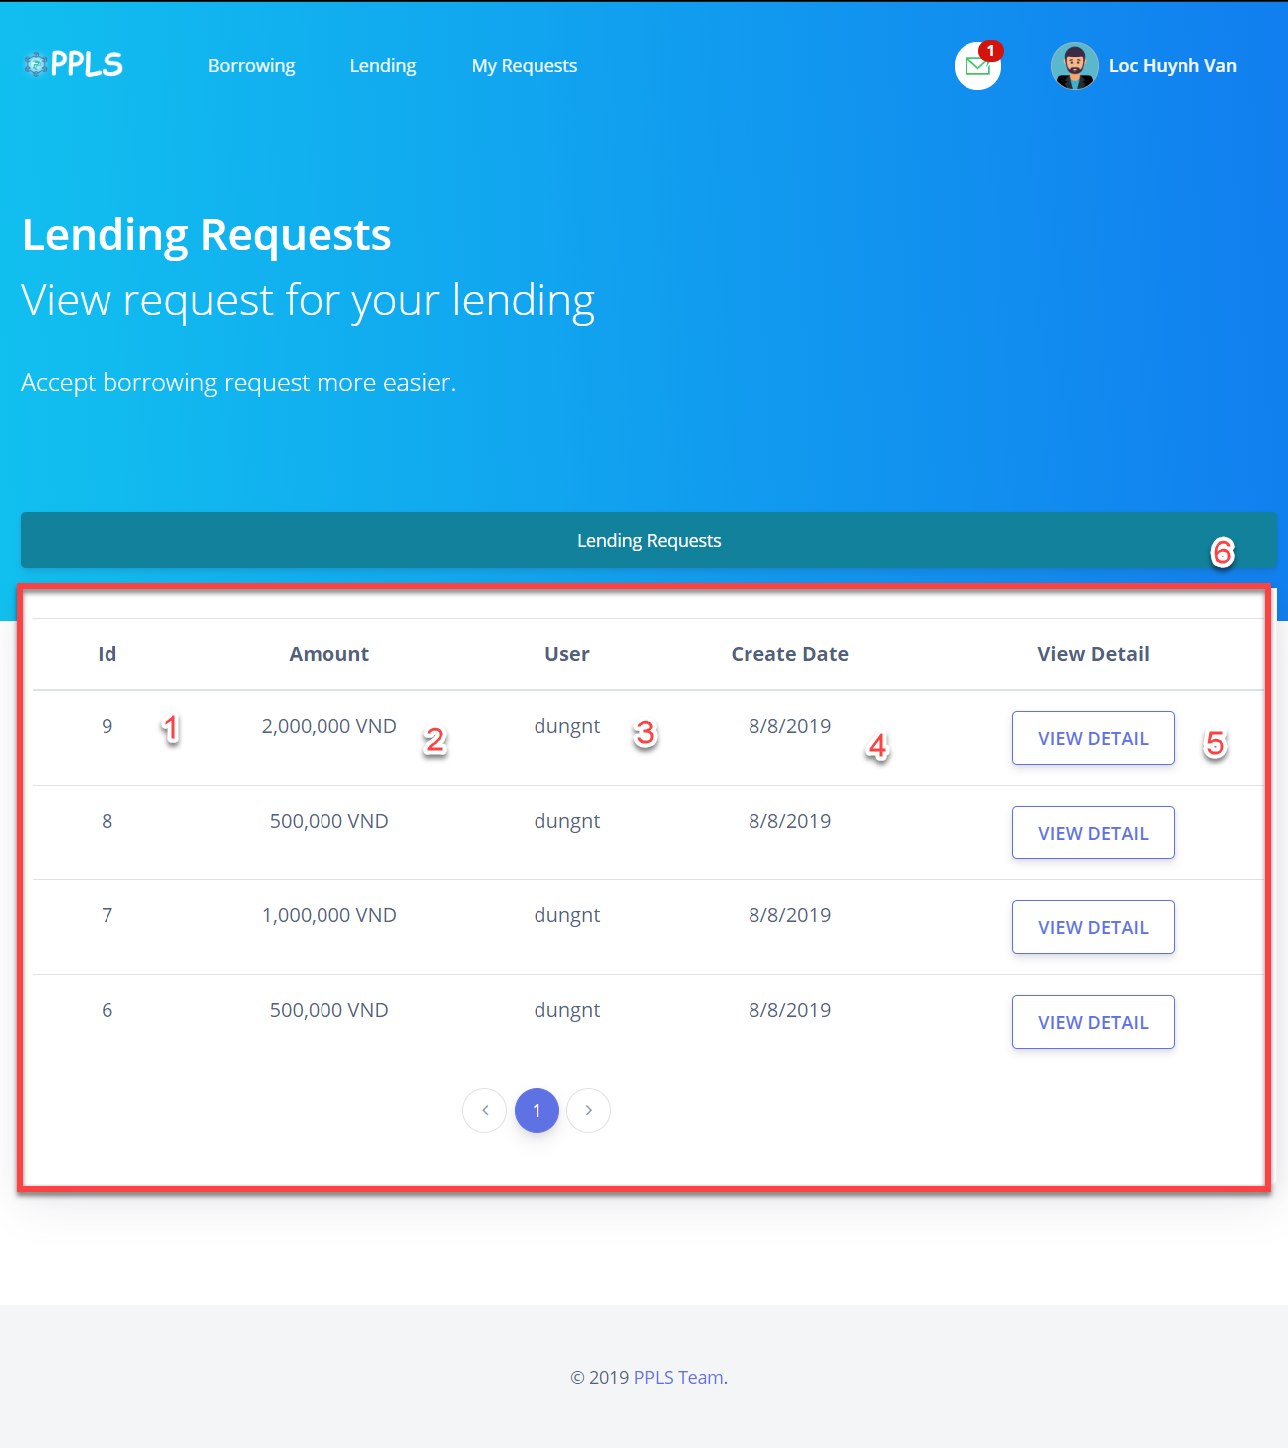

Figure 57 Lending Requests

**Fields**

|  |  |  |  |  |  |  |
| --- | --- | --- | --- | --- | --- | --- |
| **No** | **Field Name** | **Description** | **Read only** | **Mandatory** | **Control Type** | **Data Type** |
| 1 | Id | Id of request | No | Yes | Label | String |
| 2 | Amount | Amount of request | No | Yes | Label | String |
| 3 | User | User Created Request | No | Yes | Label | String |
| 4 | Create Date | Create Date of Request | No | Yes | Label | String |
| 6 | Lending Request List | List of Lending Requests | No | Yes | List | N/A |

Table 73 <Fields> Lending Requests

**Buttons/Hyperlinks:**

|  |  |  |  |  |
| --- | --- | --- | --- | --- |
| **No** | **Function** | **Description** | **Validation** | **Outcome** |
| 5 | btnViewDetail | Go to View Detail Request Page | N/A | Transfer to View Detail Request Page |

Table 74 <Buttons/Hyperlinks> Lending Requests

### **Detail Request**

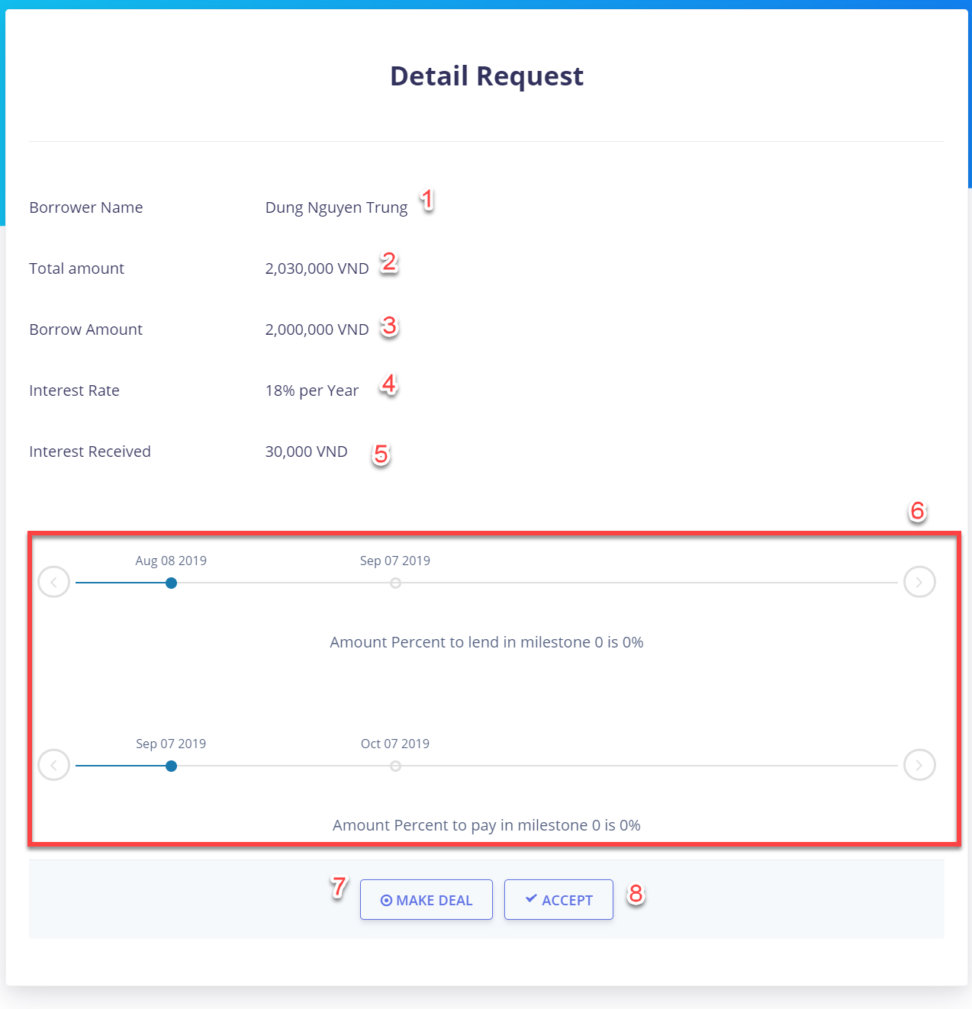

Figure 58 Detail Request (Lender)

**Fields**

|  |  |  |  |  |  |  |
| --- | --- | --- | --- | --- | --- | --- |
| **No** | **Field Name** | **Description** | **Read only** | **Mandatory** | **Control Type** | **Data Type** |
| 1 | Borrower Name | Name of Borrower | Yes | Yes | Label | String |
| 2 | Total Amount | Total amount include interest | Yes | Yes | Label | String |
| 3 | Borrow Amount | Raw borrow amount | Yes | Yes | Label | String |
| 4 | Interest Rate | Interest rate need to pay per year | Yes | Yes | Label | String |
| 5 | Interest Received | Interest for the request | Yes | Yes | Label | String |
| 6 | Timeline | Timeline for Lend and Payback | No | Yes | Label | Component |

Table 75 <Fields> Detail Request (Lender)

**Buttons/Hyperlinks:**

|  |  |  |  |  |
| --- | --- | --- | --- | --- |
| **No** | **Function** | **Description** | **Validation** | **Outcome** |
| 7 | btnMakeDeal | Make deal with borrower | N/A | Switch page into Make deal |
| 8 | btnAccept | Accept the request | N/A | Accept the request with Paypal Method |

Table 76 <Buttons/Hyperlinks> Detail Request (Lender)

### **Make Deal**

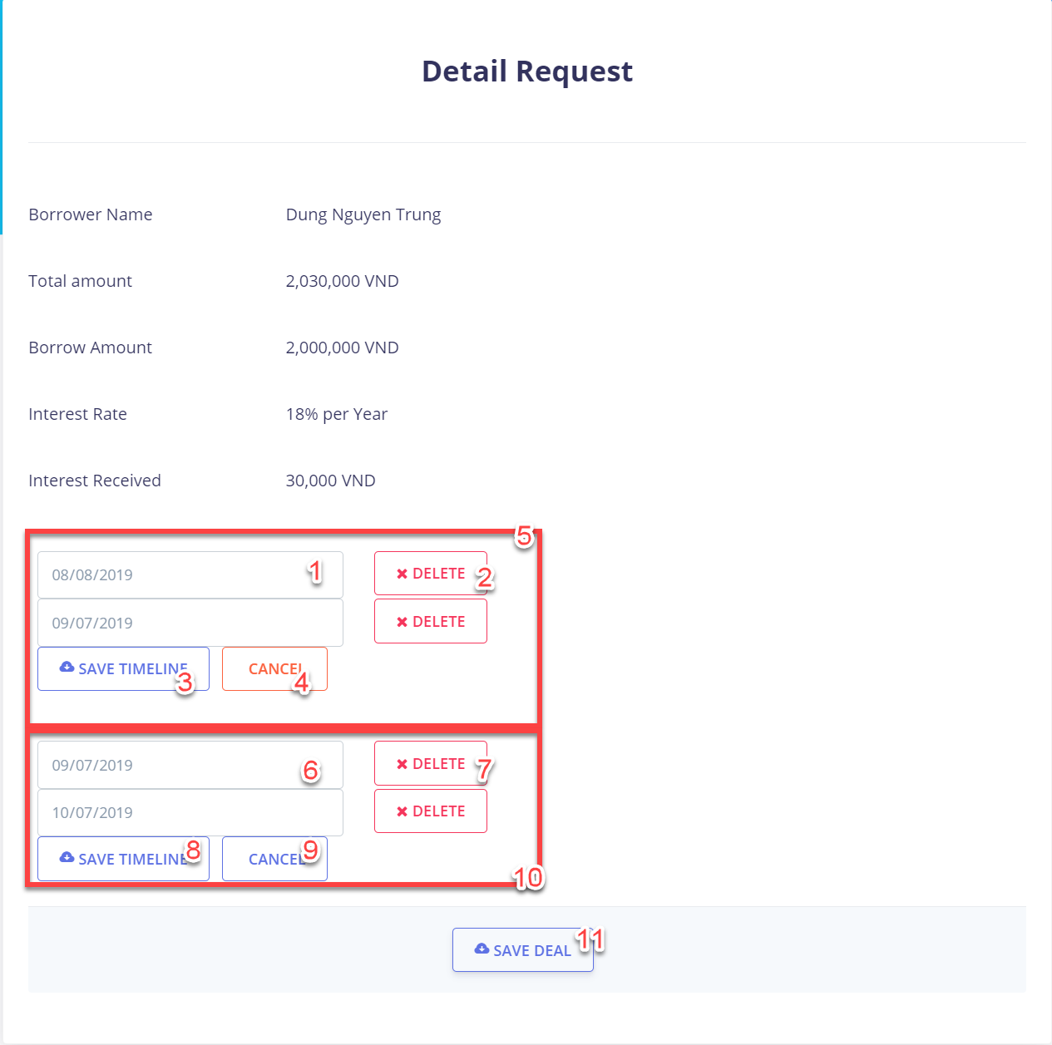

Figure 59 Make Deal (Lender)

**Fields**

|  |  |  |  |  |  |  |
| --- | --- | --- | --- | --- | --- | --- |
| **No** | **Field Name** | **Description** | **Read only** | **Mandatory** | **Control Type** | **Data Type** |
| 1 | txtLendingDate | Lending Date for create timeline | No | Yes | TextBox | Date |
| 5 | listLendingDate | List all Lending Date | No | Yes | N/A | Component |
| 6 | txtPaybackDate | Payback Date for create timeline | No | Yes | TextBox | Date |
| 10 | listPaybackDate | List all Payback Date | No | Yes | N/A | Component |

Table 77 <Fields> Make Deal (Lender)

**Buttons/Hyperlinks:**

|  |  |  |  |  |
| --- | --- | --- | --- | --- |
| **No** | **Function** | **Description** | **Validation** | **Outcome** |
| 2 | deleteLendingMilestone | Delete a lending milestone | N/A | Deleted a lending milestone |
| 3 | saveLendingTimeline | Save change lending timeline | N/A | Save changing lending timeline |
| 4 | cancelChangeLendingTL | Cancel change lending timeline | N/A | Cancel changing lending timeline |
| 7 | deletePaybackMilestone | Delete a payback milestone | N/A | Deleted a payback milestone |
| 8 | savePaybackTimeline | Save change payback timeline | N/A | Save changing payback timeline |
| 9 | cancelChangePaybackTL | Cancel change lending timeline | N/A | Cancel changing payback timeline |
| 11 | saveDeal | Save deal | N/A | Save Deal |

Table 78 <Buttons/Hyperlinks> Forgot Password

### **Do Payment**

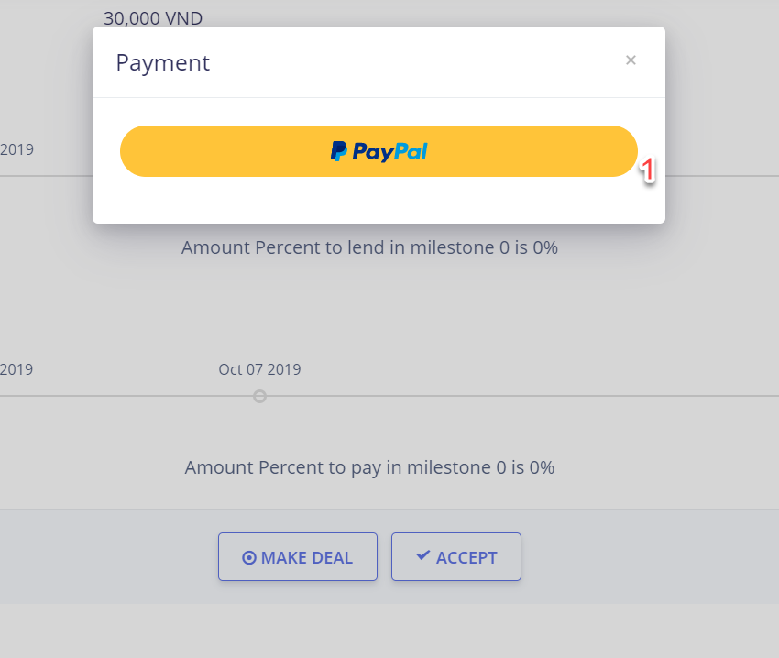

Figure 60 Do Payment

**Buttons/Hyperlinks:**

|  |  |  |  |  |
| --- | --- | --- | --- | --- |
| **No** | **Function** | **Description** | **Validation** | **Outcome** |
| 3 | doPayment | Do Payment Method with Paypal | N/A | Do payment and receive payment information |

Table 79 <Buttons/Hyperlinks> Do Payment

### **Own transactions**

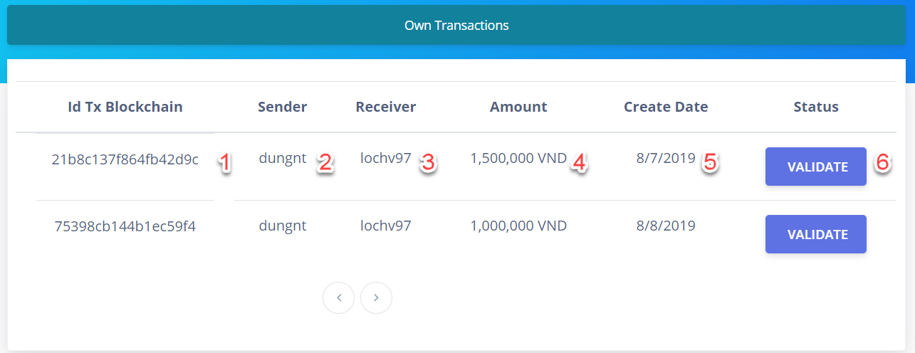

Figure 61 Own transactions

**Fields**

|  |  |  |  |  |  |  |
| --- | --- | --- | --- | --- | --- | --- |
| **No** | **Field Name** | **Description** | **Read only** | **Mandatory** | **Control Type** | **Data Type** |
| 1 | Id Tx Blockchain | Id of transaction in BigchainDB | Yes | Yes | Label | String |
| 2 | Sender | Username of sender | Yes | Yes | Label | String |
| 3 | Receiver | Username of receiver | Yes | Yes | Label | String |
| 4 | Amount | Amount of transaction | Yes | Yes | Label | String |
| 5 | Create Date | Create date of transaction | Yes | Yes | Label | Date |

Table 80 <Fields> Own transactions

**Buttons/Hyperlinks:**

|  |  |  |  |  |
| --- | --- | --- | --- | --- |
| **No** | **Function** | **Description** | **Validation** | **Outcome** |
| 6 | Validate | Check valid transaction in blockchain | N/A | Validation transaction in blockchain |

Table 81 <Buttons/Hyperlinks> Own transactions

### **Check Timeline**

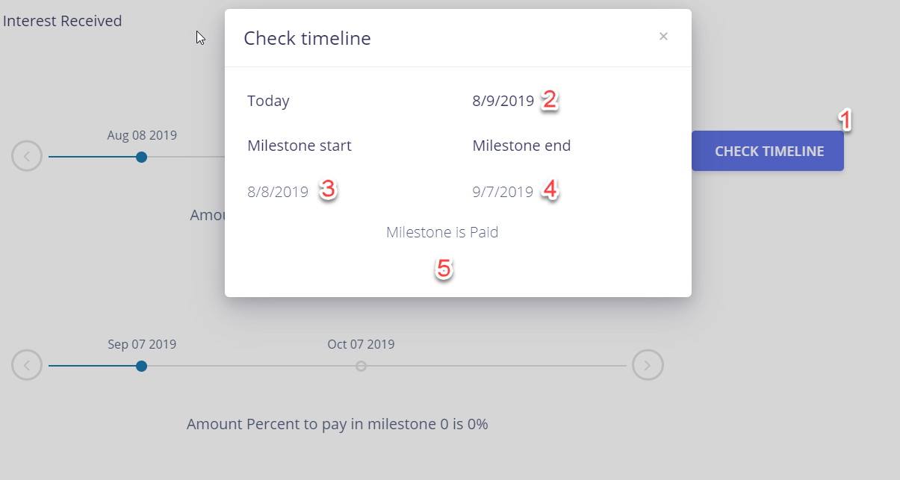

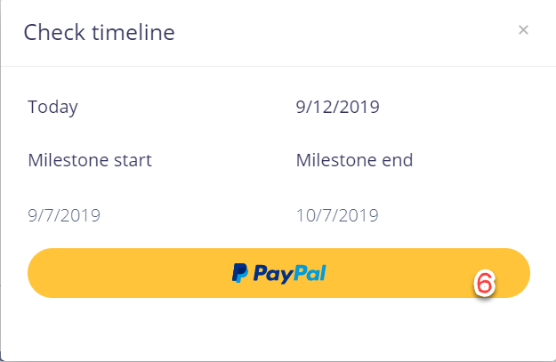

Figure 62 Check Timeline

**Fields**

|  |  |  |  |  |  |  |
| --- | --- | --- | --- | --- | --- | --- |
| **No** | **Field Name** | **Description** | **Read only** | **Mandatory** | **Control Type** | **Data Type** |
| 2 | today | Show date of today | Yes | Yes | Label | Date |
| 3 | milestoneStart | Start date of milestone | Yes | Yes | Label | Date |
| 4 | milestoneStart | End date of milestone | Yes | Yes | Label | Date |
| 5 | milestoneStatus | Status of milestone | Yes | Yes | Label | String |

Table 82 <Fields> Check Timeline

**Buttons/Hyperlinks:**

|  |  |  |  |  |
| --- | --- | --- | --- | --- |
| **No** | **Function** | **Description** | **Validation** | **Outcome** |
| 1 | checkTimeline | Check valid date in timeline | N/A | Valid date in timeline |
| 6 | doPayment | Do payment with paypal | N/A | Do payment and receive payment information |

Table 83 <Buttons/Hyperlinks> Check Timeline

### **History requests**

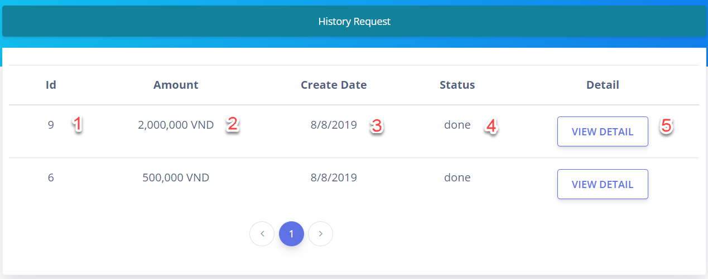

Figure 63 History Requests

**Fields**

|  |  |  |  |  |  |  |
| --- | --- | --- | --- | --- | --- | --- |
| **No** | **Field Name** | **Description** | **Read only** | **Mandatory** | **Control Type** | **Data Type** |
| 1 | Id | Id of request | Yes | Yes | Label | String |
| 2 | Amount | Amount of request | Yes | Yes | Label | String |
| 3 | Create Date | Create date of request | Yes | Yes | Label | Date |
| 4 | Status | Status of request | Yes | Yes | Label | String |

Table 84 <Fields> History Requests

**Buttons/Hyperlinks:**

|  |  |  |  |  |
| --- | --- | --- | --- | --- |
| **No** | **Function** | **Description** | **Validation** | **Outcome** |
| 5 | viewDetail | View detail of request | N/A | Transfer to View Detail Requests |

Table 85 <Buttons/Hyperlinks> History Requests

### **User Profile**

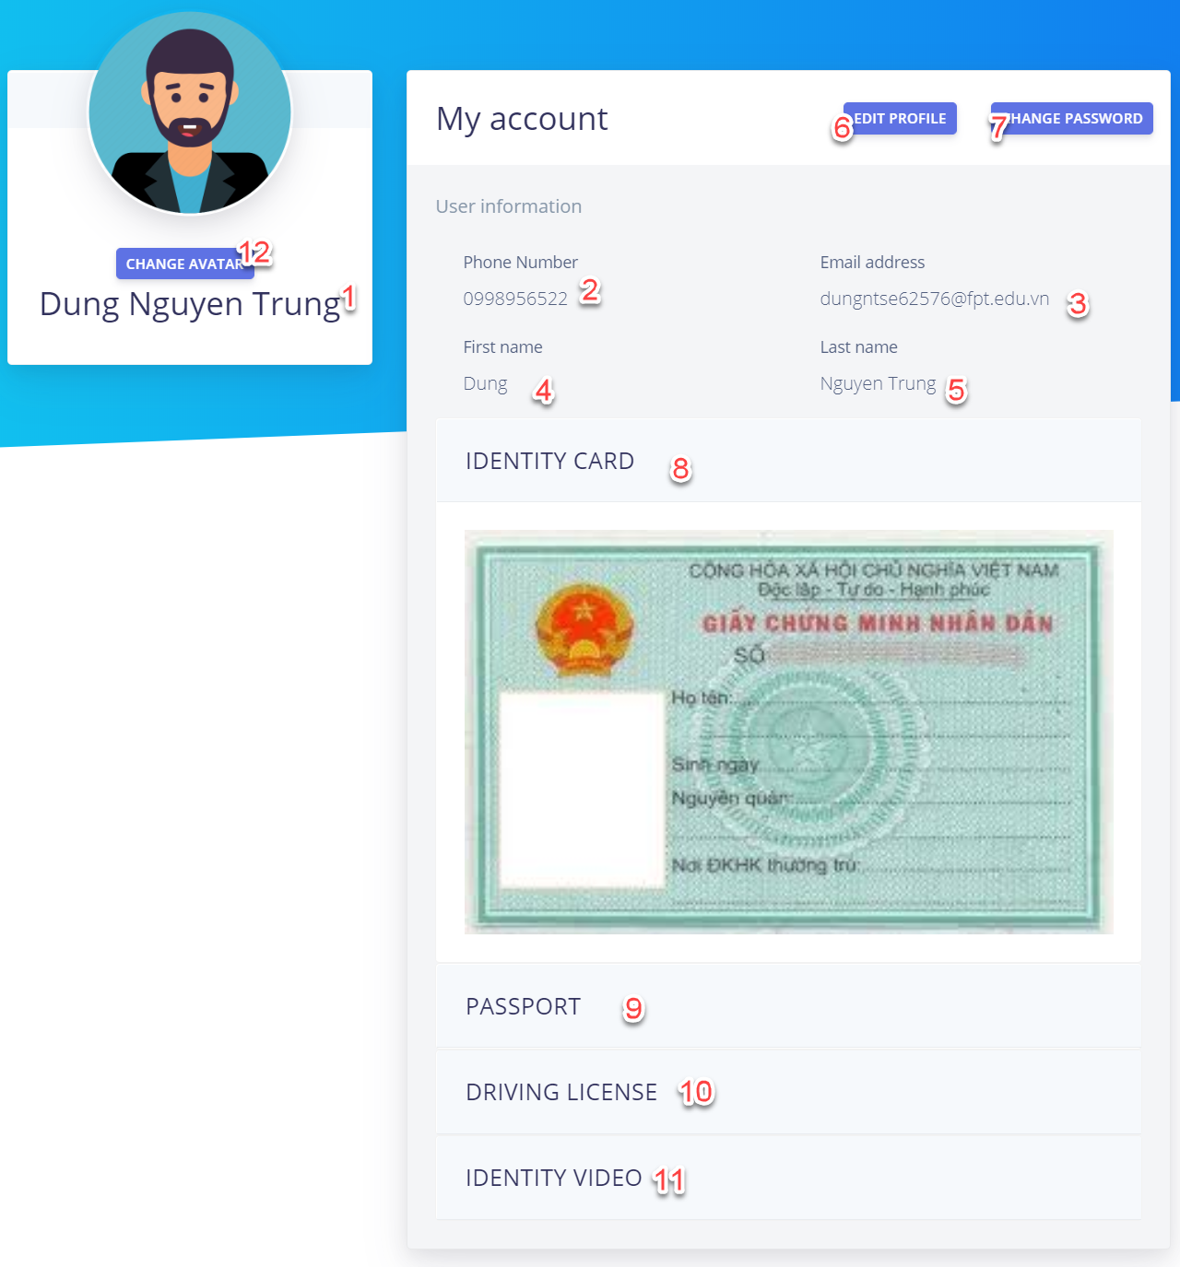

Figure 64 User Profile

**Fields**

|  |  |  |  |  |  |  |
| --- | --- | --- | --- | --- | --- | --- |
| **No** | **Field Name** | **Description** | **Read only** | **Mandatory** | **Control Type** | **Data Type** |
| 1 | Fullname | Full name of user | No | Yes | Label | String |
| 2 | Phone number | Phone number of user | No | Yes | Label | String |
| 3 | Email | Email of user | No | Yes | Label | String |
| 4 | First name | First name of user | No | Yes | Label | String |
| 5 | Last name | Last name of user | No | Yes | Label | String |

Table 86 <Fields> User Profile

**Buttons/Hyperlinks:**

|  |  |  |  |  |
| --- | --- | --- | --- | --- |
| **No** | **Function** | **Description** | **Validation** | **Outcome** |
| 6 | editProfile | Edit Profile | N/A | Show edit profile component |
| 7 | changePassword | Change Password | N/A | Show change password component |
| 8 | collapseId | Collapse to open Identity card | N/A | Open collapse of ID |
| 9 | collapsePassport | Collapse to open Passport | N/A | Open collapse of Passport |
| 10 | collapseDL | Collapse to open Driver License | N/A | Open collapse of Driver License |
| 11 | collapseVideo | Collapse to open Video | N/A | Open collapse of Video |
| 12 | changeAvatar | Change avatar of user | N/A | Change avatar |

Table 87 <Buttons/Hyperlinks> User Profile

## Admin

### **Login**

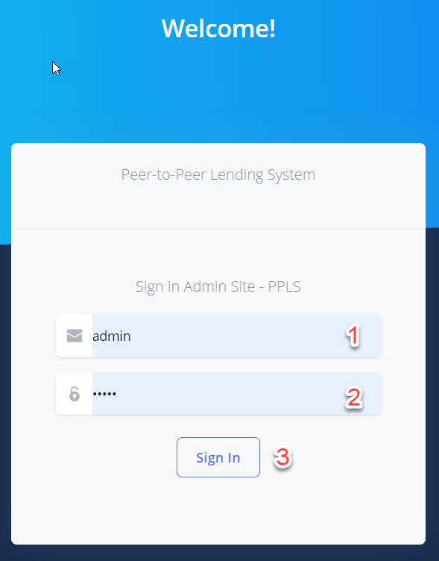

Figure 65 Login

**Fields**

|  |  |  |  |  |  |  |
| --- | --- | --- | --- | --- | --- | --- |
| **No** | **Field Name** | **Description** | **Read only** | **Mandatory** | **Control Type** | **Data Type** |
| 1 | Username | Username to login | No | Yes | TextBox | String |
| 2 | Password | Password to login | No | Yes | TextBox | String |

Table 88 <Fields> Login

**Buttons/Hyperlinks:**

|  |  |  |  |  |
| --- | --- | --- | --- | --- |
| **No** | **Function** | **Description** | **Validation** | **Outcome** |
| 3 | btnSignIn | Login into the system | Required | Transfer to Dashboard |

Table 89 <Buttons/Hyperlinks> Login

### **Manage Admin**

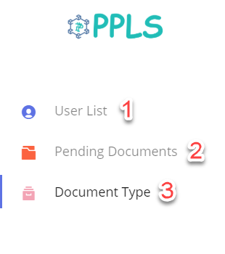

Figure 66 Manage Admin

**Buttons/Hyperlinks:**

|  |  |  |  |  |
| --- | --- | --- | --- | --- |
| **No** | **Function** | **Description** | **Validation** | **Outcome** |
| 1 | userList | View user list | N/A | Transfer to User List Page |
| 2 | pendingDocument | View list pending documents | N/A | Transfer to Pending Document Page |
| 3 | documentType | Viet list document type | N/A | Transfer to Document Type Page |

Table 90 <Fields> Manage Admin

### **Pending documents**

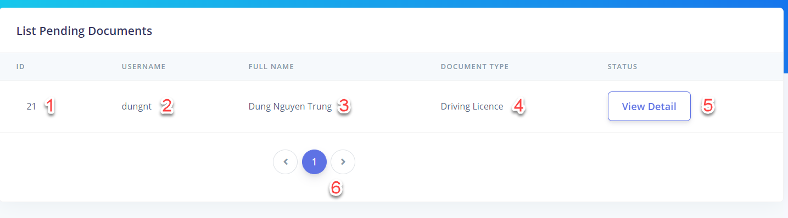

Figure 67 Pending documents

**Fields**

|  |  |  |  |  |  |  |
| --- | --- | --- | --- | --- | --- | --- |
| **No** | **Field Name** | **Description** | **Read only** | **Mandatory** | **Control Type** | **Data Type** |
| 1 | Id | Id of document | Yes | Yes | Label | String |
| 2 | Username | Username of user | Yes | Yes | Label | String |
| 3 | Fullname | Owner of document | Yes | Yes | Label | String |
| 4 | Document Type | Type of document | Yes | Yes | Label | String |

Table 91 <Fields> Pending documents

**Buttons/Hyperlinks:**

|  |  |  |  |  |
| --- | --- | --- | --- | --- |
| **No** | **Function** | **Description** | **Validation** | **Outcome** |
| 5 | viewDetailDocument | View detail document to validate | N/A | Transfer to View Detail Page |

Table 92 <Buttons/Hyperlinks> Pending documents

### **User List**

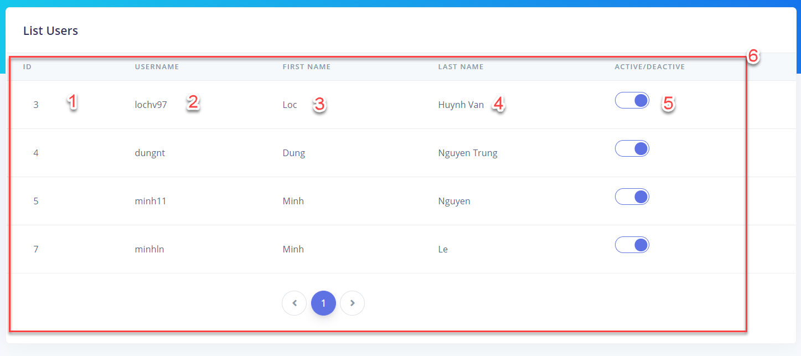

Figure 68 User List

**Fields**

|  |  |  |  |  |  |  |
| --- | --- | --- | --- | --- | --- | --- |
| **No** | **Field Name** | **Description** | **Read only** | **Mandatory** | **Control Type** | **Data Type** |
| 1 | Id | Id of user | Yes | Yes | Label | String |
| 2 | Username | User name of user | Yes | Yes | Label | String |
| 3 | First name | First name of user | Yes | Yes | Label | String |
| 4 | Last Name | Last name of user | Yes | Yes | Label | String |
| 6 | User list | List of user in the system | Yes | Yes | List | N/A |

Table 93 <Fields> User List

**Buttons/Hyperlinks:**

|  |  |  |  |  |
| --- | --- | --- | --- | --- |
| **No** | **Function** | **Description** | **Validation** | **Outcome** |
| 3 | switchStatus | Change status active of user | Required | Status of user change |

Table 94 <Buttons/Hyperlinks> User List

### **Document detail**

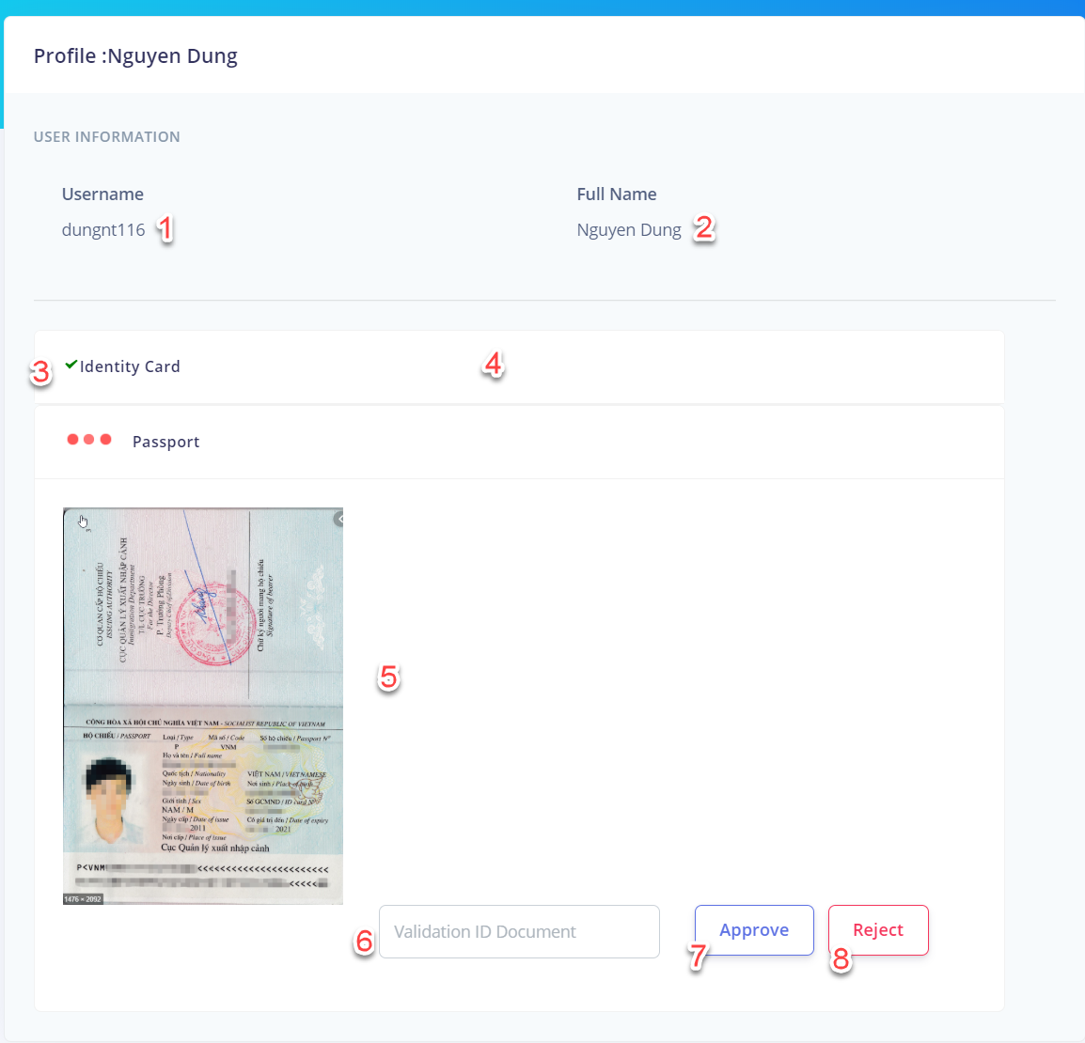

Figure 69 Document Detail

**Fields**

|  |  |  |  |  |  |  |
| --- | --- | --- | --- | --- | --- | --- |
| **No** | **Field Name** | **Description** | **Read only** | **Mandatory** | **Control Type** | **Data Type** |
| 1 | Username | Username of user | Yes | Yes | Label | String |
| 2 | Full name | Full name of user | Yes | Yes | Label | String |
| 3 | Status Document | Status of document | Yes | Yes | Icon | N/A |
| 5 | Document Picture | Picture of document | Yes | Yes | Img | Image |
| 6 | Validation Id Document | Validation Id field for admin valid document | No | Yes | TextBox | String |

Table 95 <Fields> Document Detail

**Buttons/Hyperlinks:**

|  |  |  |  |  |
| --- | --- | --- | --- | --- |
| **No** | **Function** | **Description** | **Validation** | **Outcome** |
| 4 | openCollapse | Open collapse to show document | N/A | View document in the collapse |
| 7 | approveDocument | Approve document | Confirm before approve document | Document is approved |
| 8 | rejectDocument | Reject document | Confirm before reject document | Document is rejected |

Table 96 <Buttons/Hyperlinks> Document Detail

### **List document type**

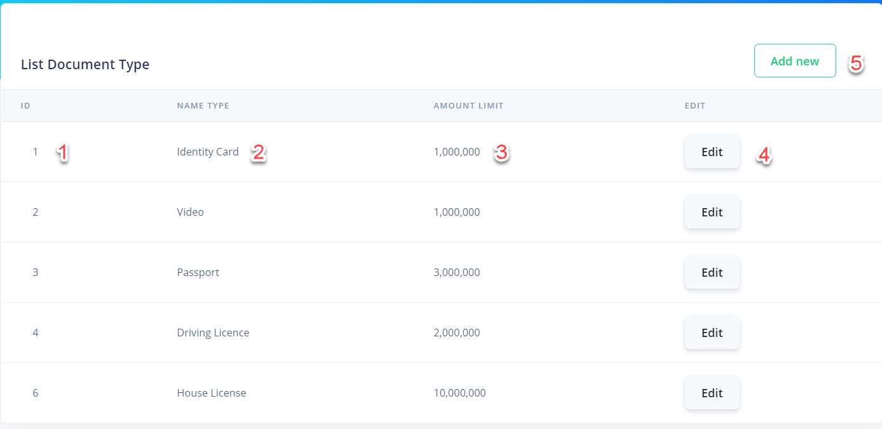

Figure 70 List document type

**Fields**

|  |  |  |  |  |  |  |
| --- | --- | --- | --- | --- | --- | --- |
| **No** | **Field Name** | **Description** | **Read only** | **Mandatory** | **Control Type** | **Data Type** |
| 1 | Id | Id of document | Yes | Yes | Label | String |
| 2 | Name Type | Type of document | Yes | Yes | Label | String |
| 3 | Amount Limit | Amount limit for each document | Yes | Yes | Label | String |

Table 97 <Fields> List document type

**Buttons/Hyperlinks:**

|  |  |  |  |  |
| --- | --- | --- | --- | --- |
| **No** | **Function** | **Description** | **Validation** | **Outcome** |
| 4 | editDocument | Edit information of document | N/A | Open pop-up to edit document |
| 5 | addNewDocument | Add new document | N/A | Open pop-up to add new document |

Table 98 <Buttons/Hyperlinks> List document type

### **Edit document type**

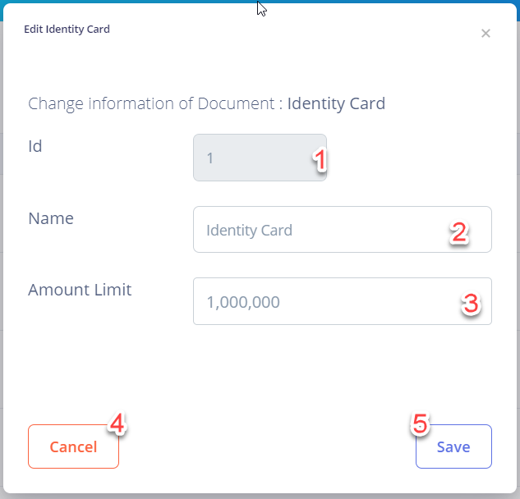

Figure 71 Edit document type

**Fields**

|  |  |  |  |  |  |  |
| --- | --- | --- | --- | --- | --- | --- |
| **No** | **Field Name** | **Description** | **Read only** | **Mandatory** | **Control Type** | **Data Type** |
| 1 | Id | Id of document | Yes | Yes | TextBox | String |
| 2 | Name | Name of document | No | Yes | TextBox | String |
| 3 | Amount Limit | Amount limit of document | No | Yes | TextBox | String |

Table 99 <Fields> Edit document type

**Buttons/Hyperlinks:**

|  |  |  |  |  |
| --- | --- | --- | --- | --- |
| **No** | **Function** | **Description** | **Validation** | **Outcome** |
| 4 | Cancel | Cancel edit document type | N/A | Cancel edit |
| 5 | Save | Save document type information | N/A | Save document type |

Table 100 <Buttons/Hyperlinks> Edit document type

### **Add new document type**

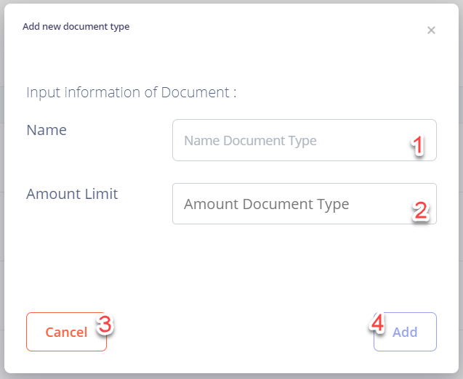

Figure 72 Add new document type

**Fields**

|  |  |  |  |  |  |  |
| --- | --- | --- | --- | --- | --- | --- |
| **No** | **Field Name** | **Description** | **Read only** | **Mandatory** | **Control Type** | **Data Type** |
| 1 | Name | Name of document type | No | Yes | TextBox | String |
| 2 | Amount Limit | Amount limit of document type | No | Yes | TextBox | String |

Table 101 <Fields> Add new document type

**Buttons/Hyperlinks:**

|  |  |  |  |  |
| --- | --- | --- | --- | --- |
| **No** | **Function** | **Description** | **Validation** | **Outcome** |
| 3 | Cancel | Cancel add new document type | N/A | Cancel add |
| 4 | addNewDocumentType | Add new document type | N/A | Add new document type |

Table 102 <Buttons/Hyperlinks> Add new document type

## Database Design

## Entity relationship diagram (ERD)

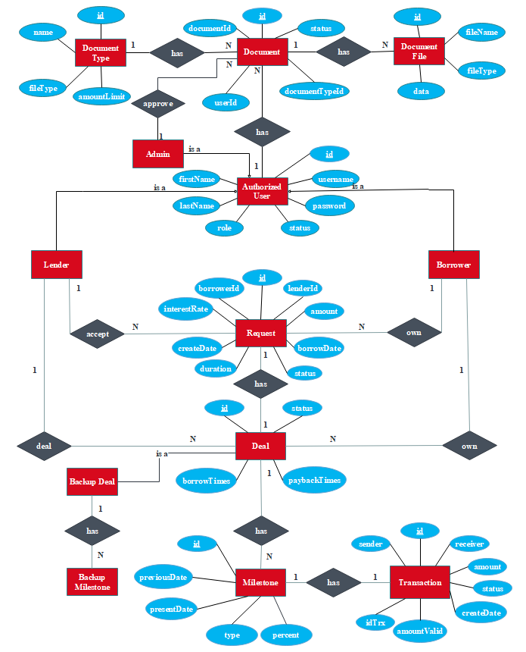

Figure 73 Entity Relationship Diagram

## Entity Data Dictionary

|  |  |
| --- | --- |
| Entity Data Dictionary: describe content of all entities | |
| Entity name | Description |
| Authorized User | Contains the authorized user’s information. |
| Admin | Contains the admin’s information. |
| Lender | Contains the lender’s information. |
| Borrower | Contains the borrower’s information |
| Request | Contains the request’s information. |
| Deal | Contains the deal’s information. |
| Backup Deal | Contains the backup deal’s information. |
| Milestone | Contains the milestone’s information. |
| Backup Milestone | Contains the backup milestone’s information |
| Transaction | Contains the transaction’s information. |
| Document | Contains the document’s information |
| Document Type | Contains the document type’s information. |
| Document File | Contains the document file’s information. |

Table 103 Entity Relationship Diagram Dictionary

|  |  |  |  |  |
| --- | --- | --- | --- | --- |
| Entity Name | Attributes | Description | Domain | Null |
| user | id | Id of user’s account | INT(11) | NO |
| username | User name of user’s account | VARCHAR(255 | NO |
| password | Password of user’s account | VARCHAR(255) | NO |
| firstName | First name of user’s account | VARCHAR(255) | NO |
| lastName | Last name of user’s account | VARCHAR(255) | NO |
| role | Role of user’s account | VARCHAR(255) | NO |
| loanLimit | Loan limit of user’s account | BIGINT(20) | NO |
| status | Status of user’s account | VARCHAR(255) | NO |
| phoneNumber | Phone number of user | VARCHAR(255) | NO |
| email | Email of user | VARCHAR(255) | NO |
| request | id | Id of request | INT(11) | NO |
| amount | Amount of a loan request | VARCHAR(255) | NO |
| borrowDate | Borrow date of a request | BIGINT(20) | YES |
| interestRate | Request's interest rate | BIGINT(20) | NO |
| createDate | Date when request created | BIGINT(20) | NO |
| status | Status's request | VARCHAR(255) | NO |
| deal | id | Id of deal | INT(11) | NO |
| status | Deal’s status | VARCHAR(255) | NO |
| borrowTimes | Number of borrow time | VARCHAR(255) | NO |
| paybackTimes | Number of payback time | VARCHAR(255) | NO |
| milestone | id | Id of milestone | INT(11) | NO |
| previousDate | Date of previous milestone | BIGINT(20) | NO |
| presentDate | Date of present milestone | BIGINT(20) | NO |
| type | Milestone’s type | VARCHAR(255) | NO |
| percent | Milestone's percent | FLOAT | NO |
| transaction | id | Id of transaction | INT(11) | NO |
| sender | Sender’s username | BIGINT(20) | NO |
| receiver | Receiver user’s name | VARCHAR(255) | NO |
| idTrx | Id of transaction on blockchain | VARCHAR(255) | NO |
| amountValid | To valid the money make | DOUBLE | NO |
| amount | Amount of money send | DOUBLE | NO |
| status | Status of the transaction | VARCHAR(255) | NO |
| createDate | Transaction's create date | BIGINT(20) | NO |
| backupDeal | id | Id of backup deal | INT(11) | NO |
| status | Status of backup deal | VARCHAR(255) | NO |
| borrowTimes | Backup borrow times | INT(11) | NO |
| paybackTimes | Backup payback times | INT(11) | NO |
| backupMilestone | id | Id of backup milestone | INT(11) | NO |
| presentDate | Backup present date of milestone | BIGINT(20) | NO |
| previousDate | Backup previous date of milestone | BIGINT(20) | NO |
| type | Milestone type’s backup | VARCHAR(255) | NO |
| percent | Milestone’s percent backup | FLOAT | NO |
| document | id | Id of  document | INT(11) | NO |
| documentId | Id on the document user upload | VARCHAR(255) | NO |
| status | Status of the document | VARCHAR(255) | NO |
| documentFile | id | Id of document file | INT(11) | NO |
| fileName | Name of the file | VARCHAR(255) | NO |
| fileType | Type of the file | VARCHAR(255) | NO |
| data | Date of file to store | LONGBLOB | NO |
| documentType | id | If of the document type | INT(11) | NO |
| name | Name of document type | VARCHAR(255) | NO |
| amountLimit | Amount to gain when complete document | BIGINT(20) | NO |

Table 104 ERD Data Dictionary

## Algorithms

### **7.1 Record Transaction**

#### 7.1.1 Definition

Record transaction is the mechanism to save transaction to blockchain database.

#### 7.1.2 Define problem

In order to provide proof of ownership, the transaction must be saved as an immutable record to blockchain database.

#### 7.1.3 Solution

BigchainDB, which is a scalable blockchain database designed to combine the blockchain properties and distributed database, is used in this system for fulfilling business corresponding to ledger. It offers a full decentralization and Byzantine Fault Tolerance, immutability and native assets that allows for the deployment of large-scale applications in a variety of use cases and industries including intellectual property.

The transaction is created as a BigchainDB’s transaction with the unique key and transaction containing information of transaction including txId, sender, receiver, amount,… this transaction is cryptographically signed by the one time key pair and written to the BigchainDB storage after it is verified as a valid transaction.

#### 7.1.4 Example

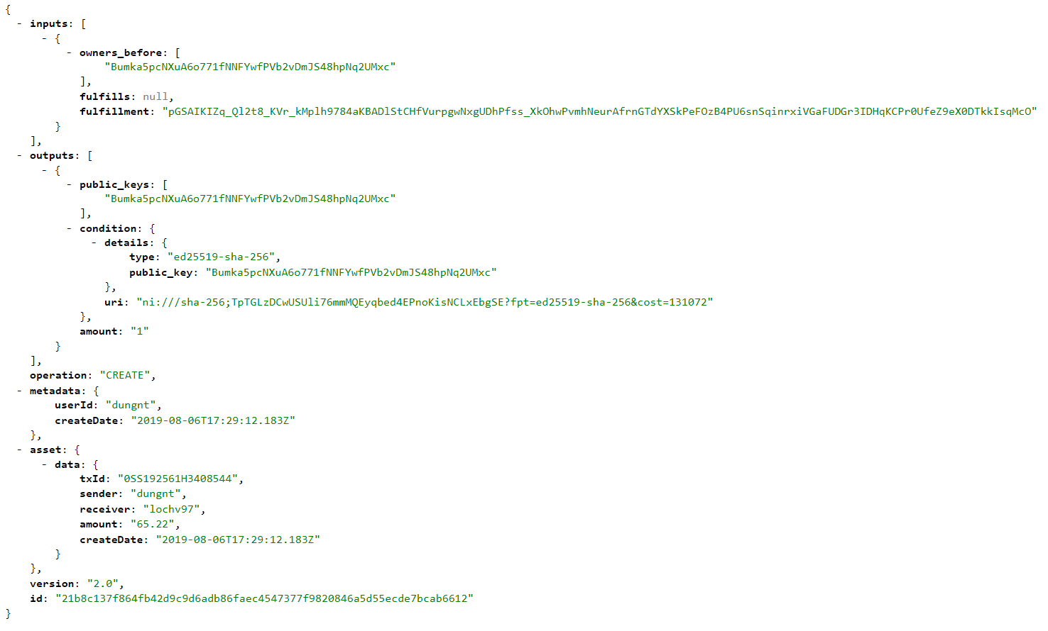

Figure 74. Example of BigchainDB transaction

### **7.2 Interest lending**

#### 7.2.1 Definition

Interest lending is a method that calculate the interest of a borrowing request.

#### 7.2.2 Define problem

Each transaction needs the consent of both parties, so that interest rates will make lenders' interests more clear.

#### 7.2.3 Solution

We use the formula below to calculate the article rank score:

$$\frac{a*\frac{l-f}{ts*30}*(\frac{ir}{12})}{100}$$

a : amount of the request

l : last milestone of the timeline(in timestamp)

f : first milestone of the timeline (in timestamp)

ts: amount of seconds in a day (86400 seconds)

ir: interest rate of the range timeline, default is 18% /year

#### 7.2.4 Example

A range timeline has amount 1.000.000 VNĐ, first milestone in timestamp is

#### 7.2.5 Complexity

The Complexity is: O(1)

### **7.3 Lending/Payback**

#### 7.3.1 Definition

Lending/Payback is the mechanism used in our system to define the payment and notify to user.

#### 7.3.2 Define problem

#### Lender or borrower need to know the due date and the amount that they need to pay for the deal. However, nobody can remember all the due date whenever the large amount of lending/borrowing requests.

#### 7.3.3 Solution

The following steps define the stage of lending/payback process:

* 1. Due date is nearly reach, system will notify to the lender or borrower through email and notification on navigation bar.
  2. Lender/Borrower login into their account and check the notification, Lender/Borrower view directly request which have the milestone need to pay, then, they need to check timeline for paying the milestone.
  3. The transaction after done processing payment will be sent to BigchainDB Driver.
  4. The transaction will be prepared and signed, then, the BigchainDB transaction’s information after being stored will be sent to system.
  5. System will send the notification after transaction done.

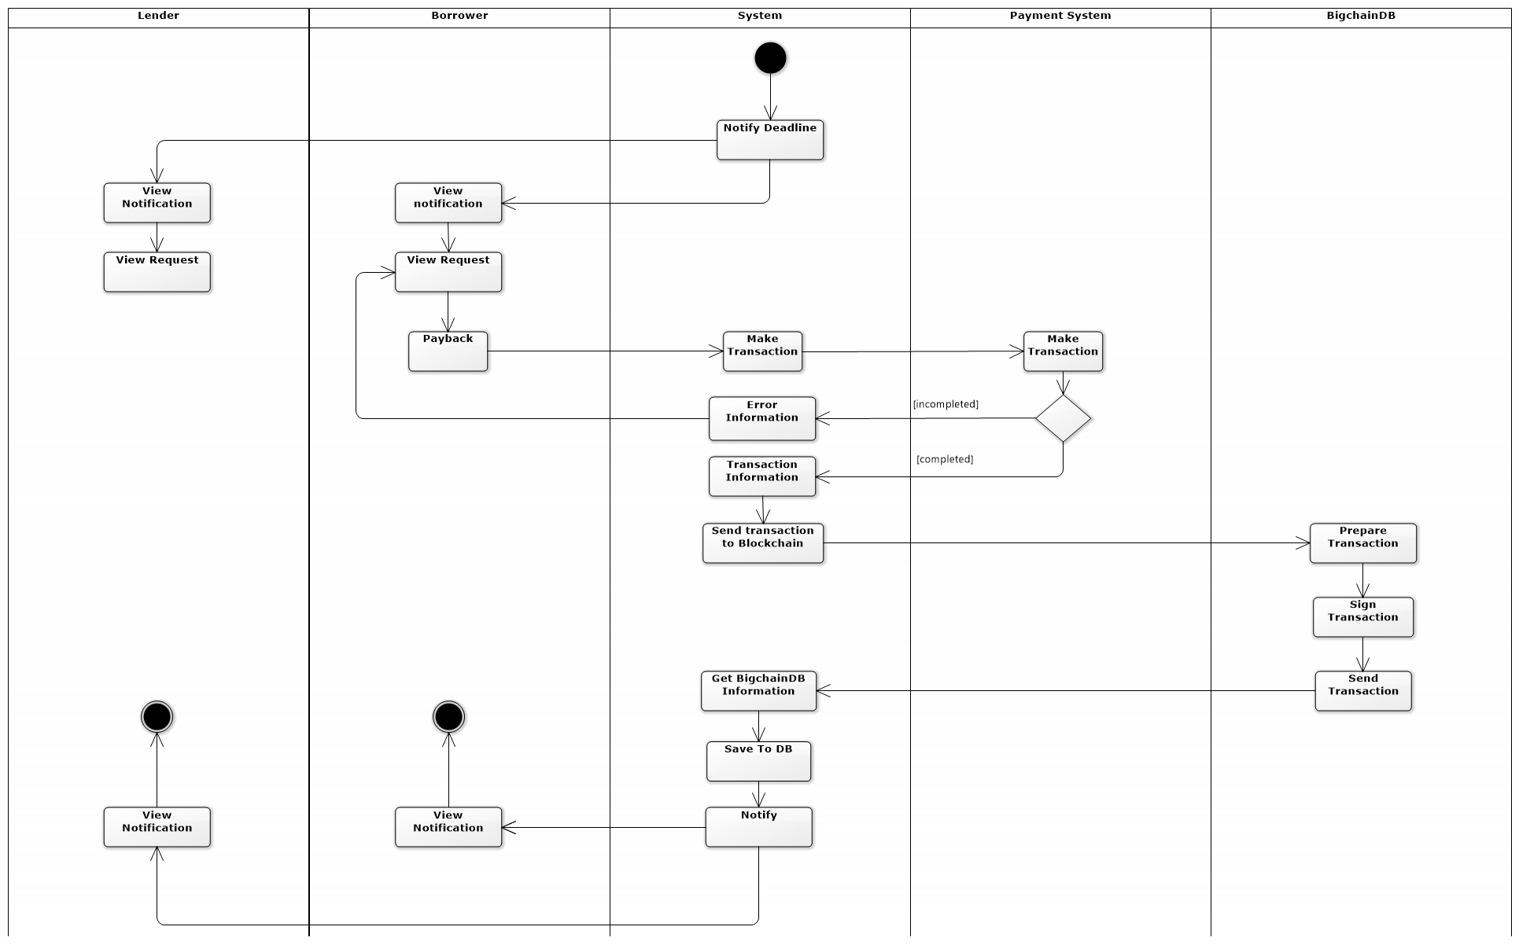

Figure 75– Lending/Payback process

# System Implementation & Test

## Introduction

* 1. **Overview**

This section describes approach and methodologies used by our team to plan, organize and manage testing process of PPLS.

It provides all necessary information about implementation and testing procedure of the system including test plans, test cases, test results and pass/fail criteria as well as testing flow to cover all possible cases.

* 1. **Test Approach**
* **Goal:** Test main features in the whole PPLS based on core flow
* **Method:** Black-box testing

## Data Relationship Diagram

### **Physical diagram**

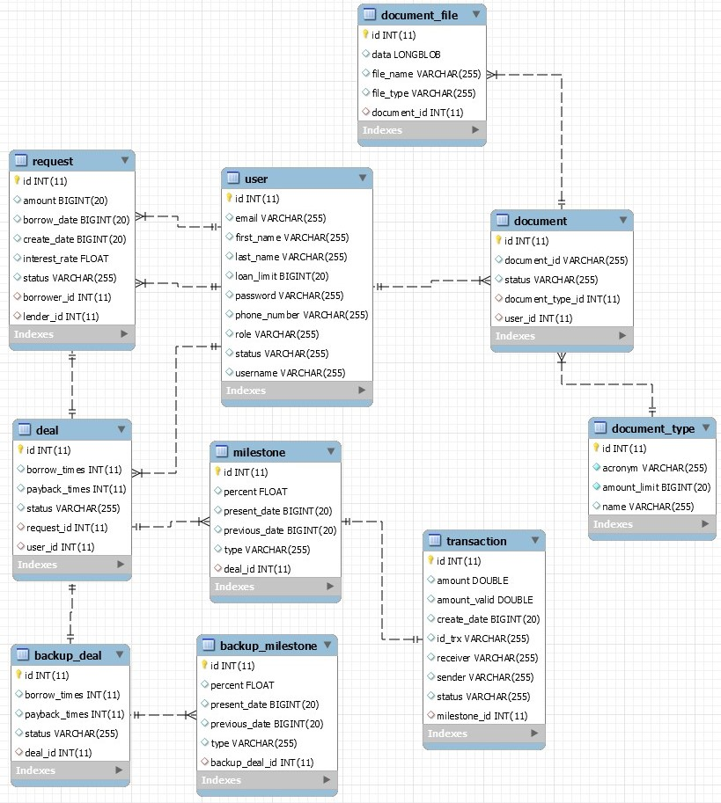

Figure 76 Physical Diagram

### **2.2 Data dictionary**

|  |  |  |
| --- | --- | --- |
| **Entity Data Dictionary: Describe content of all tables** | | |
| **No.** | **Table Name** | **Description** |
| 1 | user | Contain account information. |
| 2 | request | Contain request information. |
| 3 | deal | Contain deal information of a request. |
| 4 | milestone | Contain all the milestone of a deal |
| 5 | transaction | Contain all transaction made. |
| 6 | Backup deal | Contain backup version of the original first deal. |
| 7 | Backup milestone | Contain backup version of the original first milestone of the deal. |
| 8 | document | Contain all user document for validation. |
| 9 | Document file | Contain document file. |
| 10 | Document_type | Contain type of a document and amount of money gain when completed it |

Table 104 Physical Diagram Dictionary

## Test Plan

The overall purpose of testing is to ensure WCS meets its entire technical, functional and business requirement. The purpose of this document is to describe the test plan and strategy for testing the WCS. The following part will describe which features to be tested and which will not.

## Features To Be Tested

* Guest:
* Valid transaction
* Forgot password
* Authorized User:
* View request
* Accept request
* Make deal
* Create request
* Valid transaction
* My Profile
* Admin:
* List User
* Pending document
* List document type

## Features Not To Be Tested

* Guest: Login, sign up.
* Authorized User: Logout

## System Testing Test Case

***4.1 Guest Test Case  
 4.1.1 Valid transaction***

|  |  |  |  |  |  |  |  |
| --- | --- | --- | --- | --- | --- | --- | --- |
| ID | Test Case Description | Test case procedure | Expected output | *Inter Dependence -test Case* | Result | Test Date | Note |
| *VT_1* | Guest check validate transaction in homepage. | 1. Guest go to home page.  2. Click on validate button. | System shows valid message:   * Check Sender * Check Receiver * Check Amount * Check Create Date   After that system show:   * ID Transaction * Status | N/A | Pass | 09/08/2019 |  |
| *VT_2* | Guest view list transaction in homepage. | 1. Guest go to homepage | System show list of transaction | N/A | Pass | 09/08/2019 |  |

Table 105 <Test case> Valid transaction

***4.1.2 Forgot password***

|  |  |  |  |  |  |  |  |
| --- | --- | --- | --- | --- | --- | --- | --- |
| ID | Test Case Description | Test case procedure | Expected output | *Inter Dependence -test Case* | Result | Test Date | Note |
| *FP_1* | Guest click on forgot password. | 1. Guest click on forgot password.  2. Guest input username.  3. Guest input email.  4. Guest click on “Send" button. | System show success message and guest receive a mail. | N/A | Pass | 09/08/2019 |  |

Table 106<Test case> Forgot password

***4.2 Authorized User Test Case***  
***4.2.1 View request***

|  |  |  |  |  |  |  |  |  |
| --- | --- | --- | --- | --- | --- | --- | --- | --- |
| ID | Test Case Description | Test case procedure | Expected output | *Inter Dependence -test Case* | Result | Test Date | Note | |
| *VR_1* | Authorized user go to lending request page. | 1. Authorized user click on “Lending Requests”. | System shows list request of the other users | N/A | Pass | 09/08/2019 |  | |
| *VR_2* | Authorized user go to own request page. | 1. Authorized user click on “Own Requests”. | System show own request page with two tabs:   * Pending request   (List pending request)   * Dealing request   (List dealing request) | N/A | Pass | 09/08/2019 |  | |
| *VR_3* | Authorized user go to trading request page. | 1. Authorized user click on “Trading  Requests”. | System show trading request page with two tabs:   * Borrow   (List borrow request)   * Lend   (List lend request) | N/A | Pass | 09/08/2019 |  | |
| *VR_4* | Authorized user go to history request page. | 1. Authorized user click on “History  Requests”. | System show list of history request | N/A | Pass | 09/08/2019 |  | |
| *VR_5* | Authorized user go to own transaction page. | 1. Authorized user click on “Own  Transaction”. | System show list of current user’s transaction | N/A | Pass | 09/08/2019 |  |

Table 107 <Test case> View request

***4.2.2 Accept request***

|  |  |  |  |  |  |  |  |
| --- | --- | --- | --- | --- | --- | --- | --- |
| ID | Test Case Description | Test case procedure | Expected output | *Inter Dependence -test Case* | Result | Test Date | Note |
| *AR_1* | Authorized user accept the other user request | 1. Authorized user click on “Lending Requests”.  2. Authorized user click on “View Detail” of any request.  3. Authorized user click on “Accept” button .  4. Authorized user click on “paypal” button .  5. Authorized user login to their paypal account.  6. Authorized user click on “pay now” button. | 1. System shows list request of the other users.  2. System shows detail of request:   * Borrower Name * Total amount * Borrow amount * Interested Rate * Interested Receive * Lending timeline * Payback timeline * Make deal(button) * Accept(button)   3. System shows modal with “paypal” button.  4. Paypal show login modal.  5. Paypal shows payment page.  6. System hide modal paypal in step 3, show success modal and redirect to trading request page. | N/A | Pass | 09/08/2019 |  |

Table 108 <Test case> Accept request

***4.2.3 Make deal***

|  |  |  |  |  |  |  |  |
| --- | --- | --- | --- | --- | --- | --- | --- |
| ID | Test Case Description | Test case procedure | Expected output | *Inter Dependence -test Case* | Result | Test Date | Note |
| *MD_1* | Authorized user make deal to the request | 1. Authorized user click on “Lending Requests”.  2. Authorized user click on “View Detail” of any request.  3. Authorized user click on “make deal”.  (lend one, payback one)  4. Authorized user click on “change timeline lending”.  5. Authorized user change time of milestone (valid day).  6. Authorized user click “save timeline”.  7. Authorized user click “save deal”. | 1. System shows list request of the other users.  2. System shows detail of request:   * Borrower Name * Total amount * Borrow amount * Interested Rate * Interested Receive * Lending timeline * Payback timeline * Make deal(button) * Accept(button)   3. If timeline have more than two milestone, type lending timeline is “Lend one” else type lending timeline is “Lend many”.  4. System show the same number of input as number of milestone and 3 button include:   * Delete (button) * Save timeline (button) * Cancel (button)   6. System show timeline with day is edited.  7. System save deal to database and notify to owner deal. | N/A | Pass | 09/08/2019 |  |
| *MD_2* | Authorized user make deal to the request | 1. Authorized user click on “Lending Requests”.  2. Authorized user click on “View Detail” of any request.  3. Authorized user click on “make deal”.  (lend many, payback many)  4. Authorized user click on “change timeline lending”.  5. Authorized user add milestone (valid day).  6. Authorized user click “save timeline”.  7. Authorized user click “save deal”. | 1. System shows list request of the other users.  2. System shows detail of request:   * Borrower Name * Total amount * Borrow amount * Interested Rate * Interested Receive * Lending timeline * Payback timeline * Make deal(button) * Accept(button)   3. If timeline have more than two milestone, type lending timeline is “Lend one” else type lending timeline is “Lend many”.  4. System show the same number of input as number of milestone and 3 button include:   * Delete (button) * Save timeline (button) * Cancel (button)   6. System show timeline with new milestone.  7. System save deal to database and notify to owner deal. | N/A | Pass | 09/08/2019 |  |
| *MD_3* | Authorized user make deal to the request | 1. Authorized user click on “Lending Requests”.  2. Authorized user click on “View Detail” of any request.  3. Authorized user click on “make deal”.  (lend one, payback one)  4. Authorized user click on “change timeline lending”.  5. Authorized user edit milestone (second milestone day is smaller than first milestone day).  6. Authorized user click “save timeline”.  7. Authorized user click “save deal”. | 1. System shows list request of the other users.  2. System shows detail of request:   * Borrower Name * Total amount * Borrow amount * Interested Rate * Interested Receive * Lending timeline * Payback timeline * Make deal(button) * Accept(button)   3. If timeline have more than two milestone, type lending timeline is “Lend one” else type lending timeline is “Lend many”.  4. System show the same number of input as number of milestone and 3 button include:   * Delete (button) * Save timeline (button) * Cancel (button)   6. System show timeline with milestone is edited and rearrange the data properly.  7. System save deal to database and notify to owner deal. | N/A | Pass | 09/08/2019 |  |
| *MD_4* | Authorized user make deal to the request again (mean that the other user create new deal after receive a deal) | 1. Authorized user click on “Own Requests”.  2. Authorized user click on “Dealing Request” tab.  3. Authorized user click on “View Detail” of any request.  4. Authorized user click on “make deal”.  (lend one, payback one)  5. Authorized user click on “change timeline lending”.  6. Authorized user edit milestone (second milestone day is smaller than first milestone day).  7. Authorized user click “save timeline”.  8. Authorized user click “save deal”. | 1. System shows own request page with 2 tabs:   * Pending request * Dealing request   2. System shows list dealing request :   * ID * Amount * Create Date * View Detail (button) * Cancel (button)   3. System shows detail of request:   * Borrower Name * Total amount * Borrow amount * Interested Rate * Interested Receive * Lending timeline * Payback timeline * Make deal(button) * Accept(button)   4. If timeline have more than two milestone, type lending timeline is “Lend one” else type lending timeline is “Lend many”.  5. System show the same number of input as number of milestone and 3 button include:   * Delete (button) * Save timeline (button) * Cancel (button)   7. System show timeline with milestone is edited and rearrange the data properly.  8. System save deal to database and notify to owner deal. | N/A | Pass | 09/08/2019 |  |

Table 109 <Test case> Make deal

***4.2.4 Create request***

|  |  |  |  |  |  |  |  |
| --- | --- | --- | --- | --- | --- | --- | --- |
| ID | Test Case Description | Test case procedure | Expected output | *Inter Dependence -test Case* | Result | Test Date | Note |
| *CR_1* | Authorized user click on create request | 1. Authorized user input filed amount with value is “500,000” VND  2. Authorized user click on “create request” button (default timeline). | 2. System save request and show pop-up success | N/A | Pass | 09/08/2019 |  |
| *CR_2* | Authorized user click on create request | 1. Authorized user input filed amount with value is “600,000” VND and current loan limit is 7,000,000. | 1. System show error “the amount must be a multiple of 500.000 VND!” . | N/A | Pass | 09/08/2019 |  |
| *CR_3* | Authorized user click on create request | 1. Authorized user input filed amount with value is “500,000” VND and current loan limit is 0. | 1. System show error “the amount must be lower than loan limit”. | N/A | Pass | 09/08/2019 |  |
| *CR_4* | Authorized user click on create request | 1. Authorized user input filed amount with value is “500,000” VND.  2. Authorized user change type lending timeline to “lend many”  3. Authorized user click on “change timeline lending” button.  4. Authorized user click on “add milestone” button and select a valid day.  5. Authorized user change type payback timeline to “payback many”  6. Authorized user click on “change timeline payback” button.  7. Authorized user click on “add milestone” button and select a valid day.  8. Authorized user click on “create request” button. | 2. Type lending timeline change to “lend many”  3. System show the same number of input as number of milestone and 3 button include:   * Delete (button) * Save timeline (button) * Cancel (button).   4. System shows new input and a valid day.  5. Type payback timeline to “payback many”  6. System show the same number of input as number of milestone and 3 button include:   * Delete (button) * Save timeline (button) * Cancel (button).   7. System shows new input and a valid day.  8. System save request anh show pop-up success. | N/A | Pass | 09/08/2019 |  |

Table 110 <Test case> Create request

***4.2.5 Valid Transaction (Authorized User)***

|  |  |  |  |  |  |  |  |
| --- | --- | --- | --- | --- | --- | --- | --- |
| ID | Test Case Description | Test case procedure | Expected output | *Inter Dependence -test Case* | Result | Test Date | Note |
| *VTAU_1* | Authorized user check validate transaction in own transaction. | 1. Authorized user click on “Own transactions”.  2. Click on “validate” button. | 1. System show own transaction page:   * ID Tx Blockchain * Sender * Receiver * Amount * Create Date * Status (button)   1. System shows valid message:   * Check Sender * Check Receiver * Check Amount * Check Create Date   After that system show:   * ID Transaction * Status (valid transaction) | N/A | Pass | 09/08/2019 |  |

Table 111 <Test case> *Valid transaction (Authorized User)*

***4.2.6 My Profile***

|  |  |  |  |  |  |  |  |
| --- | --- | --- | --- | --- | --- | --- | --- |
| ID | Test Case Description | Test case procedure | Expected output | *Inter Dependence -test Case* | Result | Test Date | Note |
| *MP_1* | Authorized user edit their profile.. | 1. Authorized user click on “My Profile”.  2. Click on “edit profile” button.  3. Authorized user change information in input (valid information)  4. Authorized user click on “save profile” button | 1. System show my profile page:   * Avatar user * User Information (phone, email, first name, last name) * Document (3 document or more) * Edit profile (button) * Change password (button)   2. System shows four input, hide “change password” button and fill old data to input:   * Phone number * Email * First name * Last name   4. System save new information and reload data in “My profile” page. | N/A | Pass | 09/08/2019 |  |
| *MP_2* | Authorized user edit their profile.. | 1. Authorized user click on “My Profile”.  2. Click on “edit profile” button.  3. Authorized user change information in input (invalid information) | 1. System show my profile page:   * Avatar user * User Information (phone, email, first name, last name) * Document (3 document or more) * Edit profile (button) * Change password (button)   2. System shows four input, hide “change password” button and fill old data to input:   * Phone number * Email * First name * Last name   3. System shows error in below each input. | N/A | Pass | 09/08/2019 |  |
| *MP_3* | Authorized user change their password. | 1. Authorized user click on “My Profile”.  2. Click on “change password” button.  3. Authorized user input old password, new password, and confirm password (correctly)  4. Authorized user click on “save” button | 1. System show my profile page:   * Avatar user * User Information (phone, email, first name, last name) * Document (3 document or more) * Edit profile (button) * Change password (button)   2. System shows three input and hide “edit profile” button:   * Old password * New password * Confirm password   4. System save new password and reload data in “My profile” page. | N/A | Pass | 09/08/2019 |  |
| *MP_4* | Authorized user change their password. | 1. Authorized user click on “My Profile”.  2. Click on “change password” button.  3. Authorized user input old password, new password, and confirm password (incorrect)  4. Authorized user click on “save” button | 1. System show my profile page:   * Avatar user * User Information (phone, email, first name, last name) * Document (3 document or more) * Edit profile (button) * Change password (button)   2. System shows three input and hide “edit profile” button:   * Old password * New password * Confirm password   4. System shows error “password wrong”, “confirm password not match”. | N/A | Pass | 09/08/2019 |  |
| *MP_5* | Authorized user upload document (except upload identify video). | 1. Authorized user click on “My Profile”.  2. Click on “Choose Files” button.  3. Authorized user select one or more image.  4. Authorized user click on “save” button | 1. System show my profile page:   * Avatar user * User Information (phone, email, first name, last name) * Document (3 document or more) * Edit profile (button) * Change password (button)   2. Browser shows window select image pop-up.  3. Browser shows quantity of image file or name image file.  4. System shows success pop-up and reload document data. | N/A | Pass | 09/08/2019 |  |
| *MP_5* | Authorized user upload document (except upload identify video). | 1. Authorized user click on “My Profile”.  2. Click on “Choose Files” button.  3. Authorized user select other file type.  4. Authorized user click on “save” button | 1. System show my profile page:   * Avatar user * User Information (phone, email, first name, last name) * Document (3 document or more) * Edit profile (button) * Change password (button)   2. Browser shows window select image pop-up.  3. System shows error message “please select image files”.  4. System shows error “please select image to upload”. | N/A | Pass | 09/08/2019 |  |
| *MP_6* | Authorized user upload identify video. | 1. Authorized user click on “My Profile”.  2. Click on identify video collapse.  3. Authorized user click on “start camera” button.  4. Authorized user click on “accept” button.  5. Authorized user click on “start recording” button.  6. Authorized user click on “play” button.  7. Authorized user click on “save video” button | 1. System show my profile page:   * Avatar user * User Information (phone, email, first name, last name) * Document (3 document or more) * Edit profile (button) * Change password (button)   2. System shows identify video collapse. All button is disable (except “start camera" button)  3. Browser show permission media pop-up.  4. System shows button “start recording” (unlock button).  5. System disable all button and change “start recording” button to “recording” button.  6. After 5 seconds (fix time record video), system shows all button (unlock button).  7. System shows success message, turn status identify collapse to uploaded video and show message “You had already upload video, system will keep your Identity Video due to User Privacy” | N/A | Pass | 09/08/2019 |  |

Table 112 <Test case> *My Profile*

***4.1 Admin Test Case***  
***4.1.1 List user***

|  |  |  |  |  |  |  |  |
| --- | --- | --- | --- | --- | --- | --- | --- |
| ID | Test Case Description | Test case procedure | Expected output | *Inter Dependence -test Case* | Result | Test Date | Note |
| *LU_1* | Admin switch to another page (check pagination). | 1. Admin click on user list in side bar  2. Admin click on page two of user list | 1.System shows first page of user contain:   * ID * Username * First name * Last name * Activate/Deactivate   2.System shows second page of user contain:   * ID * Username * First name * Last name * Activate/Deactivate | N/A | Pass | 09/08/2019 |  |
| *LU_2* | Admin deactivate user | 1. Admin click on user list in side bar  2.Admin click on toggle switch button of a user  3.Admin click yes | 1.System shows first page of user contain:   * ID * Username * First name * Last name * Activate/Deactivate   2.System show pop up dialog “are you sure to change status of lochv97” (lochv97 is username)  3.User toggle switch button – switch off and user account is deactivate | N/A | Pass | 09/08/2019 |  |
| *LU_3* | Admin reactivate user | 1. Admin click on user list in side bar  2.Admin click on toggle switch button of a user that are currently switch off  3.Admin click yes | 1.System shows first page of user contain:   * ID * Username * First name * Last name * Activate/Deactivate   2.System show pop up dialog “are you sure to change status of lochv97” (lochv97 is username)  3.User toggle switch button – switch on and user account is activate. | N/A | Pass | 09/08/2019 |  |

Table 113 <Test case> *List user*

***4.1.2 Pending document***

|  |  |  |  |  |  |  |  |
| --- | --- | --- | --- | --- | --- | --- | --- |
| ID | Test Case Description | Test case procedure | Expected output | *Inter Dependence -test Case* | Result | Test Date | Note |
| *PD_1* | Admin go to pending document | 1. Admin click on pending document in side bar  2. Admin click on “view detail” of a document  3.Admin click on identity card  4.Admin click on video | 1.System shows first page of user’s pending document wait for valid   * Id * Username * Full name * Document type * Status   2.System show list of all user document including document that need admin to check valid  3.System show all user’s uploaded identity card picture  4.System show user’s uploaded video | N/A | Pass | 09/08/2019 |  |
| *PD_2* | Admin approve a user’s uploaded document | 1. Admin click on pending document in side bar  2. Admin click on “view detail” of a document  3.Admin click on identity card  4.Admin leave the “validation id document” field null and hit approve  5.Admin input “02258789” to “validation id document” field and hit approve.  6.Admin click yes | 1.System shows first page of user’s pending document wait for valid:   * Id * Username * Full name * Document type * Status   2.System show list of all user document including document that need admin to check valid  3.System show all user’s uploaded identity card picture  4.System display a message “validation id document cannot be blank” below input field  5.System pop-up with message approve “identity card of lochv97” (lochv97 is username)?  6.System display a tick next to identity card | N/A | Pass | 09/08/2019 |  |
| *PD_3* | Admin reject a user’s uploaded document | 1. Admin click on pending document  2. Admin click on “view detail” of a document  3.Admin click on passport  4.Admin click button reject  5.Admin click yes | 1.System shows first page of user’s pending document wait for valid:   * Id * Username * Full name * Document type * Status   2.System show list of all user document including document that need admin to check valid  3.System show all user’s uploaded passport picture  4.System display pop-up “reject passport of lochv97?”. (lochv97 is username)  5.System display a x cross next to passport | N/A | Pass | 090/08/2019 |  |

Table 114 <Test case> *Pending documents*

***4.1.1 List document type***

|  |  |  |  |  |  |  |  |
| --- | --- | --- | --- | --- | --- | --- | --- |
| ID | Test Case Description | Test case procedure | Expected output | *Inter Dependence -test Case* | Result | Test Date | Note |
| *LDT_1* | Admin add new document type | 1. Admin click on document type in side bar  2.Admin click on add new button  3.Admin input “Registration book” and “2,000,500” to name and amount field  4.Admin input “” and “2,000,000” to name and amount field  5.Admin input “Registration book” and “2,000,000” to name and amount field and hit add | 1.System shows list of all document type in the system that user can upload:   * Id * Name type * Amount valid * Edit   2.System display pop-up window with 2 field “name and amount” of the document type admin can input  3.System display message “The amount must be a multiple of 500.000 VNĐ !” below input field  4.System display message “Document name cannot be blank” below input field  5.System display alert add successfully | N/A | Pass | 09/08/2019 |  |
| *LDT_2* | Admin edit a document type | 1. Admin click on document type in side bar  2.Admin click edit button in “House License” line  3.Admin edit name to “House Licenses” and amount to “1,000,000” and hit save | 1.System shows list of all document type in the system that user can upload:   * Id * Name type * Amount valid * Edit   2.System display pop-up window with 2 field “name and amount” of the document type with current value and a field that admin can input edit info  3.System display alert “saved successfully” | N/A | Pass | 09/08/2019 |  |

# Software User’s Manual

1. **Installation Guide**
   1. **Setting up enviroment at server side**
      1. **Hardware requirements**

|  |  |  |
| --- | --- | --- |
| **Server** | **Minimum Requirements** | **Recommended** |
| **Internet Connection** | Cable, Wi-Fi (8 Mbps) | Cable, Wi-Fi (50 Mbps or more) |
| **Operating System** | XP, Vista, 7, 10, Window Server 2008 | 10, Window Server 2008 |
| **Computer Processor** | Intel® Xeon ® 1.4GHz | Intel® Xeon ® Quad Core (12M Cache, 2.50 GHz) |
| **Computer Memory** | 4GB RAM | 32GB or more |
| **Storage space** | 1GB | 5GB or more |

Table 140 - Hardware requirement for server

* + 1. **Software requirements**

|  |  |  |
| --- | --- | --- |
| **Name** | **Name/Version** | **Description** |
| **Environment** | Java EE 8.0,Node v10,npm v6 | Specification for developing web application |
| **Operating System** | Window 10 | Operating system and platform for development |
| **Modeling tool** | StarUML | Used to design diagram |
| **IDE** | IntelliJ IDEA 2018.1.5, Visual Studio Code 1.27.2 | Programming tools |
| **DBMS** | MySQL 8.0 | Used to create & manage the database for system |
| **Web server** | Apache Tomcat 8 | Deployment environment |
| **Web browser** | Chrome 69 or above. | Testing browser |

Table 141 - Software requirement for server

* 1. **Deployment at server side**

**1.2.1 Prepare deployement package**

**Step 1:** Download and Install Java 8

Link download: <http://www.oracle.com/technetwork/java/javase/downloads/java-archive-javase8-2177648.html>

**Step 2:** Download and setup Tomcat 9

Link download: <https://tomcat.apache.org/download-80.cgi>

**Step 3:** Download and Install Node v10

Link download: https://nodejs.org/en/download/

**Step 4:** Download and Install Eclipse

Link download: <https://www.jetbrains.com/idea/download/#section=windows>

**Step 5:** Download, Install and configure MySQL 8.0

Link download: <https://dev.mysql.com/downloads/installer/>

**1.2.2 Configure server before deploy**

Step 1: Go to %Tomcat folder%\conf\

Step 2: Edit port to 8080 in server.xml at

<Connector port="8080" protocol="HTTP/1.1"

connectionTimeout="20000"

redirectPort="8443" />

Step 3: Delete all files and folders in %Tomcat folder%\webapps

Step 4: Rename production java build to ROOT.WAR and copy to

%Tomcat folder%\webapps.

* 1. **Setting up enviroment at client side**

The client devices should have one of the following browsers to access the website:

* + - Google Chrome

Link download: <https://www.google.com/chrome/>

* + - Firefox

Link download: <https://www.mozilla.org/vi/firefox/channel/desktop/>

**2. User Guide**

**2.1 Guest**

**2.1.1 Validate transaction**

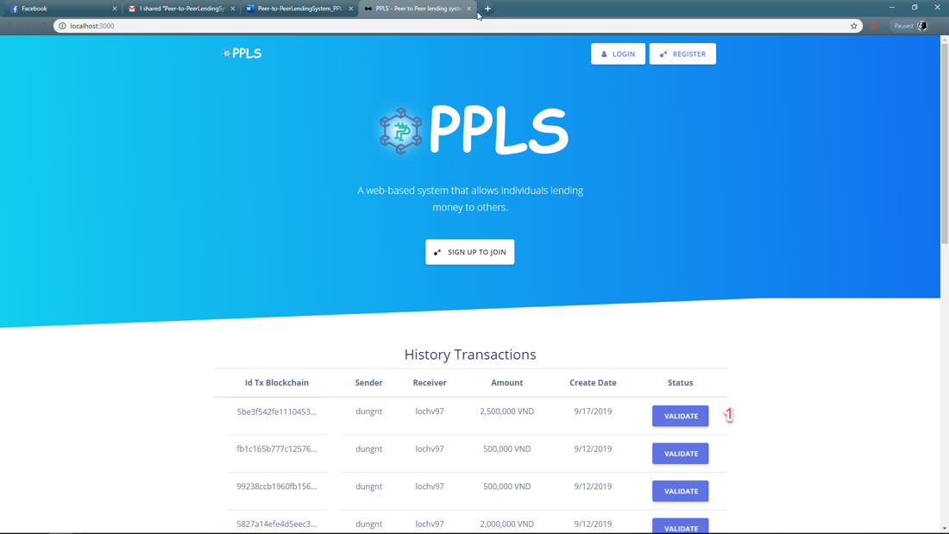

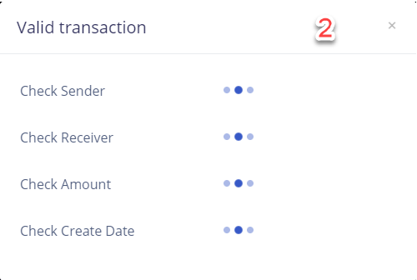

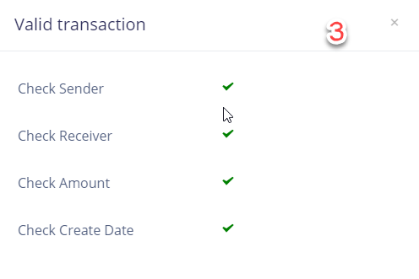

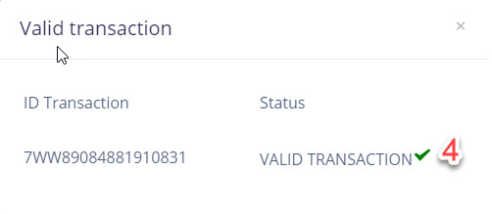

|  |  |
| --- | --- |
| **Step** | **Description** |
| Pre-condition | N/A |
| 1 | Click on “Validate” button. |
| 2 | Guest wait for checking. |
| 3, 4 | Result after checking. |

**2.1.2 Guest Login**

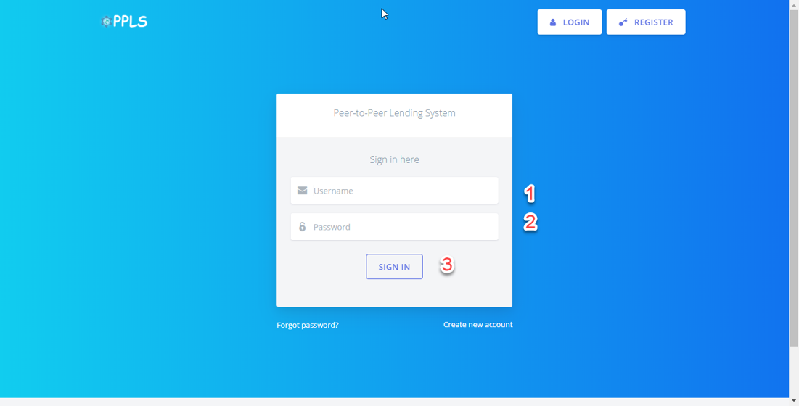

|  |  |
| --- | --- |
| **Step** | **Description** |
| Pre-condition | N/A |
| 1 | Guest input usename or email. |
| 2 | Guest input password. |
| 3 | Guest clicks on “Sign in” button. |

**2.1.3 Guest Register**

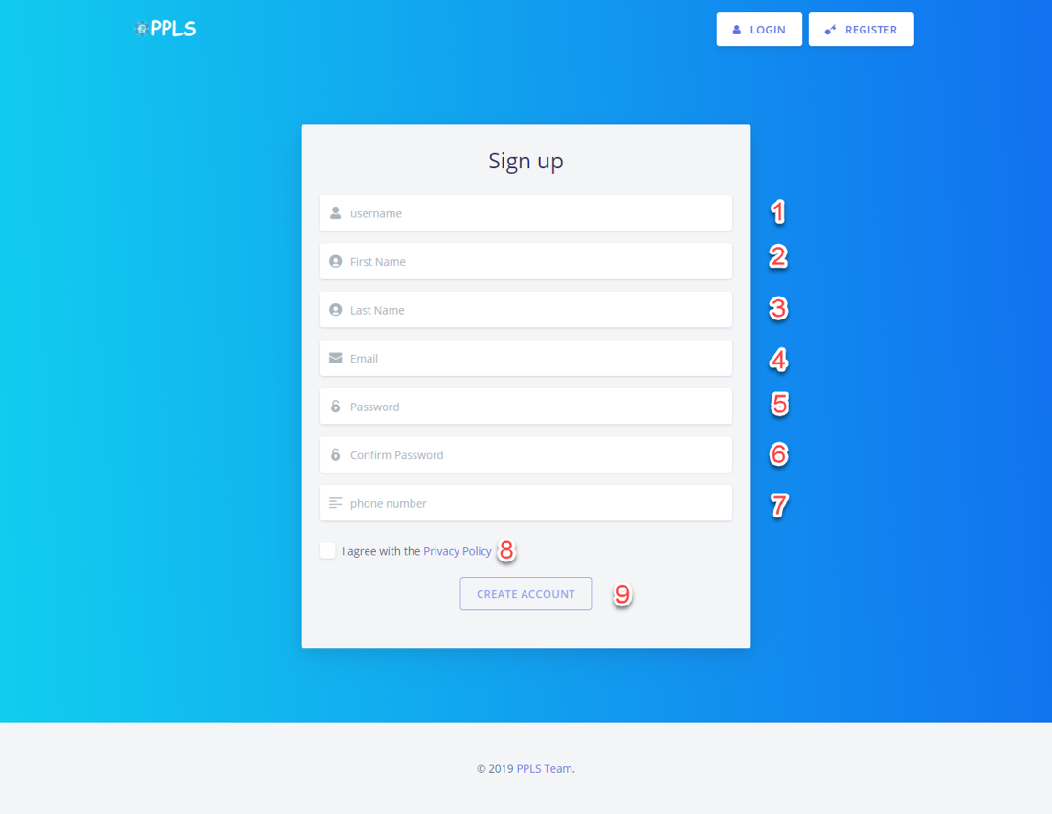

|  |  |
| --- | --- |
| **Step** | **Description** |
| Pre-condition | N/A |
| 1 | Guest input usename (not input special characters). |
| 2 | Guest input firstname (not input number). |
| 3 | Guest input lastname (not input number). |
| 4 | Guest input email (example format email example@gmail.com). |
| 5 | Guest input password (length at least 6 characters) |
| 6 | Guest input confirm password (confirm password match with password) |
| 7 | Guest input phone number (length at least 10 digit). |
| 8 | Guest check on “I agree with the Privacy Policy” (required). |
| 9 | Guest clicks on “Create Account” button. |

**2.2 Admin**

**2.2.1 Deactivate/reactivate user**

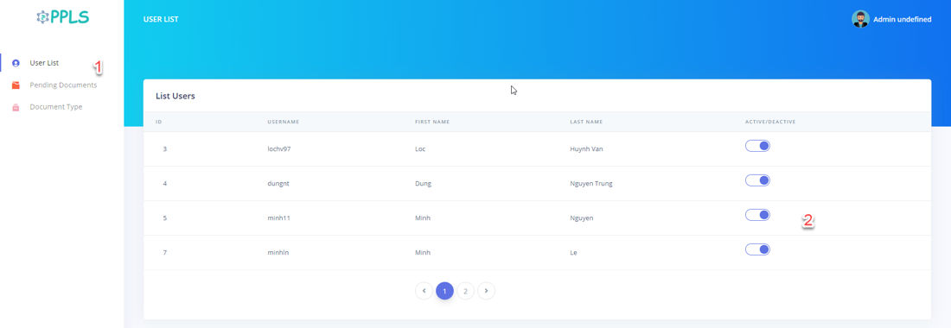

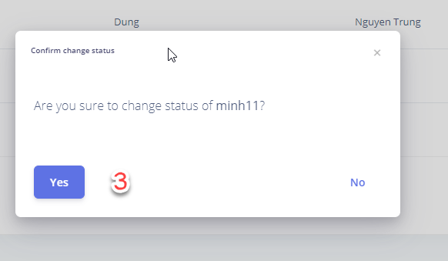

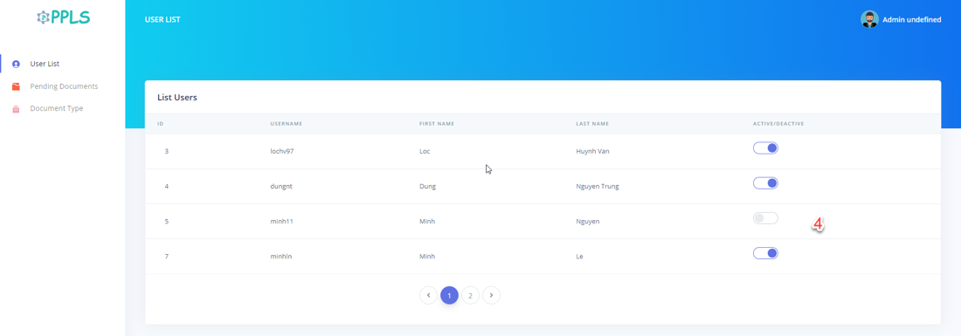

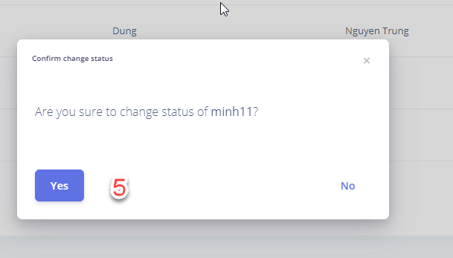

Figure 92 – User list UI

Figure 93 - Add Staff Popup

|  |  |
| --- | --- |
| **Step** | **Description** |
| Pre-condition | Login as Admin |
| 1 | Click “User list” in the side bar |
| 2 | Click toggle switch button next to a user |
| 3 | Click “yes” button |
| 4 | Click toggle switch button next to a user that currently witch off |
| 5 | Click “yes” button |

Table 142 - Deactvivate/reactivate user steps.

**2.2.2 New Document Type**

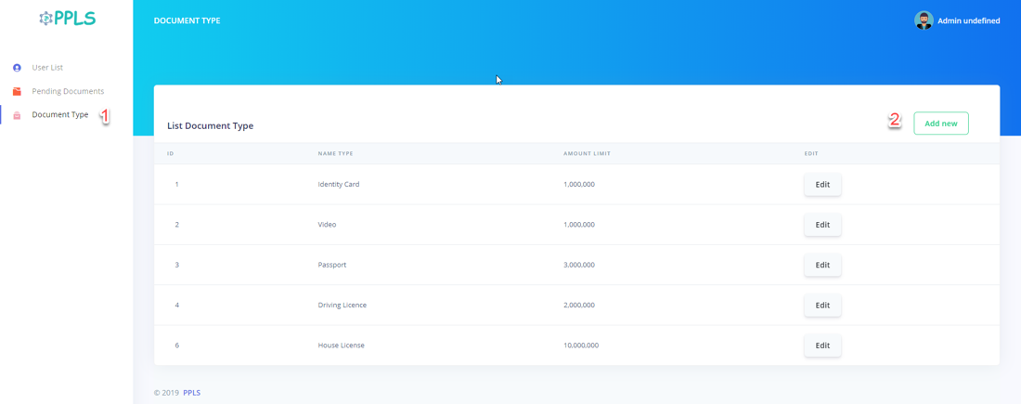

Figure 94 – New Document Type UI

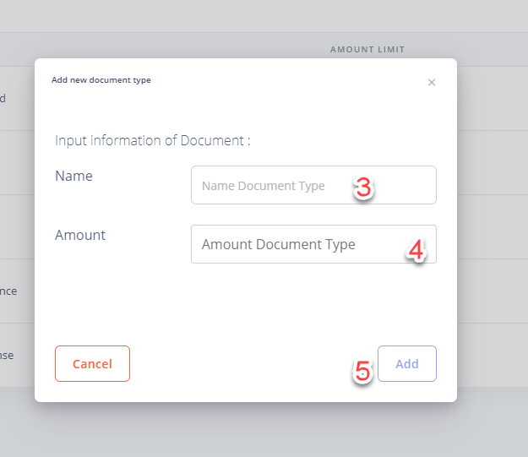

Figure 95 - New Document Type Popup

|  |  |
| --- | --- |
| **Step** | **Description** |
| Pre-condition | Login as Admin |
| 1 | Click “Document Type” in the side bar |
| 2 | Click “Add new” button |
| 3 | Fill the field “Name” |
| 4 | Fill the field “Amount” |
| 5 | Click “Add” button |

Table 143 – New Document Type Steps

**2.2.3 Edit Document Type**

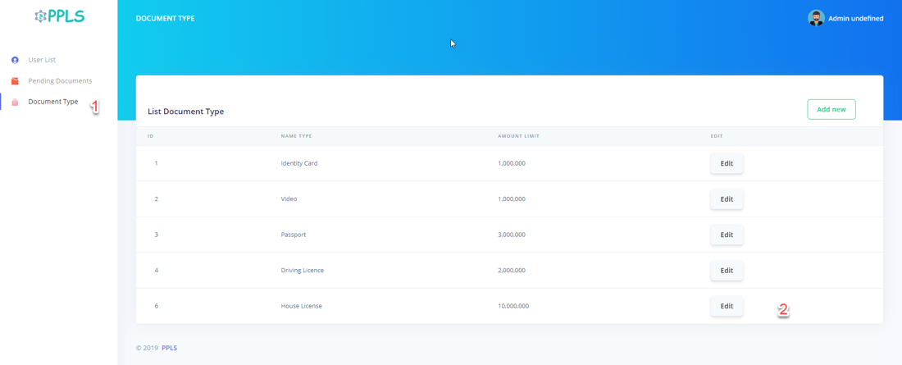

Figure 96 – Edit Document Type UI

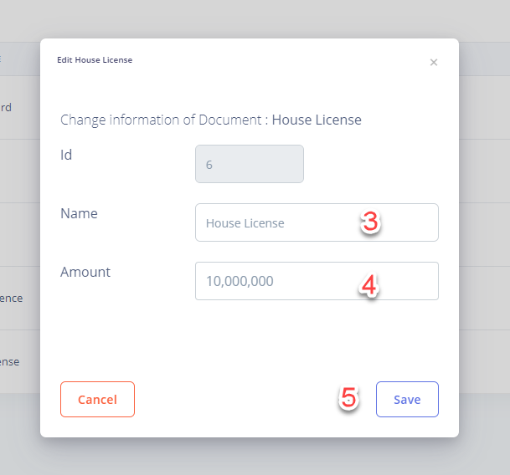

Figure 97 – Edit Document Type Popup

|  |  |
| --- | --- |
| **Step** | **Description** |
| Pre-condition | Login as Admin |
| 1 | Click “Document Type” in the side bar |
| 2 | Click “Edit” button |
| 3 | Fill the field “Name” |
| 4 | Fill the field “Amount” |
| 5 | Click “Save” button |

Table 144 – Edit Document Type Steps

**2.2.4 Validate a document**

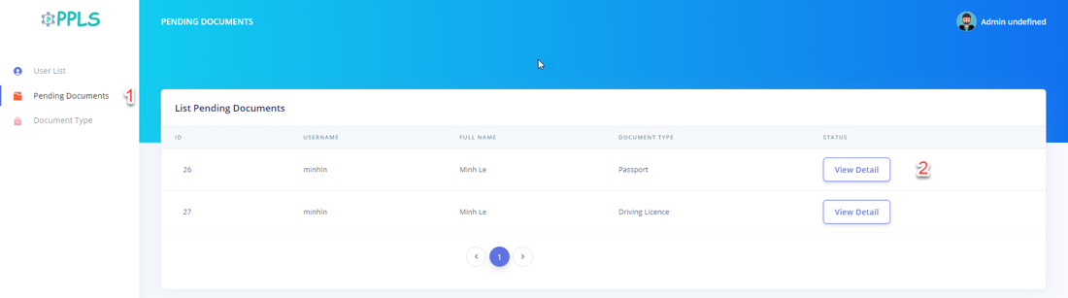

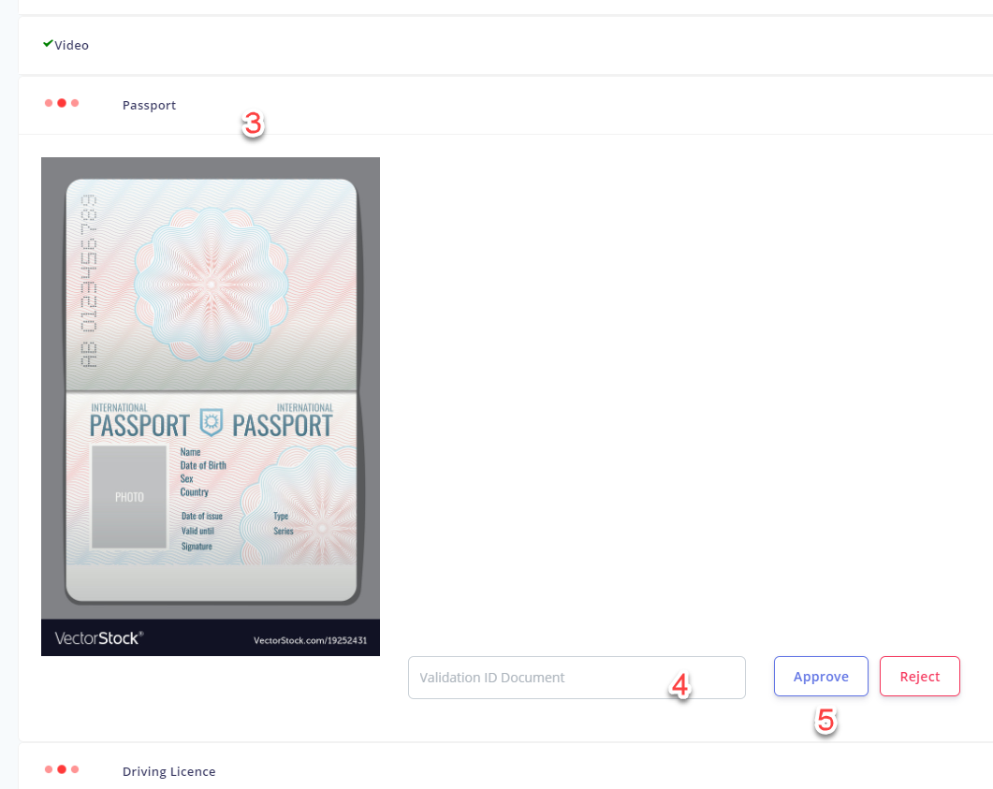

Figure 98 – View Document need to validate UI

|  |  |
| --- | --- |
| **Step** | **Description** |
| Pre-condition | Login as Admin |
| 1 | Click “Pending document” in the side bar |
| 2 | Click “View Detail” button |
| 3 | Click “Passport” |
| 4 | Fill in “validation id document” field |
| 5 | Click “Approve” button |

Table 145 – Validate document Steps

**2.2.5 Reject Document**



Figure 99 – View Document need to validate UI

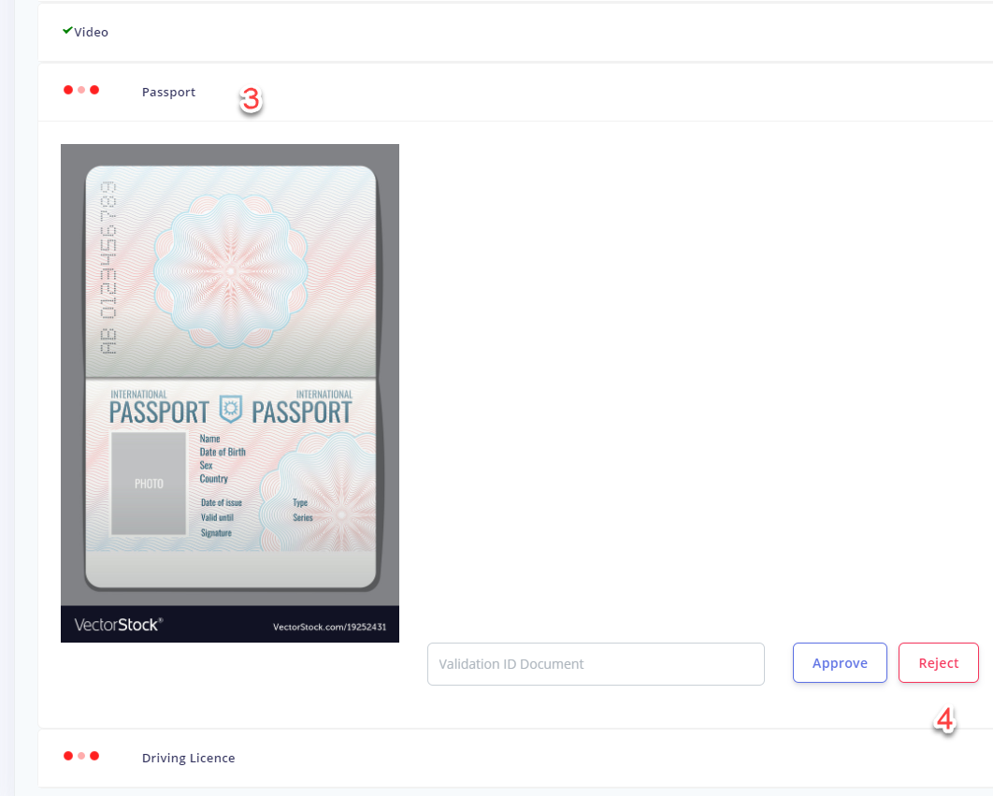

Figure 100 – Reject document

|  |  |
| --- | --- |
| **Step** | **Description** |
| Pre-condition | Login as Admin |
| 1 | Click “Pending documents” in the side bar |
| 2 | Click “View Detail” button |
| 3 | Click “Passport” |
| 4 | Click “Reject” button |

Table 146 - View Sitemap Steps

**2.3 Authorized User**

**2.3.1 Create Request**

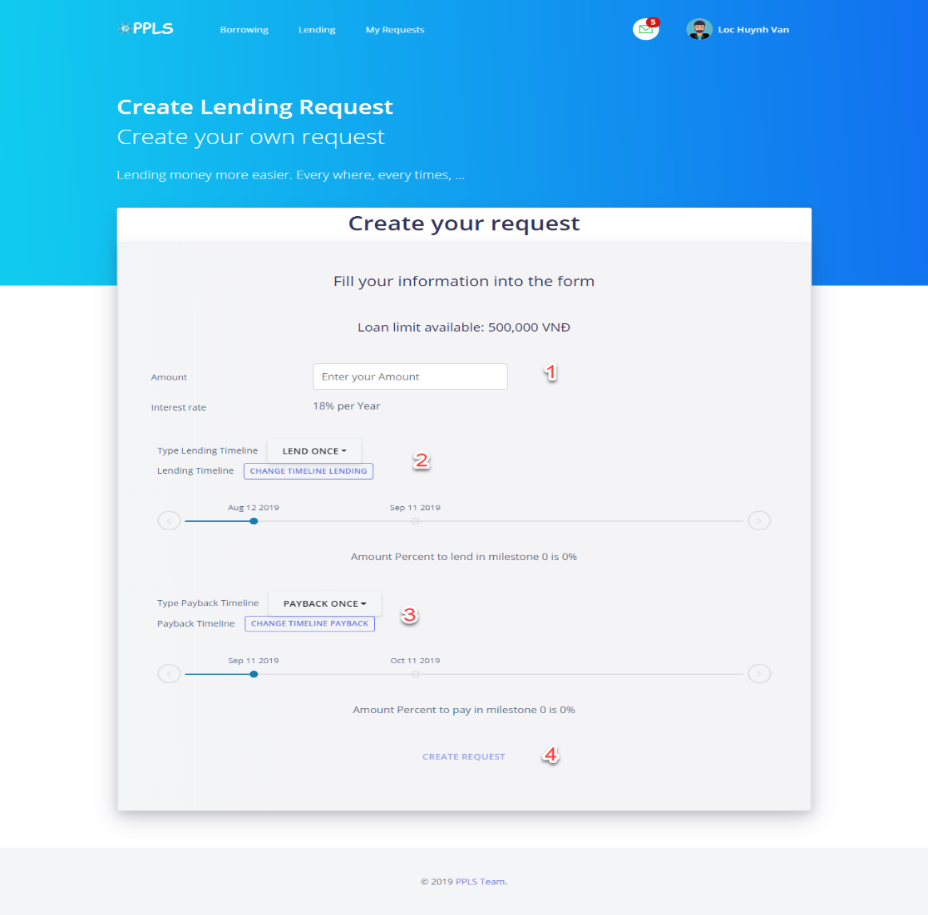

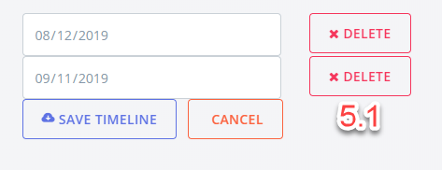

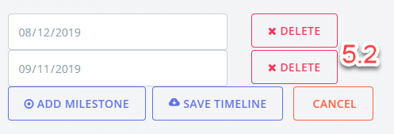

|  |  |
| --- | --- |
| **Step** | **Description** |
| Pre-condition | Login as Authorized user |
| 1 | Authorized user input amount (Amount is less than or equal loan limit available). |
| 2 | - Type lending timeline have two option:   * Lend once (default with 2 milestone). * Lend many (can add more than 2 milestone).   - Authorized user clicks on “Lend once” to change type lending timeline.  - Authorized user clicks on “change timeline lending” to edit milestone in timeline (edit day, remove milestone, add milestone). |
| 3 | - Type payback timeline have two option:   * Payback once (default with 2 milestone). * Payback many (can add more than 2 milestone).   - Authorized user clicks on “Payback once” to change type payback timeline.  - Authorized user clicks on “change timeline payback” to edit milestone in timeline (edit day, remove milestone, add milestone). |
| 4 | Authorized user clicks on “Create request” button. |
| 5.1 | * Lend Once  - Authorized user clicks on “delete” button if authorized user want to delete milestone.  - Authorized user edit day.  - Authorized user save edit.  - Authorized user cancel edit. |
| 5.2 | * Lend Many  - Authorized user clicks on “delete” button if authorized user want to delete milestone.  - Authorized user clicks on “add milestone” button if authorized user want to create a new milestone.  - Authorized user edit day.  - Authorized user save edit.  - Authorized user cancel edit. |

**2.3.2 Make Deal Request**

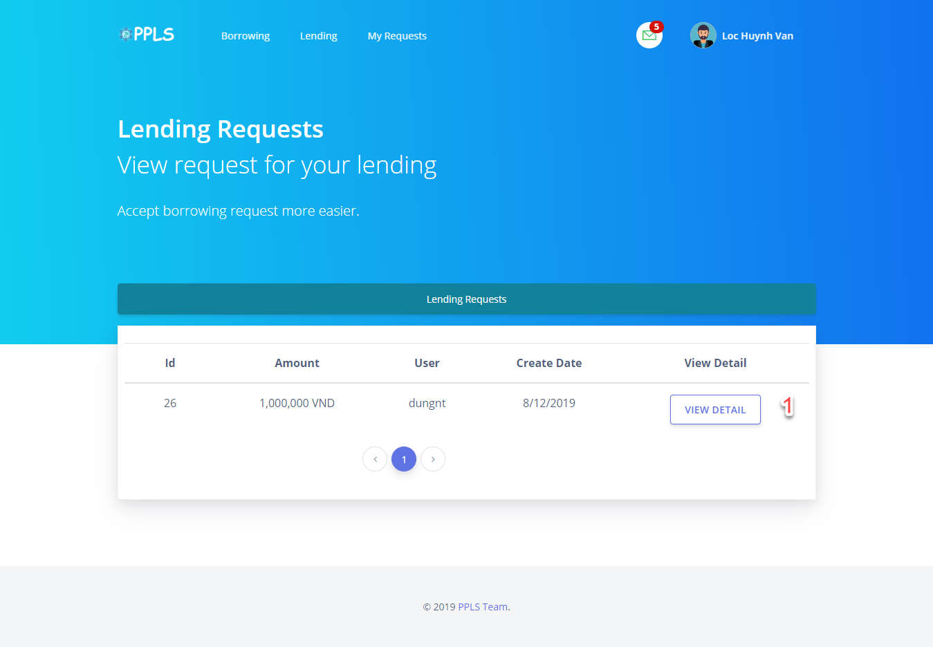

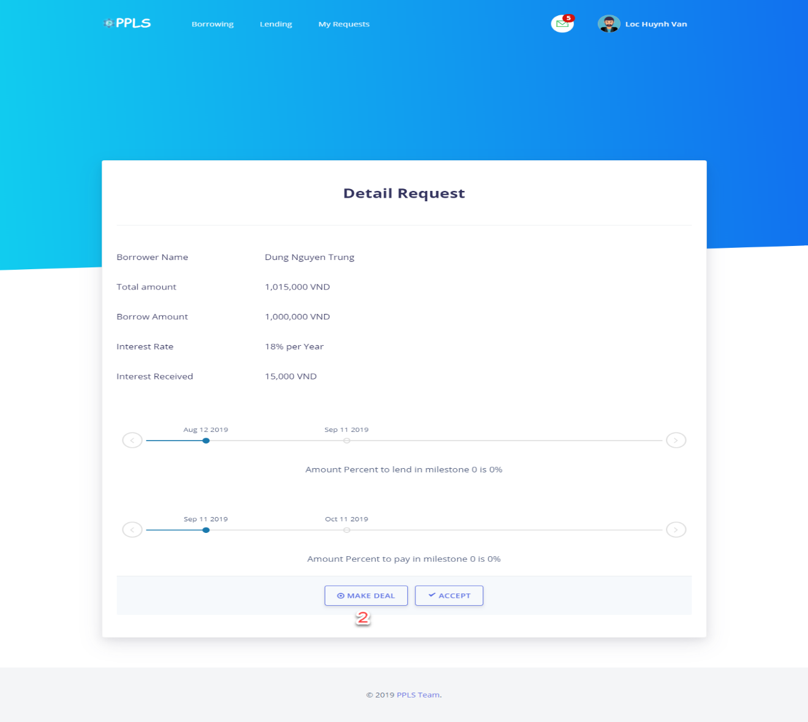

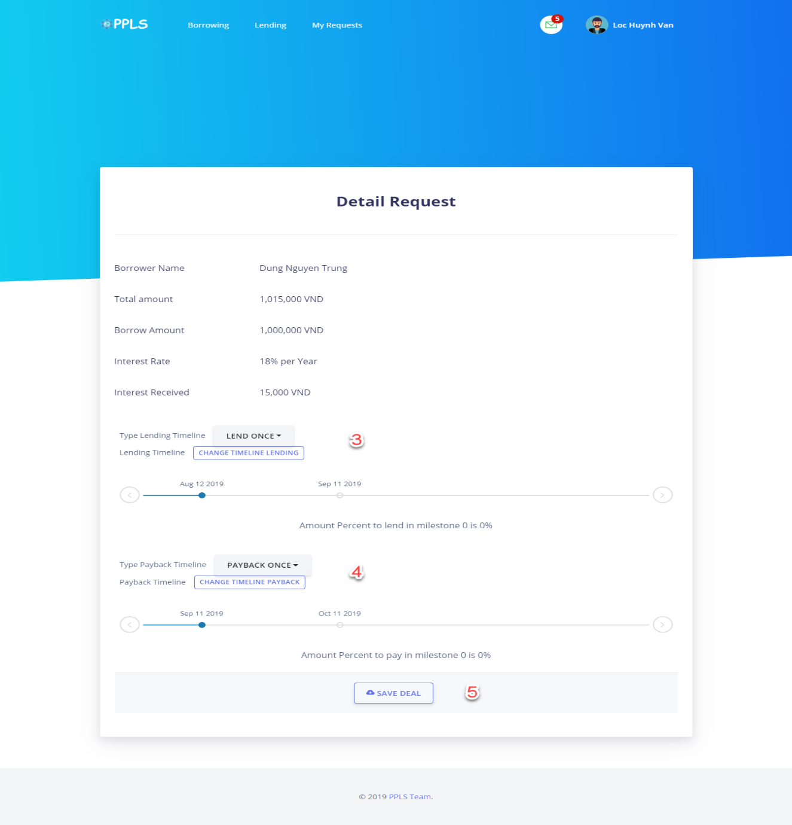

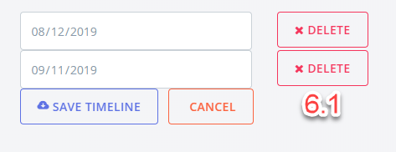

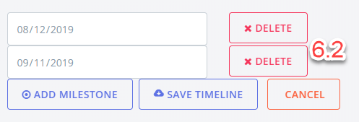

|  |  |
| --- | --- |
| **Step** | **Description** |
| Pre-condition | Login as Authorized user |
| 1 | Authorized user clicks on “view detail” button. |
| 2 | Authorized user clicks on “make deal” button. |
| 3 | - Type lending timeline have two option:   * Lend once (default with 2 milestone). * Lend many (can add more than 2 milestone).   - Authorized user clicks on “Lend once” to change type lending timeline.  - Authorized user clicks on “change timeline lending” to edit milestone in timeline (edit day, remove milestone, add milestone). |
| 4 | - Type payback timeline have two option:   * Payback once (default with 2 milestone). * Payback many (can add more than 2 milestone).   - Authorized user clicks on “Payback once” to change type payback timeline.  - Authorized user clicks on “change timeline payback” to edit milestone in timeline (edit day, remove milestone, add milestone). |
| 5 | Authorized user clicks on “Save deal” button. |
| 6.1 | * Lend Once  - Authorized user clicks on “delete” button if authorized user want to delete milestone.  - Authorized user edit day.  - Authorized user save edit.  - Authorized user cancel edit. |
| 6.2 | * Lend Many  - Authorized user clicks on “delete” button if authorized user want to delete milestone.  - Authorized user clicks on “add milestone” button if authorized user want to create a new milestone.  - Authorized user edit day.  - Authorized user save edit.  - Authorized user cancel edit. |

**2.3.3 Accept Request**



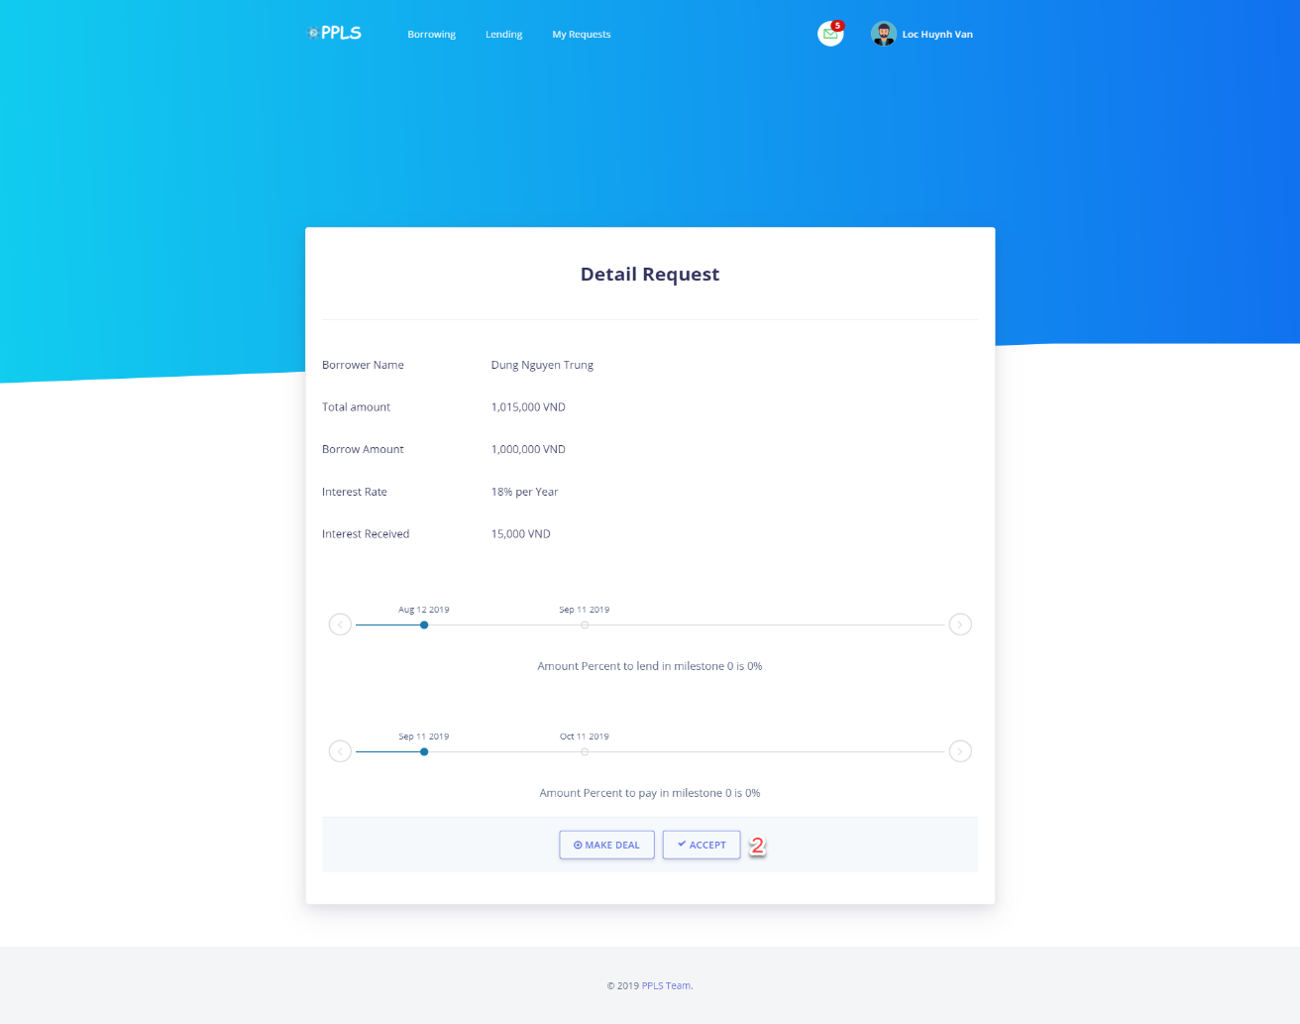

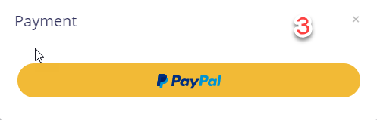

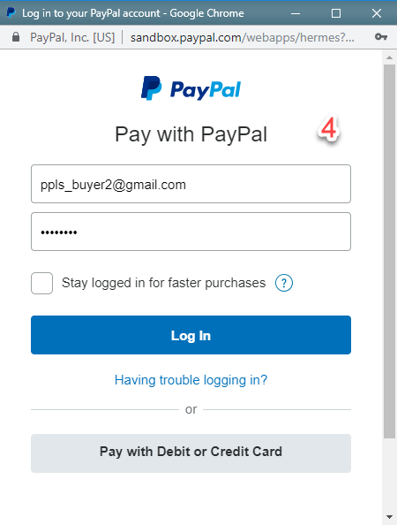

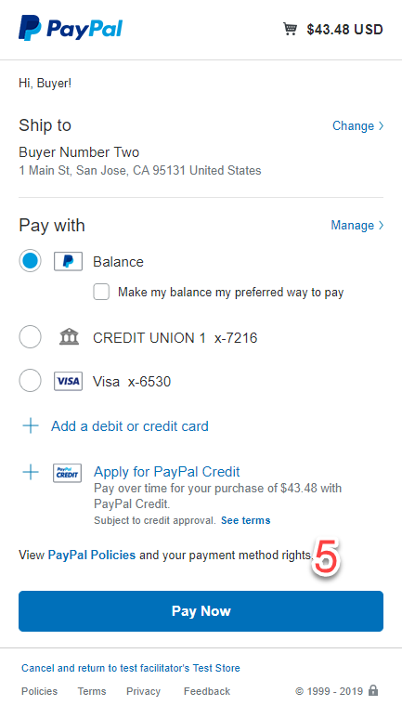

|  |  |
| --- | --- |
| **Step** | **Description** |
| Pre-condition | Login as Authorized user |
| 1 | Authorized user clicks on “view detail” button. |
| 2 | Authorized user clicks on “accept” button. |
| 3 | Authorized user clicks on “paypal” button. |
| 4 | Authorized user clicks on “Log in” after input their paypal account. |
| 5 | Authorized user clicks on “Pay now” button after select payment method of paypal. |